iPad videoing – Evidence – Dragonflies – 21.10.24

**Learning Objective: to use an iPad to successfully record a video**

**What is important when making a video?**

* Don’t press random buttons. It might change your voice or body size – KC
* Don’t send it to strangers – BM
* Use a kids’ app when searching for pictures to keep safe – KC
* Check with parents before you make it – TG
* Don’t video others without their permission – DJ
* Don’t video people if they don’t want you to – P-RP
* If they ask you to delete it, then delete it - EP

Mrs Kemp & Miss Scott demonstrated videoing a child and asked what she had done well / badly. The children identified:

* The iPad did not stay focused on Kit the whole time – it pointed to the floor and the ceiling.
* The teachers started filming the other children when the children were still talking
* The video started well, focussed on Kit – not too close / too far away so you could hear what he was saying

As a class we also discussed:

* Not walking in between the iPad and someone being filmed
* Filming in a well lit area
* Holding the iPad still

Dragonflies:

After making the videos, we watched each other’s and gave feedback:

* “Harper chopped off Annabelle’s head! The camera needed to be further back.”
* “I could see all of him in the video.”

Pondskaters:

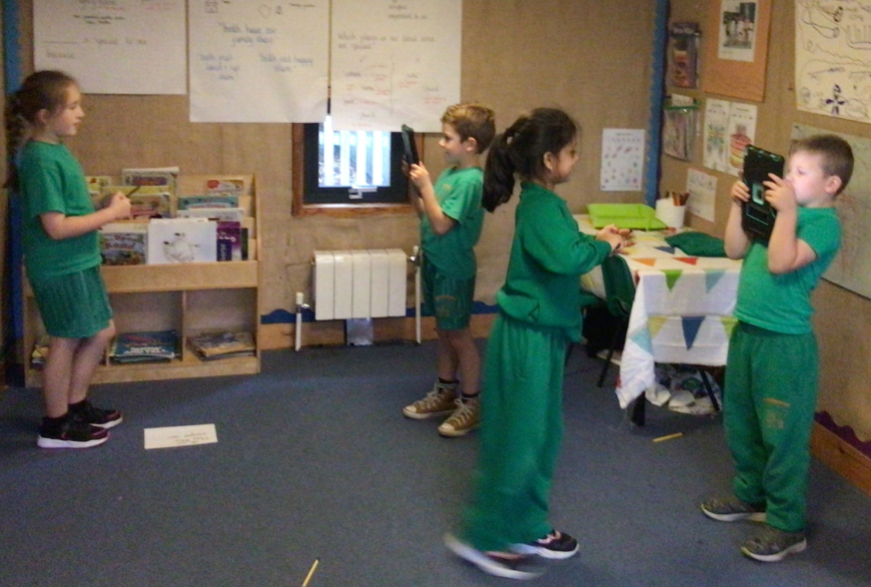

After making the videos, we watched each other’s and gave feedback:

* “Paisley stood near to the window so there was lots of light”
* “Ronin stood too close – it was a bit blurry”
* “David kept the camera still and zoomed in to see Erika’s face more clearly”
* “You need to rehearse what you are saying first – otherwise you get muddled”