**Autumn 2**

**Lesson 1 and 2**

In our computing sessions, we have been recalling our year 5 skills on Microsoft Word.

Year 6 have been learning about Ancient Egypt in History. They learnt about the process of mummification and what sorts of items people would have been buried with. Using this knowledge and their computing knowledge, they created some instruction pages.

There was a tick list that they definitely needed to try and include in their instructions or just have a go at using.

* Underlining
* Changing font style, colour, size, boldness
* Inserting a picture
* Using bullet points

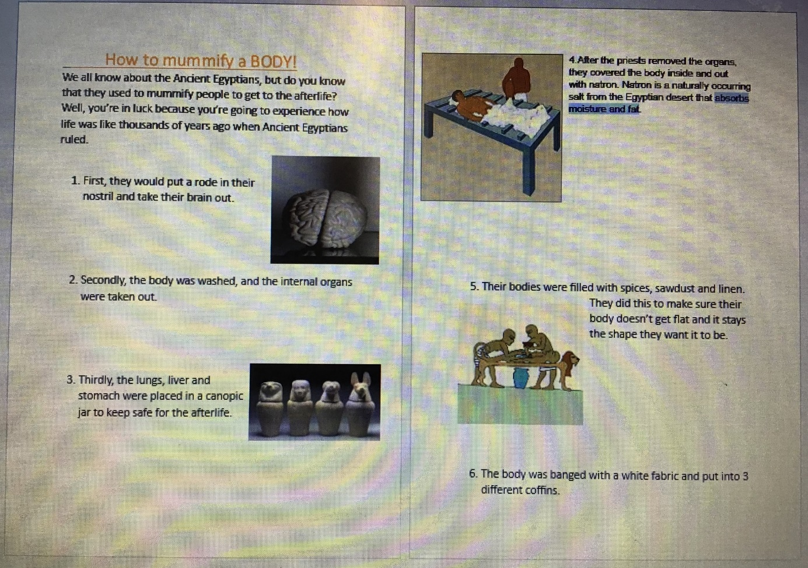

One of the really good things we found was that if we accidentally missed a comma or spelt something wrong, it would have a squiggly line under it. All we needed to do was right click and correct it.

Next time, I’m going to figure out how to have a boarded made of pictures. I tried to do this with the pyramids but it was taking ages. I would google a quick way to do this.

I was surprised about how much I could remember from year 5. I added the pictures using the insert tab and found so many online.

At first, we kept clicking the space bar to make our title start in the middle of the page. But we googled how to do this quickly. We just clicked the text aligning button and could make it go in the middle or start normally.

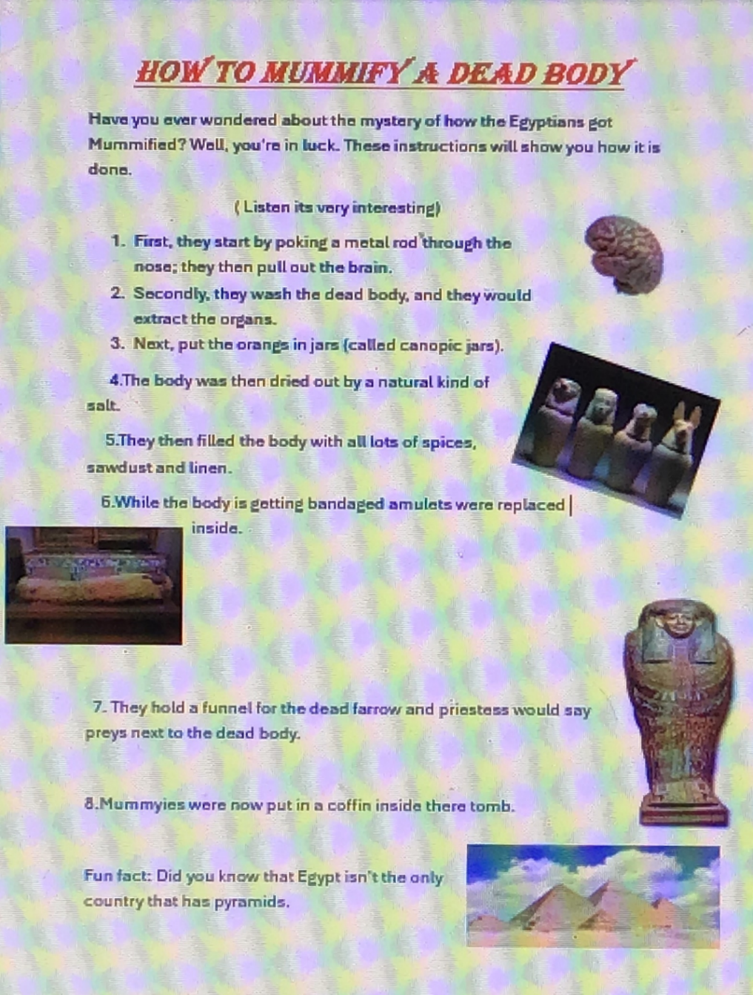

We remembered how to insert text boxes and shapes.

My favourite part is the border we found and inserting the scroll shape at the bottom. We wanted to make it look old so we also changed the colour of the page.