|  |
| --- |
| Computing – Online search |
| LO: To use technology purposefully to retrieve digital content in the context of using a search engine online |

**How do we find out information?**

“Dictionary”

“Search it up on Google”

“Ask your mum”

“Look at the news?

**What do we know about the internet?**

“You can watch channels on the internet”

“We can play some games on it!

“You can watch stuff”

“Internet helps you to watch things”

“Listen to music”

“Hey Siri” – it would do whatever we tell it – discussion about Siri only being able to do things using the internet e.g. finding out information.

**What would you do if something online made you feel upset/scared/uncomfortable?**

“Tell your parents”

“Tell a teacher”

“Tell a member of your family

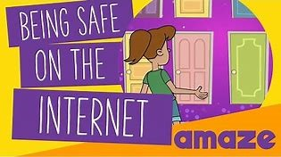**As a class, we talked about staying safe on the internet and the importance of using websites that our grown-ups know about.**

Then, we were introduced to the vocabulary ‘www’ and web browser.  We did not know that there are a number of different options out there but each has a similar job.

We learned how to open the website KIDDLE.CO (a child friendly web browser) using the key skills we had learned in year one (e.g. click the internet browser tab, click on the bar at the top, type in the website, press enter)

We typed in the key word ‘space’ and discussed what we found.     
*Did everyone have the same results? What was the same what was different?*