**Year 2 - Computing – Online Search – 30.09.24**

LO: To use technology purposefully to retrieve digital content in the context of using an online search engine

We recapped our prior learning and could remember that the name of the child friendly search engine is Kiddle.

We discussed how to search more successfully – using more key words when searching e.g. type ‘space for kids’ rather than ‘space’.

Using Kiddle, we searched ‘space for kids’ and noted the results.

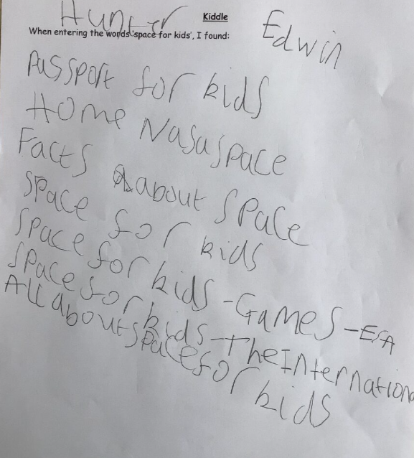

Next, we were introduced to another child friendly search engine called Swiggle. We searched ‘space for kids’ again and noted the results this time.

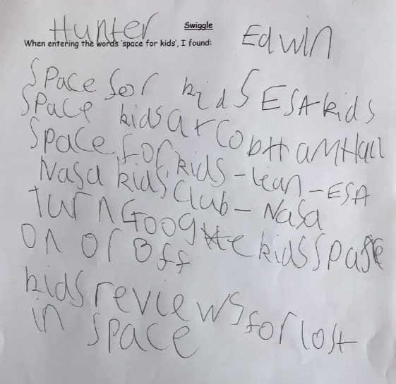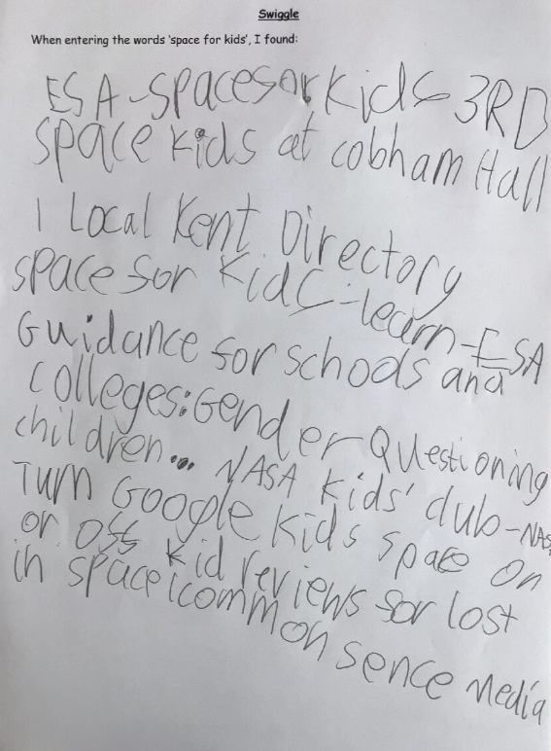

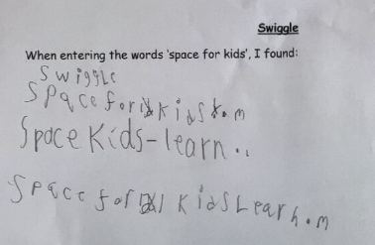

We discovered, despite searching for the same thing each time, the results were different the second time.