**Year 4 – Computing Journey**

**Autumn 1**

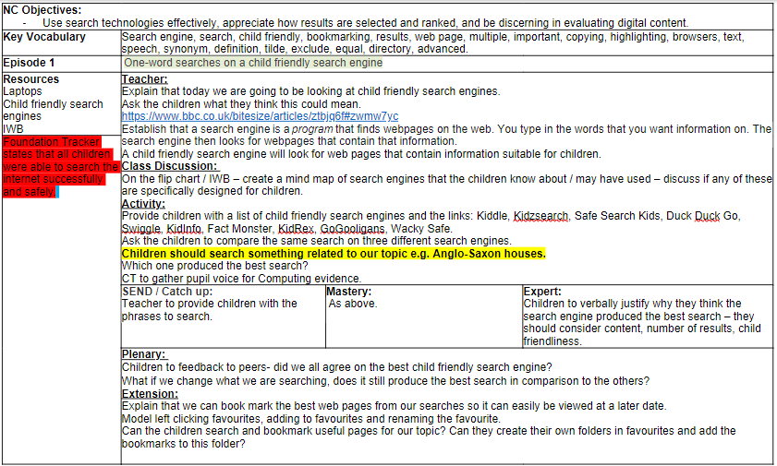**23.09.2024 – JR**

**What search engines are we already familiar with?**

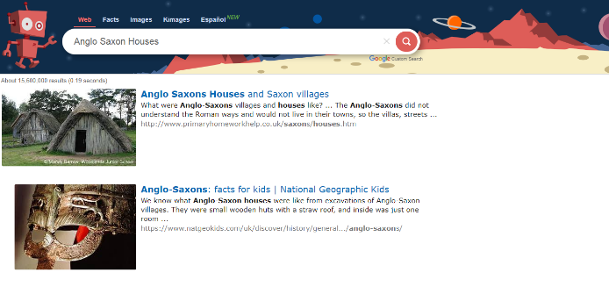

Kidde

Duck Duck Go

Swiggle

Wacky Safe

Kidzsearch

Kid Info

Safe Search Kids

Fact Monster

Kid Rex

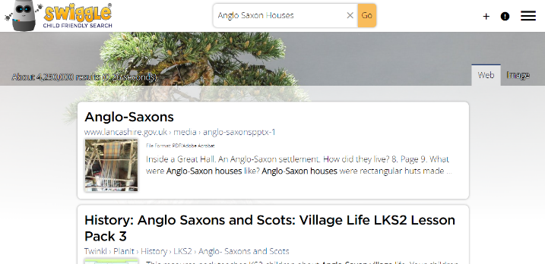

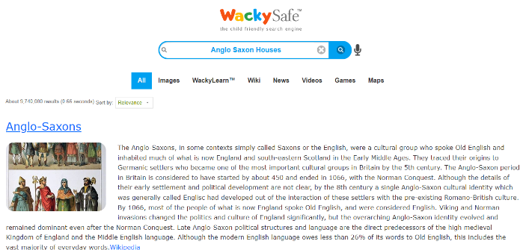

Duck Duck Go didn’t work - IM

**What was the best child friendly search engine?**

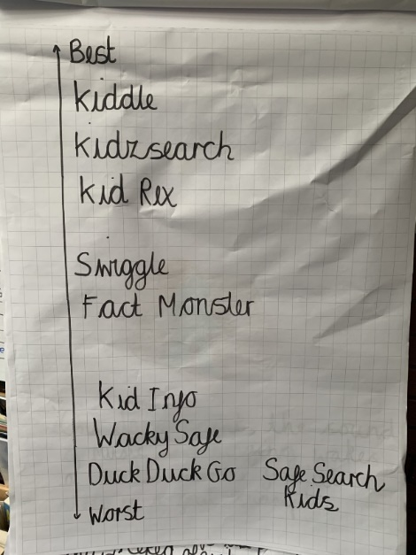

**Darcie Turnbull, Lenny Edney, Rosie-May Bennett – Adult support to conduct searches in the next lesson – further guidance on what makes a search engine the best.**

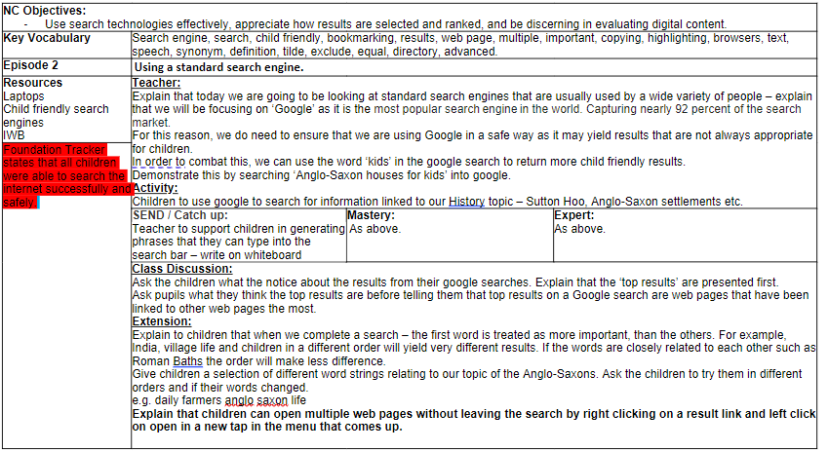**08.10.2024 – JR**



‘Google’ is the most popular search engine in the world. Capturing nearly 92 percent of the search market.

We need to use the word ‘kids’ when doing a ‘Google’ search so gives us more child friendly results - IC

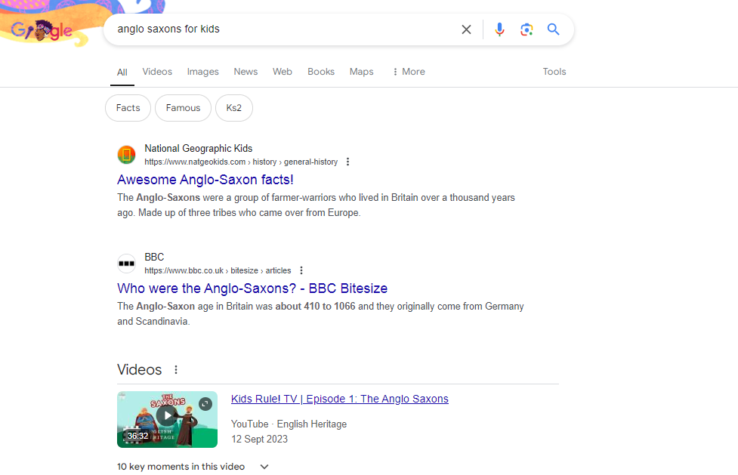

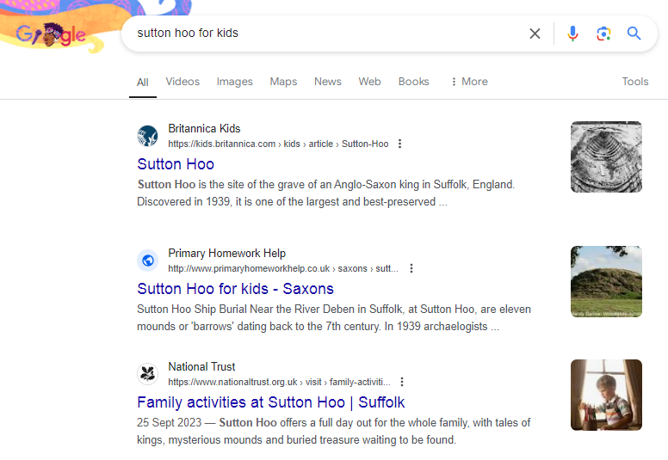

I notice that the top results are presented first – GC

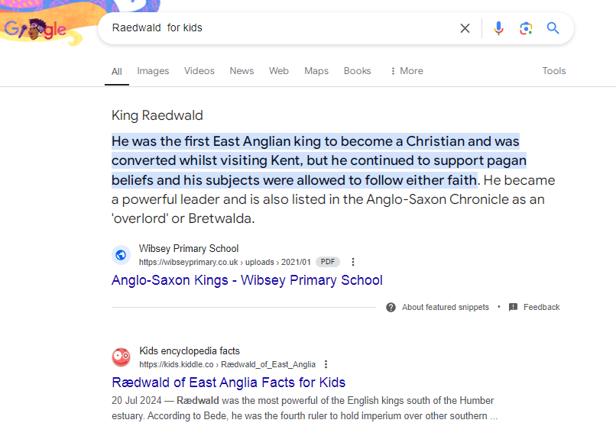

**Did you know that top results on a Google search are web pages that have been linked to other web pages the most?**

We **can open multiple web pages without leaving the search by right clicking on a result link and left click on open in a new tap in the menu that comes up.**

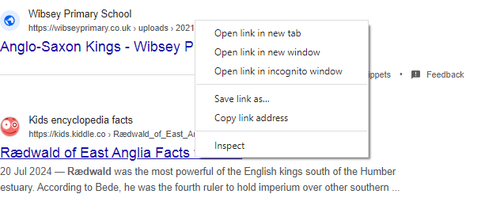

**Maycie Hyett, Lenny Edney, Darcie Turnbull, Harrison Page, Meheriya Mirkhill, Rosie-May Bennet – support to understand results and that the top results are likely to be the most relevant.   
Kai Carter McLachlan, Frankie Page, Isla Creighton, Mollie Doswell not present during lesson so may need additional support.**

**21.10.2024 – JR / SHL**

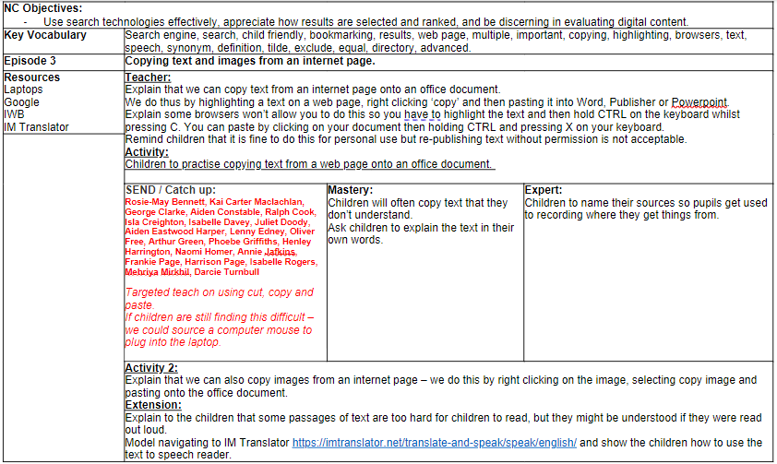

We can copy text from an internet page to an office document.   
Highlight a text on a web page, right click ‘copy’ and then paste it into Word, Publisher or Powerpoint.    
Some browsers won’t allow you to do this so you have to highlight the text and then hold CTRL on the keyboard whilst pressing C. You can paste by clicking on your document then holding CTRL and pressing X on your keyboard.

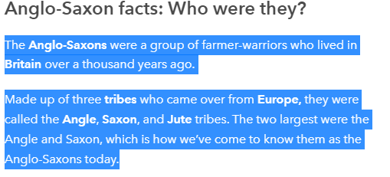

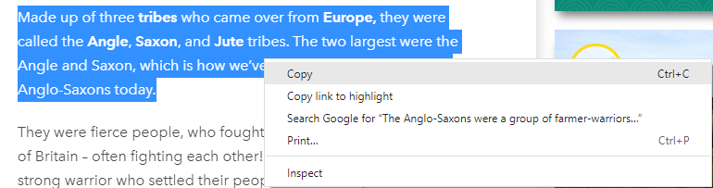

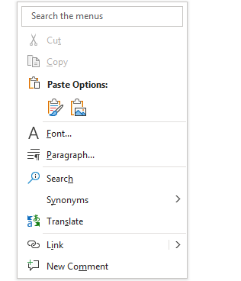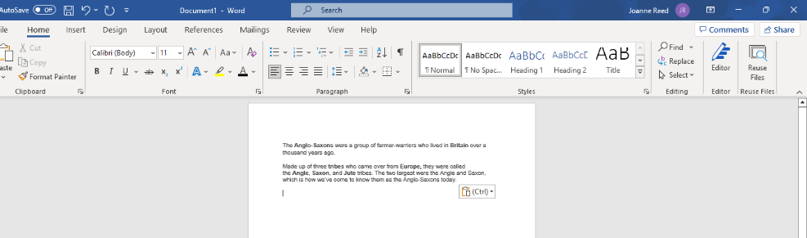

It is fine to do this for personal use but re-publishing text without permission is not acceptable.

I discovered you can copy images from an internet page by right clicking on the images and selecting copy. KMR

**Kai Carter Maclachlan, Henley Harriongton – Absent.**

**Rosie-May Bennett, Ralph Cook, Isabelle Davey, Naomi Homer, Frankie Page, Darcie Turnbull, Lenny Edney, Maycie Hyett – Require further consolidation and additional practise (some children struggled with using their fine motor skills on the track pad).**

**Autumn 2**

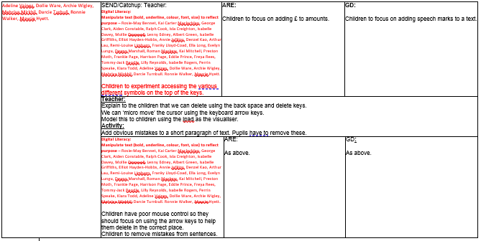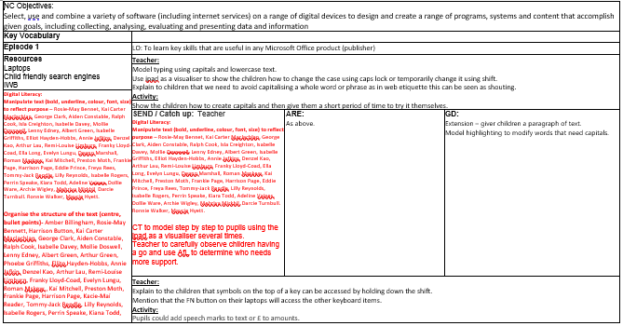**4.11.2024 / 18.11.24– JR SHL**

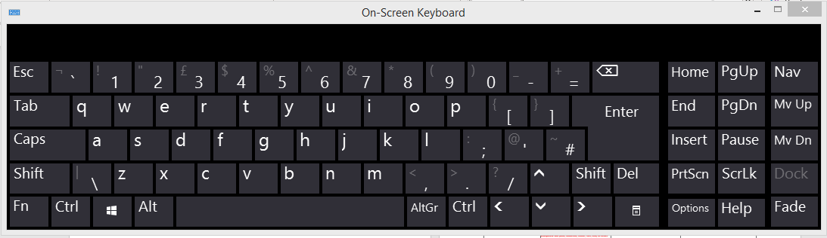**How do we use capital letters and lower-case text?**

**We can hold ‘shift’ and press a letter to also change it into a capital.**

If we press ‘CAPS’ or CAPS LOCK’ we can type using capital letters. If we turn it off, it will be lower case letters. PS.



We need to avoid capitalising a whole word or phrase as in web etiquette this can be seen as shouting.

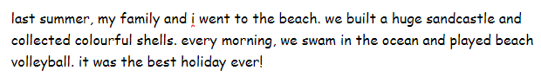

We had to edit the text and change all the words that needed capital letters. HS

**How can we access symbols at the top of the keyboard?**

Symbols on the top of a key can be accessed by holding down the shift.

Can you add inverted commas and £?.

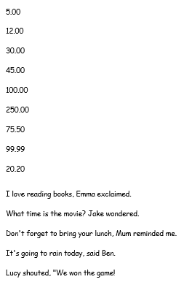

Its difficult to move the cursor to where I want to add the symbols. IC.

All children in NEWTS class were able to type using capital letters and lower case text. They were all able to access the different symbols.   
DT- required peer support.

**26.11.24 – JR SHL**

We can click the undo/redo tab button to restore previous work.

“You can use the drop down menu to locate something more specific.” AEH

It is best to have sequential versions of documents so you can go back to previous versions if needed.

“It is also important that we save the documents we are working on, if we want to keep them and access them again on, if we want to keep them and access them again.” HS

Introduced intermittent saving, children found this difficult due to SharePoint – CT unable to access work that has been saved by children unless they are logged in on that child’s account.