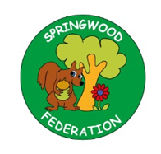

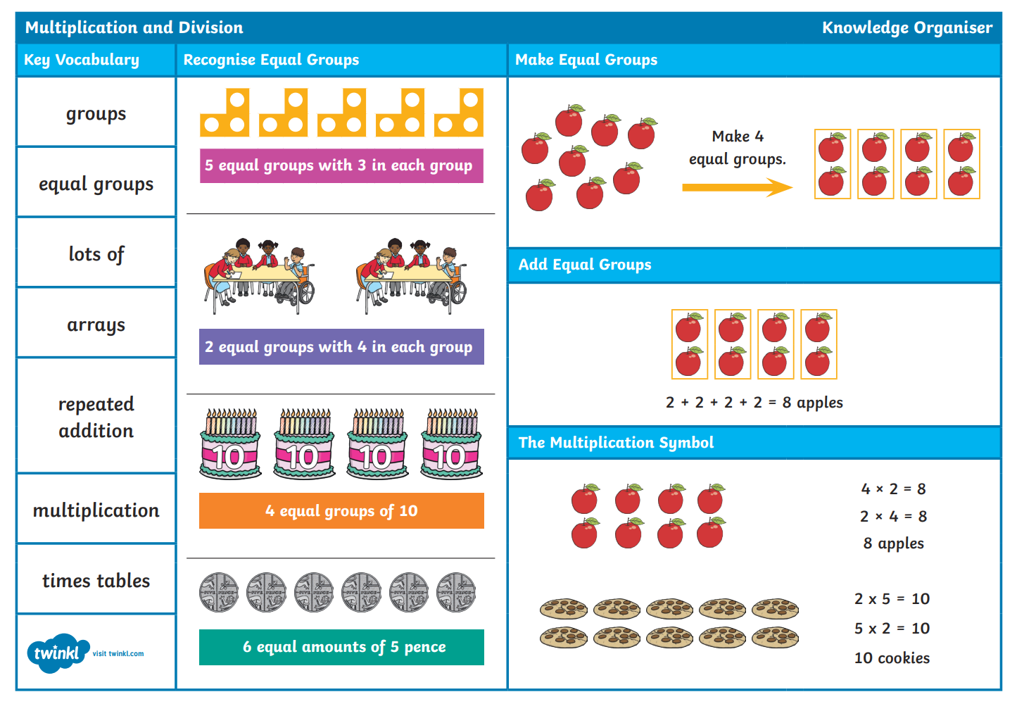

**Pre-teach poster**

**Year 3**

**Autumn 2**

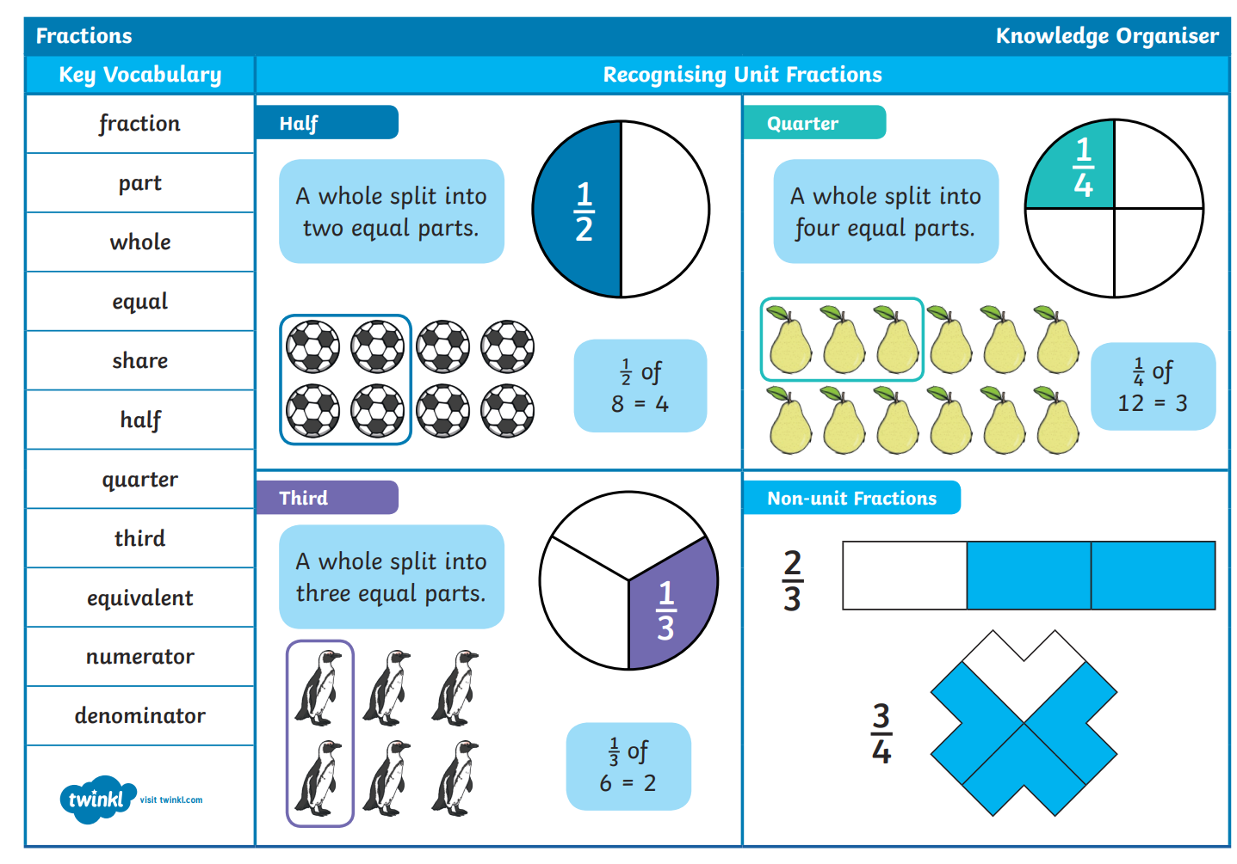

|  |  |  |  |
| --- | --- | --- | --- |
| **Writing**  Literacy Shed Plus - Literacy Shed Plus - Teaching Resources Made Easy | | Skill: To write a short narrative based on a section of the clip. |  |
| **Phonics** | To secure our understanding of Phase 3 and 5 sounds | | |