Task to be completed over this half term | Phonics  Continue to practise your sounds that you find tricky at home.  Continue practising reading and spelling phase 4 tricky words and beginning to read phase 5 tricky words.  easy challenge medium challenge most challenge  Phase 2: the to I no go into Phase3: he she we me be was you they all are my her Phase 4: have like so some come said were there little one when what out Phase 5: oh their people Mr Mrs looked called asked could Others: Who What Where Why When How |  | Maths  *How many ways can you find to make 5/6/7/8/9/10 with addition?  *Can you subtract two numbers within 20 using the draw and cross out method?  e.g. 4-2=2  *Practise writing your numbers from 10-20, making sure they are the right way around.  Challenge: Write the 10s numbers (10-20-30-40-50-60-70-80-90-100), again making sure the digits are the right way around.  *We have been discussing length using the words “longer”, “shorter”, “double” and “half”. Maybe you can arrange your toys by height? Or arrange pieces of spaghetti by their length? | Reading  *Continue to read your book with a ‘number’ on it at least 3 times a week.  Try to:  - segment and blend using your phonic  - read tricky words on sight  *Can you re-read the sentence once you have sounded it out?  There are decodable book on our Oxford Owl site for children to read 3x a week.  Look at the stories we’ve studied so far. Can you:  -What do these stories have in common?  -What is your favourite part?  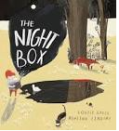  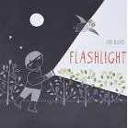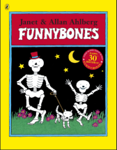  Flashlight- Lizi Boyd  Funnybones – Janet and Allen Ahlberg  The Night Box- Louise Grieg and Ashling Lindsay |  | Creative Family project:  Submission date:  Handed in by Friday 13th December.  Geography: human and physical features in and around our school.  Think about your favourite place near our school. Could you draw or paint it, or create a model of it in a shoebox?  Physical features: Things that happen naturally, such as trees, ponds and flowers.  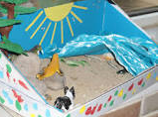  Human features: Things that are built by humans.  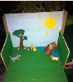  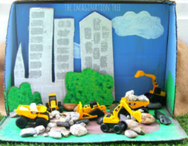
Suggested timetable | Week 1  Practise spellings / flashcards  Maths – Practise forming numbers 1-10-  Reading – Read 3 books set on Oxford Owl  *Where is the book set? | Week 2  Practise spellings / flashcards  Maths – How many addition facts within ten can you remember?  Reading – Read 3 books set on Oxford Owl  *Who is the main character? | Week 3  Practise spellings / flashcards  Maths – Practise forming numbers 10-20  Reading – Read 3 books set on Oxford Owl  *Does it remind you of any other books? | Week 4  Practise spellings / flashcards  Maths – Write down addition facts.  Reading – Read 3 books set on Oxford Owl  *Are there any new and interesting words in your book? | Week 5  Practise spellings / flashcards  Maths – Practise forming 10s numbers  Reading – Read 3 books set on Oxford Owl  *Can you think of a different ending? |  | Week 6  Practise spellings / flashcards  Maths – Try some subtraction number sentences.  Reading – Read 3 books set on Oxford Owl  *Who would you recommend this book for?
In Geography, we are learning about:  - My school and local area. | In Science, we are learning about:  - How animals survive. | Curriculum Overview  Autumn 2  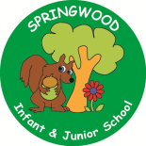  Year 1 | In PSHE, we are learning about:  Health and Wellbeing  Keeping Safe by:  - Who are our safe adults in different situations?  - The difference between a secret (you’re told that no one can know and can make us feel worried, scared or sad) and a surprise (everyone eventually finds out and it feel happy or exciting). | In RE, we will be learning about:  - Theme/Unit: The Nativity Journey  - Concept: Journey’s end
In PE, we are learning about:  - Ball skills (hands)  - Gymnastics (body parts) | In Computing, we are learning:  - to use Scratch to program movement. |  | In Music, we are learning about:  - Dimensions Focus: timbre & dynamics | In Art, we are:  - Exploring drawing portraits of a teddy linked to illustrator and author Shirley Hughes (Dogger)
In English, we will be writing a sequence of captions linked to our key text, Flashlight by Lizi Boyd.  In Reading we will be Reading complimentary texts including:  The Night Box, The Dark – Lemony Snicket, flashlight by Lizi Boyd |  |  | In Maths, we will continue to develop our Arithmetic skills.  We will also develop our skills and knowledge in:  - Multiplication and division  -Fractions and Geometry  -Number Place Value  -Addition and Subtraction

