Task to be completed over this half term | Early Reading / Phonics    Help your child to login to their Essential Letters and Sounds E Library Account using the password you have been provided with separately.  To best support us in teaching your child how to read we ask that you read the online decodable text shared by the school 4 times across the week.  Spending 10 minutes a day reading with your child will hugely support them in their journey to becoming an independent reader  If you do not have access to a computer, tablet or smart phone, please contact the school.  Read and spell:  Phase 2: the to I no go into Phase3 : he she was you they all are my Phase 4: have like so some come said were what | Maths  *Can you read all the door numbers in your road?  *Practise writing your numbers from 1-20, making sure they are round the right way and formed the correct way.  Challenge: Can you write the numbers 20-30 making sure the digits are in the correct place?  *Tell someone what is the same and what is different about  14 and 41.  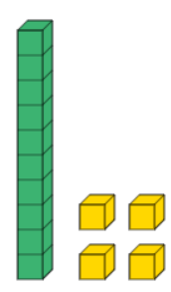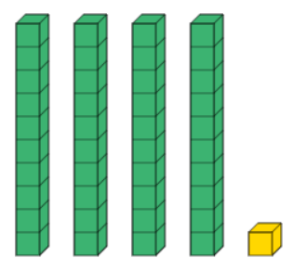 | Reading for Pleasure  Challenge yourself to read a mix of story books and an information book this half term.  Your teacher recommends these authors and will be reading some of their books with you:  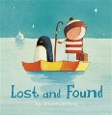  Lost and Found – Oliver Jeffers  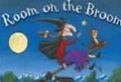  Room on the Broom – Julia Donaldson  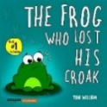  The Frog who lost his croak – Toni William | Creative family project:  Submission date: 24.10.24  This term we would like you to design a board game based on one of the books we have read.  It could involve a racing track, snakes and ladders or your own ideas.  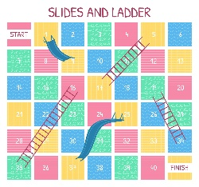  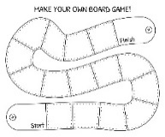  Open classroom event  Parents are invited to our open classroom session on Monday 23rd September 2:30 - 3pm to see your child's learning.
Suggested timetable | Week 1  Maths – Number bonds to 5.  Reading – Phonics / Reading –we ask that you read the online decodable text shared by the school 4 times across the week.  *What is the setting of your book? | Week 2  Maths – Recognising numbers to 20.  Reading – Phonics / Reading –we ask that you read the online decodable text shared by the school 4 times across the week.  *Who is the main character in your book? | Week 3  Maths – Number bonds to 6.  Reading – Phonics / Reading –we ask that you read the online decodable text shared by the school 4 times across the week.  *Does it remind you of any other books? | Week 4  Maths – Recognising numbers to 20  Reading – Phonics / Reading –we ask that you read the online decodable text shared by the school 4 times across the week.  *Are there any new and interesting words in your book? | Week 5  Maths – Number bonds to 10.  Reading – Phonics / Reading –Can you read the online text shared by the school 4 times across the week.  *Can you think of a different ending? | Week 6  Maths – Recognising numbers to 30  Reading – Phonics / Reading –we ask that you read the online decodable text shared by the school 4 times across the week.  *Who would you recommend this book for?
In History, we are learning about:  - The history of toys. | In Science, we are learning about:  - Describing materials, sorting them and exploring what objects are made of. | Curriculum Overview  Autumn 1  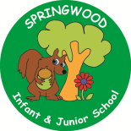  Year 1 | In PSHE, we are learning about:  Treating others as you wish to be treated.  - What makes us special and unique and how we are the same. | In RE, we will be learning about:  - Harvest through the concept of being thankful.
In PE, we are learning about:  - Locomotion, practising the skill of running.  - Gymnastics shapes (wide, narrow and curled) | In Computing, we are learning:  - How to use Bee Bots through play  - Making a Bee Bot map |  | In Music, we are learning about:  - Pitch  - Rhythm  through singing and by playing percussion instruments | In DT, we are:  - Planning  - Making  - Evaluating  how to make a free-standing enclosure
In English, we are writing using Room on the Broom – Julia Donaldson and The Frog Who Lost his Croak – Toni Williams to write labels and captions, and as an introduction to sentence building.  Once upon a Jungle – Laura Knowles will be used as a basis for a diary entry, whilst Little Lost Dragon – Wayne Anderson, will be used to annotate a map. Dogger – Shirley Hughes will introduce your children to questions and predictions.  In Reading we are exploring books with the themes of lost and found, animals and nature, bravery and courage. Some of the texts we are reading include Isadora Moon Goes to School – Harriet Muncaster, Freddy the frog – Axel Scheffler, and A First Book of Animals – Nicola Davies. |  |  | In Maths, we will continue to develop our Arithmetic skills.  We will also develop our skills and knowledge in:  - Number and Place Value  Learning to count to 30, order numbers, say the value of each digit in a 2-digit number, say what is 1 more and 1 less than a given number  - Addition and Subtraction  Using objects, mathematical resources, and using known number facts.

