Task to be completed over this half term | Suggested Timetable:  Week 1 Spellings Oxford Reading Buddy Maths focus – TTRS  Week 2 Spellings Oxford Reading Buddy Maths focus – Addition of numbers up to 1000  Week 3 Spellings Oxford Reading Buddy Maths focus – TTRS  Week 4 Spellings Oxford Reading Buddy Maths focus – Subtraction of numbers up to 1000  Week 5 Spellings Oxford Reading Buddy Maths focus – Fractions |  | Maths:  In year 2 we begun to secure our knowledge of multiplication and division.  In year 3 we are going to further this knowledge becoming more secure and precise with our calculations. This also involved solving the problems quickly and recall the facts by heart.  We will be focusing on multiples of x2, x5, x10 and x3.   |  | Reading  Continue to read at least 3 times a week. This can be on Oxford Reading Buddy and/or a library book.  Challenge yourself to read a narrative and a non-fiction book this half term.  Your teacher recommends and will be reading with you:  - George’s Marvellous Medicine  - The Barnabus Project  - The Boy Whose Wishes Came True  Use non-fiction books to learn about:  - The Ivory Coast  - Fair Trade  - Skeletons and the human body |  | A creative family project:  Submission date: Friday 13th of December  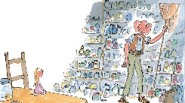  In Writing we are going to be learning about The BFG focusing on the dreams that he creates for others.  We would like the children to create or design their own dream jar.  The children need to think about:  -What would their dreams include?  -What colours would their dreams be?  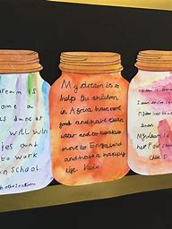  How to make a BFG Dream Jar  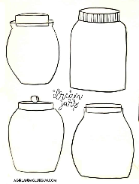  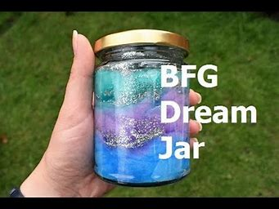
Spelling words to practise | Week 1 (Testing on 15.11) | Week 2 (Testing on 22.11) |  | Week 3 (Testing on 29.11) |  | Week 4 (Testing on 06.12) |  | Week 5 (Testing on 13.12)
 | squash  purred  stroked  different  creaky  froze  fur  loudly  throat  footsteps | misbehave  mislead  misunderstood  mistake  misspell  misplace  miscalculate  misguide  mishap  misjudge |  | young  touch  double  trouble  couple  country  cousin  London  some  colour |  | always  rain  weight  break  eight  waist  delay  game  crayon  reindeer |  | picture  nature  creature  feature  measure  treasure  leisure  adventure  pleasure  puncture

In Geography, we are learning about:  - The Ivory Coast  - Understanding of economic activity linked to chocolate and how the UK is connected to the Ivory Coast through trade. | In Science, we are learning about:  - Magnets  - Animals, skeletons, and movement | Curriculum Overview  Autumn 2  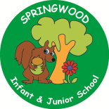  Year 3 | In PSHE, we are focusing our learning on the themes of:  - Stay Safe  - Try Your Best and Be Proud | In RE, we will be learning about:  - Theme/Unit: Angels  Concept: Angels
In PE, we are learning:  - Gymnastics  - Handball | In Computing, we are learning about:  - How a web search works  - Online safety |  | In Music, our learning links to:  - Stone Age  - Ivory Coast | In DT, we are looking at:  - Food:  - Healthy and Varied Diet  - Protein balls
In English, we are using the following text drivers:  - The Dreamgiver (Literacy Shed Video) - writing a narrative.  - The BFG (Roald Dahl) - writing a recipe for our own dream.  In Reading, we will be looking at a variety of different texts linked to the themes visited within the Writing quality text drivers. These themes focus on dreams and stepping into the unknown. |  | In MFL, we are beginning to learn French through the topics of:  - Animals | In Maths, we will continue to develop our Arithmetic skills.  We will also develop our skills and knowledge.  - Multiplication and Division  - Fractions  - Geometry  - Time

