Task to be completed over this half term | Suggested Timetable:  Week 1 Spellings Oxford Reading Buddy Maths focus – TTRS  Week 2 Spellings Oxford Reading Buddy Maths focus – Measure  Week 3 Spellings Oxford Reading Buddy Maths focus – TTRS  Week 4 Spellings Oxford Reading Buddy Maths focus – Addition  Week 5 Spellings Oxford Reading Buddy Maths focus – Subtraction |  | Maths:  In Maths, we have been looking at measure and converting units for example, knowing that there are 100cm in 1m.  There are 100cm = 1m.  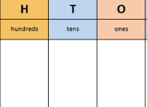  Can you practice solving problems similar to the ones below. Remember you need to convert to the same unit of measure. Use a PV grid to help you.  - 100cm + 1m =  - 2m + 103cm =  - 499cm + 100cm =  - 3m + 104cm = |  | Reading  Continue to read at least 3 times a week. This can be on Oxford Reading Buddy and/or a library book.  Challenge yourself to read a narrative and a non-fiction book this half term.  Your teacher recommends and will be reading with you:  - The Rainforest Book  - The Great Kapok Tree  - What a Waste  - The Last Tree  Use non-fiction books to learn about:  - Our Local Area (Geography)  - Solids, Liquids and Gases (Science)  - Rocks and soils (Science)  - The Rainforest and saving our planet |  | Creative family project:  Submission date: w.c. 31st March 2025, designs to be in school no later than the 3rd of April 2025  Get creative this Easter!  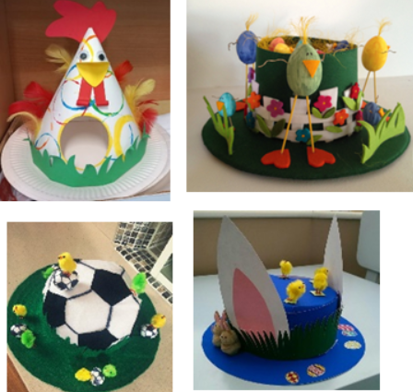  Design and make your very own Easter headpiece, bonnet, or hat using materials from around your home. Let your imagination run wild—you could even create something that reflects your personality! We’ve teamed up with FOSS (Friends of Springwood Schools), who will judge the designs on Friday 4th April, the last day of term. Winners from each class will receive a delicious chocolate egg! We can’t wait to see the amazing creations!
Spelling words to practise | Week 1 (Testing on 7.03) | Week 2 (Testing on 14.03) |  | Week 3 (Testing on 21.03) |  | Week 4 (Testing on 28.03) |  | Week 5 (Testing on 4.04)
 | earth  early  circle  guide  heart  breath  library  decide  answer  promise | often  possible  grammar  February  question  woman  history  eight  breathe  extreme |  | accident  bicycle  purpose  thought  notice  naughty  island  material  strange  although |  | possess  calendar  experience  experiment  centre  complete  consider  knowledge  natural  fruit |  | length  exercise  therefore  separate  ordinary  popular  position  women  actually  quarter

In Geography, we are learning about:  - Our Local Area | In Science, we are learning about:  - Solids, Liquids and Gases  - Rocks and soils | Curriculum Overview  Spring 2  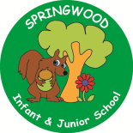  Year 3 | In PSHE, we are focusing our learning on the theme of Try your best and be proud with a focus on:  - Health and wellbeing  - Managing conflicting feelings. | In RE, we will be learning about:  Theme/Unit: Changing emotions  Concept: Love
In PE, we are learning:  - Tag Rugby  - Dance | In Computing, we are learning about:  - Emailing |  | In Music, our learning links to:  - Our Local Area | In DT, we are looking at:  - Roman coin purses
In English, we are using the following text drivers:  - The Great Kapok Tree – writing an additional entry to the book convincing the man to not cut down the tree.  - What a Waste – writing an information page about deforestation or pollution.  In Reading, we will be looking at a variety of different texts linked to saving the planet, the rainforest and people within the world who are trying to impact and change our views e.g. David Attenborough and Greta Thunberg. |  | In MFL, we are beginning to learn French through the topic of:  - Je peux…  I am able… | In Maths, we will continue to develop our Arithmetic skills.  We will also develop our skills and knowledge.  - Addition and subtraction  - Multiplication and division  - Measure  - Shape

Other important information
World Book Day – 6th of March

