

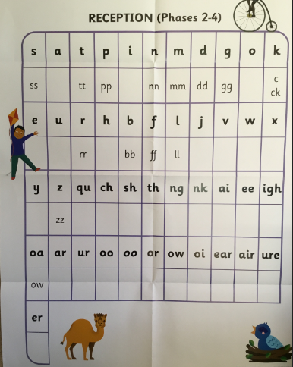

Revise these previously taught sounds.

Practise reading and writing them with the correct letter formation.

**Pre-teach poster**

**Year 1**

**Autumn 1**

|  |  |  |
| --- | --- | --- |
| **Reading** | Hard to read words to learn by sight:    Words to read and understand the meaning of:  Soft, toy, cuddly, pointed, upwards, lost, brown, fur, when, where, who, how, why.  **Skill:** How to understand a text. |  |
| **Writing** | The witch has lost her ________ .  (hat, cat, broom, dog, frog)  **Skill:** To write in sentences using a capital letter at the beginning and a full stop at the end. |  |
| **Maths** | * Counting on and back (0-20) * Ordering and sequencing numbers * 1 more and 1 less * Addition and subtraction within 10, then 20   **Skill:** Counting and ordering numbers. |  |