Task to be completed over this half term | Phonics  Early Reading / Phonics  Continue to read at home...  - Read at home using Oxford Owl.  - Read your library book.  - Read additional books free from: www.oxfordowl.co.uk/for-home/find-a-book/library-page/  - Visit your local library  - Read for pleasure using SORA  Begin to ask your child questions about the books that they are reading. This will support their comprehension skills.  If you do not have access to a computer, tablet or smart phone, please contact the school.  Spellings  It would be very helpful for your child’s writing learning to practise these Harder to Read and Spell words spellings.  easy challenge medium challenge most challenge  the to I no go into he she we me be my her was you they all are have like so were little one when what out some come said oh their there people Mr Mrs looked called asked could |  |  | Maths  *Practise writing your numbers from 1-20.  Challenge: Can you write the teen numbers 11-19 making sure the digits are in the correct place?  *Tell someone what is the same and what is different about 14 and 41.  Number Bonds to 20  *Pick two numbers that make 20. e.g. 6 + 14 = 20. What happens when you reverse the numbers? Does it still make 20? e.g. 14 + 6 = 20  *Use this sentence to talk about your number bonds.  20 is the whole, …… is a part and …. is a part.  e.g. 20 is the whole, 15 is a part and 5 is a part.  20 is the whole, 18 is a part and 2 is a part.  Challenge: Can you find 3 numbers that make 10? e.g. 2 + 2 + 6 =10  Challenge:  Can you count in  - 1s, 2s, 5s, 10s |  | Reading for pleasure  This half term we are learning about Traditional Tales, starting with Cinderella  - What traditional tales do you know?  - What do all traditional tales have in common?  - What can you find out about Aesop’s Fables?  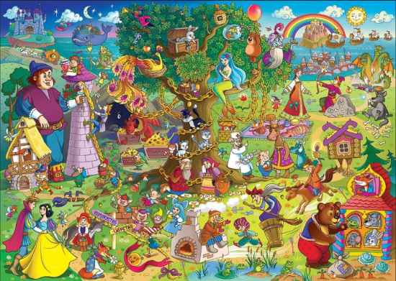  You could discuss these stories and listen to them from YouTube as part of your home learning!  Or perhaps you could visit the local library and find tales there… |  | Creative Family project:  Submission date: week of 10.2.25  Florence Nightingale was known as the “Lady of the Lamp.”  - Can you make an old fashioned lantern at home?  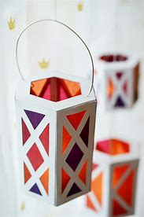  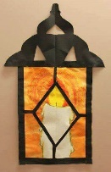  Here are some ideas on how you could do this.  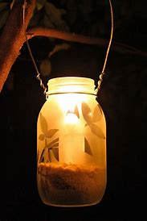  Open classroom Parent event – 20.01.25 14.30 – 3pm sharing reading, writing, maths and wider curriculum books and displays.  Year 1 science Walk learning about habitats (Parent event)  6.2.2025 - 2:00 - 3pm  Please come and join us for a Welly Walk around our woods and school environment. This will run regardless of the weather so please ensure both yourself and your children have wellies and coats in school.
Suggested timetable | Week 1  Practise spellings/ flashcards  Maths – Practise forming numbers 1-20  Reading – Read at least 4 times *Where is the book set? | Week 2  Practise spellings/ flashcards  Maths – Number bonds to 20  Reading – Read at least 4 times *Who is the main character? | Week 3  Practise spellings/ flashcards  Maths – Practise forming numbers 1-20  Reading – Read at least 4 times *Does it remind you of any other books? |  | Week 4  Practise spellings / flashcards  Maths – Number bonds to 20  Reading – Read at least 4 times *Are there any new words in your book? |  | Week 5  Practise spellings / flashcards  Maths – Practise forming numbers 1-20  Reading – Read at least 4 times *Can you think of a different ending? |  | Week 6  Practise spellings / flashcards  Maths – Number bonds to 20  Reading – Read at least 4 times *Who would you recommend this book for?
In History, we are learning about:  - The life and contributions to healthcare of Florence Nightingale and Mary Seacole | In Science, we are continuing to learn about:  - Animals and their habitats. | Curriculum Overview  Spring 1  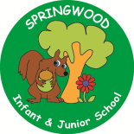  Year 1 | In PSHE, we are learning about:  What keeps bodies healthy, hygiene routines, and how to look after our local environment. | In RE, we will be learning about: A sense of belonging.  - Followers of Jesus (through the concept precious)
In PE, we are learning about:  - Ball skills: Feet  -Dance: Growing | In Computing, we are learning:  - Using Kapow to learn how computer skills can help us to design.  - Keyboard / mouse skills. |  | In Music, we are learning about:  - Dimensions Focus:  Dynamics- respond to, recognise and identify getting louder and quieter.  Tempo- respond to, recognise and recognise getting faster and slower.  Through the context of Chinese New Year, Dragons and traditional stories and fairy tales. | In Art, we are:  - Creating a collaborative Giant Beanstalk made from painted and printed leaves.  - Designer: Orla Kiely
In English, we are starting our learning journey using ‘Cinderella’ as our stimulus to write an invitation, Red Riding Hood to write a character description of the wolf, The Three Little Pigs to write a setting description and a non-fiction book about pigs to write a non-chronological report about what we have learned.  In Reading we will be Reading complimentary texts including: - Prince Cinders – Babette Cole  The Deep Dark Wood – Algy Craig Hall  Jack and the Baked Beanstalk  Fairy Tales for Mr Barker  Jim and the Beanstalk  Know Your Pigs – Jack Byard |  |  | In Maths, we will continue to develop our Arithmetic skills.  We will also develop our skills and knowledge in:  - Number place value  -Addition and Subtraction  -Time  -Mass  -Fractions and Geometry  -Multiplication and Division

