Task to be completed over this half term | Suggested Timetable  Week 1  *Oxford Owl Reading  *Spelling practise  Week 2  *Oxford Owl Reading  *Spelling practise  *Make a clock  Week 3  *Oxford Owl Reading  *Spelling practise  *Make and read o’clock times  Week 4  *Oxford Owl Reading  *Spelling practise  *Make and read half past times  Week 5  *Oxford Owl Reading  *Spelling practise  *Use Teaching clock- what times can you make?  Week 6  *Oxford Owl Reading  *Spelling practise  *Make yourself a timetable- what time do you wake up? Eat breakfast? Go to school? Go to bed? |  |  | Maths  *We have been learning to tell the time. In year 1, we need to be able to tell the time to the hour and to the half past the hour.  Perhaps you can…  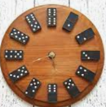  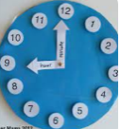  *Make a clock and practise telling the time?  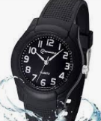  *Spot the o’clock and half past times throughout the day on a wristwatch?  *Use Teaching Clock (topmarks.co.uk) to make times. |  | Reading for pleasure  Well done, to those children who have been receiving certificates for reading books in multiples of 10.  Keep looking on oxford owl for books set to your child’s reading book band.  -Please ask if you have any problems with books or logging on.  Don’t forget to return your library book on a Friday so it can be exchanged for a new one, the library computer will not issue a new book until the outstanding book is returned.  To start with this half term, we are going to be writing a recount of events in the story Hom by Jeannie Willis  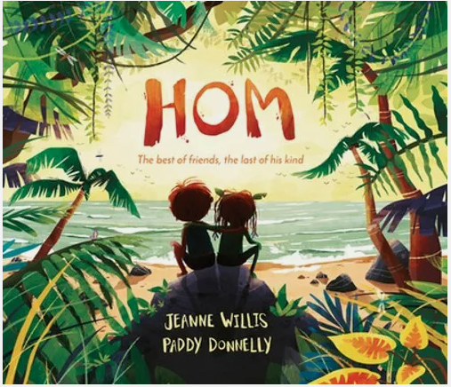 |  | Creative family project:  Submission date: W/C 31st March 2025, designs to be in school no later than the 3rd April 2025.  Get creative this Easter! Design and make your very own Easter headpiece, bonnet, or hat using materials from around your home. Let your imagination run wild—you could even create something that reflects your personality! We’ve teamed up with FOSS (Friends of Springwood Schools), who will judge the designs on Friday 4th April, the last day of term. Winners from each class will receive a delicious chocolate egg! We can’t wait to see the amazing creations!  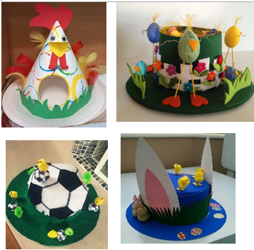
Spelling practise | Week 1  was  you  they  all  are  have  like | Week 2  so  were  little  one  when  what  out | Week 3  some  come  said  oh  their (like: it’s their cupcake)  there (like: The plant is over there) |  | Week 4  people  Mr  Mrs  looked  called  ask |  | Week 5  children  should  would  could  asked  love |  | Week 6  house  mouse  water  want  very
In Geography, we are learning about:  - Our local area | In Science, we are continuing to learn about:  - Animals and their habitats.  - Seasons | Curriculum Overview  Spring 2  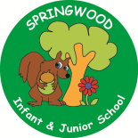  Year 1 | In PSHE, we are learning about:  Trying our best and being proud  -Looking after our local environment | In RE, we will be learning about:  - The Easter story though the concept of love, happiness and sadness.
In PE, we are learning about:  -Ball skills: Hands  -Dance: The Zoo | In Computing, we are learning:  - Online safety  Learning about online safety, including using useful tips to stay safe when online; how to manage feelings and emotions when someone or something has upset us online; learning about the responsibility we have as online users; exploring the idea of a ‘digital footprint’. |  | In Music, we are continuing to learn about:  - Dimensions Focus: Dynamics- respond to, recognise and identify getting louder and quieter.  Tempo- respond to, recognise and recognise getting faster and slower.  Through the context of carnival of the animals. | In DT, we are:  - Creating a fruit salad by learning how to prepare fruits and vegetables.
In English, we are starting our learning journey using ‘Hom” as our stimulus to write: a simple recount of events, Follow Me Little Fox – Camilla Correa  To write a descriptive poem of a fox, Where The Wild Things Are – Maurice Sendak to write a Character description and The Storm Whale - Benji Davis  To write a letter to an important person.  Reading linked texts:  In Reading we will be Reading complimentary texts including: Grandad’s Island, Beti and the Little Round House – Atinuke, The Best, Worst Day Ever – Sophy Henn, Higglety Pigglety Pop! Or there must be more to life – Maurice Sendak, Bumble – Ardy – Maurice Sendak |  |  | In Maths, we will continue to develop our Arithmetic skills.  We will also develop our skills and knowledge in:  -Shape (recognising 2d shapes / halves and quarters)  -Multiplication and Division (counting in 1s, 2s, 10s, 5s)  -Money (coin recognition and making totals)  -Place Value (tens and 1s)  -Subtraction and Addition  (knowing totals by heart to 10 / 20)  (using a number line to add and subtract)

