Task to be completed over this half term | Suggested Timetable  Week 1  *Oxford Owl Reading  *Spelling practise  *Have a look at different coins.  Week 2  *Oxford Owl Reading  *Spelling practise  *Sort coins into bronze/silver/gold  Week 3  *Oxford Owl Reading  *Spelling practise  *Can you count 1p coins?  Week 4  *Oxford Owl Reading  *Spelling practise  *What if you have two small value (less than 20p) coins? How much does it make together? |  | Maths  Last half term we were learning about coins. We have named them, talked about their values and made totals with them.  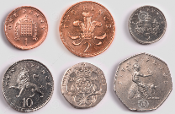  Counting in multiples of 2s, 5s and 10s.  What is…  6 lots of 10?  3 lots of 5?  7 lots of 2?  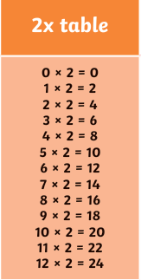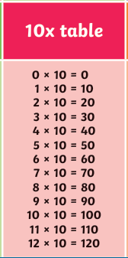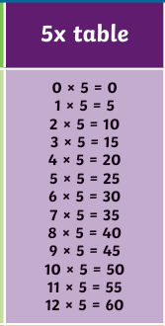 |  | Reading for pleasure  This half term, we will be looking at books by Julia Donaldson. We will be starting with What the Ladybird Heard and using this book as inspiration for our writing.  How many Julia Donaldson books do you know?  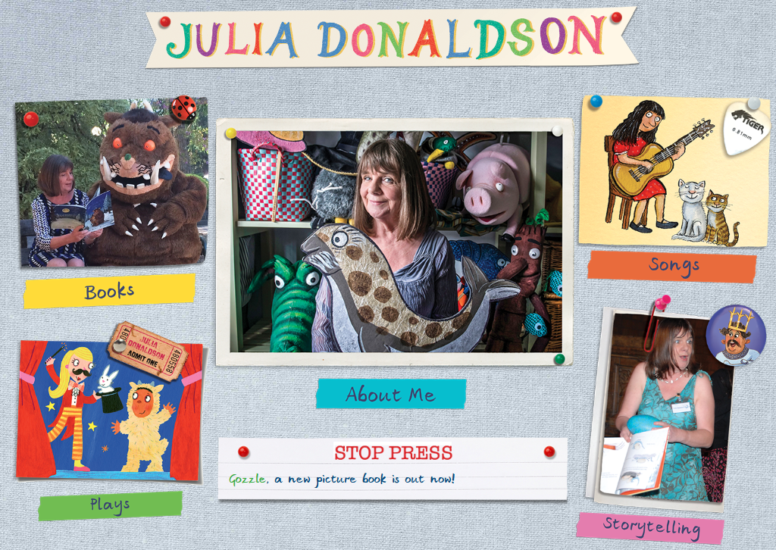  https://www.juliadonaldson.co.uk |  | Creative Family project: Friday 24th May 2024  This half term, we’re learning about the Titanic. As we know, boats these days are much safer!  For your creative challenge, can you create a boat that will safely float?  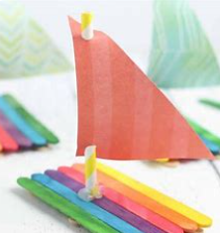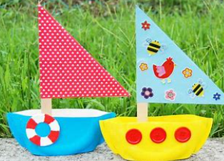
Reading and Spelling practise of hard to read and spell words: | Week 1  please  once  should  would  could  do | Week 2  any  many  ask  asked  people  the | Week 3  again  who  Mr  Mrs  a  no | Week 4  whole  where  there  you  your  of |  | Half term:  two  here  children  love  little  is |  | Half term:  sugar  because  friend  some  come  put

In History, we are learning about:  Titanic (significant event, beyond living memory & local study) | In Science, we are learning about:  -Seasons | Curriculum Overview  Summer 1  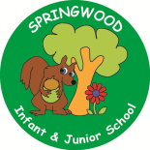  Year 1 | In PSHE, we are learning about:  Treating Others How You Wish To Be Treated:  -Sharing views and ideas | In RE, we will be learning about:  -Community through Hindu traditions.
In PE, we are learning about:  -Jumping  - Games for understanding | In Computing, we are learning:  - Creating media: Digital imagery  - (using an iPad to plan a photo story, searching safely for images, editing photographs and making a collage) |  | In Music, we are learning about:  -The Wispy Willow  -The Jolly Rogers | In Art, we are:  - Creating a clay Titanic tile.  Craftsperson: Natalie Blake
In English, we are starting our learning journey using ‘What the Ladybird Heard” as our stimulus to write:  -A narrative  -Instructions  In Reading we will be Reading complimentary texts including:  - The Gruffalo  -The Highway Rat  -The Snail and the Whale  - Charlie Cooks favourite book  - Zog  - Stick man |  |  | In Maths, we will continue to develop our Arithmetic skills.  We will also develop our skills and knowledge in:  -Multiplication and division  - Geometry  - Number and Place Value - learning number facts  - Addition and subtraction

