Task to be completed over this half term | Suggested Timetable:  Week 1 Spellings Oxford Reading Buddy Maths focus – 2x table  Week 2 Spellings Oxford Reading Buddy Maths focus – Number bonds to 20  Week 3 Spellings Oxford Reading Buddy Maths focus – 5x table  Week 4 Spellings Oxford Reading Buddy Maths focus – Number bonds to 20  Week 5 Spellings Oxford Reading Buddy Maths focus – 10x table |  |     Maths  Help your child to login to their Numbots and Times Tables Rockstar accounts using the password provided (it is the same for both programmes)  Can they achieve 1000 coins on TTRS?  We will be solving problems that include the 2, 5 and 10x table. Practise using arrays and a number line to count in these multiples.  Please continue to practise learning your number bonds to 20 fluently. |  | Reading for Pleasure  Reading  *Continue to read at least 3 times a week. Try to read both fiction and non-fiction texts.  Use Oxford Reading Buddy to login and read books at your child’s reading level. You will also find comprehension questions to answer about the text.    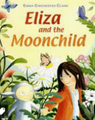  Your teacher recommends and will be reading a range of stories focusing on our reading theme of ‘Stepping into the unknown’  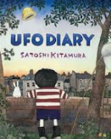  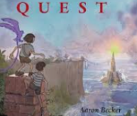 |  | Creative Family project:  Submission date: Handed in by Friday 13th December  In History, we will be learning about Guy Fawkes and the famous Gunpowder Plot. Can you create a firework display of your own? Challenge yourself to be creative with a range of materials! Here are some ideas:  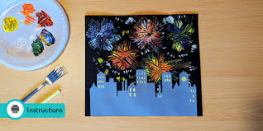  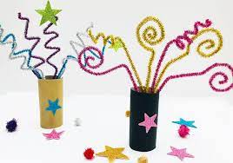  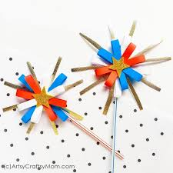  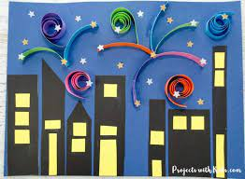  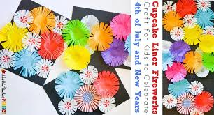    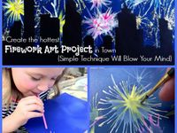  Parents are invited to our History themed event on 26th November from 2.30pm-3pm.  Parents are also invited to our open classroom event on 2nd December at 2.30pm-3pm to see your child’s learning.
Weekly Spelling | Week 1 (Test on 15.11)  should  could  would  called  any  again | Week 2 (Test on 22.11)  because  people  half  improve  busy  after |  | Week 3 (Test on 29.11)  Mr  Mrs  beautiful  Christmas  only  behind |  | Week 4 (Test on 6.12)  even  many  pretty  clothes  child  children |  | Week 5 (Test on13.12)  sure  sugar  great  water  whole  climb
In History, we are learning about:  - Guy Fawkes and the Gunpowder Plot | In Science, we are learning about:  - Changing Materials | Curriculum Overview  Autumn 2  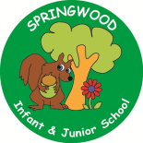  Year 2 | In PSHE, we are learning about:  Keeping safe by considering:  - Keeping safe in different situations  - Getting help in an emergency  - How to ask for help if we are worried about something | In RE, we will be learning about:  - Theme: Advent Concept: Waiting
In PE, we are learning about:  - Ball Skills: Hands  - Gymnastics: Pathways | In Computing, we are learning:  - Beebots and programming |  | In Music, we are learning about:  - Samba | In Art, we are:  - Sculpting – Guy Fawkes clay heads
In Writing, we will be exploring the texts…  Man on the Moon – Simon Bartram  Journey – Aaron Becker  Pet Dragon - MP Robertson  We will be writing a diary entry, a setting description and an information text about our very own dragon.  In Reading we will be Reading texts like…  Toys in space – Mini Grey  Q Pootle 5 – Nick Butterworth  Eliza and the Moonchild – March and Rich Chamberlin  UFO Diary – Satoshi Kitamura  The Queen’s Lift-Off – Steve Antony  The Tunnel – Anthony Brown |  |  | In Maths, we will continue to develop our Arithmetic skills.  We will also develop our skills and knowledge in:  - Multiplication and division  - Fractions and geometry  - Number and place value  - Addition and subtraction  - Statistics

