Task to be completed over this half term | Suggested Timetable:  Week 1 Spellings Oxford Reading Buddy Maths focus – Times Table Rock Stars  Week 2 Spellings Oxford Reading Buddy Maths focus – 10 more 10 less  Week 3 Spellings Oxford Reading Buddy Maths focus – Addition  Week 4 Spellings Oxford Reading Buddy Maths focus – Subtraction  Week 5 Spellings Oxford Reading Buddy Maths focus – Times Table Rock Stars |  | Maths  It is very important that we master solving problems using the following operations:  Addition, subtraction, multiplication and division.  + - x ÷  Use our guidance on the website that demonstrates workings that we use in school.  (e.g. numberlines, dienes)    You can also use TTR to rehearse the timetables that you are learning. |  | Reading  *Continue to read at least 3 times a week. Try to read both fiction and non-fiction texts.  *Focus on your fluency – how many words can you read without having to sound them out?  Use Oxford Reading Buddy to login and read books at your child’s reading level. You will also find comprehension questions to answer about the text.  (Logins will be sent home with all children)    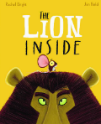  Your teacher recommends and will be reading a range of stories focusing on our reading theme of ‘Lost and Found / Courage’ |  |  | A creative family project  Submission date: 24.10.24  Design the perfect beach      What makes the perfect beach? Does it need sand to make sandcastles, rock pools to explore, restaurants nearby for a tasty drink and snack?  Create your perfect beach by designing a 3D model, painting, collaging or simply drawing a picture – it’s up to you! Be as creative as you like
Weekly Spellings | Week 1 (Testing on 20.09)  Words ending in y – ‘ee’ sound:  happy  funny  bumpy  stinky  hurry  nasty | Week 2 (Testing on 27.09)  Words ending in y – ‘igh’ sound:  why  cry  try  reply  apply  July |  | Week 3 (Testing on 04.10)  Er and est suffix:  coldest  sweetest  tallest  shorter  longer  smaller |  | Week 4 (Testing on 11.10)  Plural – s or es?  books  shells  pets  buses  dishes  boxes | Week 5 (Testing on 18.10)  Drop the y and add ied:  cried  spied  tried  dried  fried  copied |  | Week 6 (Testing on 25.10)  Drop the y and add ies:  babies  worries  stories  berries  copies  lollies

In Geography, we are learning about:  - Brilliant Beaches | In Science, we are continuing to learn about:  - Animal Lifecycles | Curriculum Overview  Autumn 1  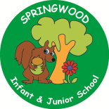  Year 2 | In PSHE, we are thinking about treating others the way we wish to be treated:  - Listening to others  - Playing cooperatively  - Appropriate and inappropriate touch | In RE, we will be learning about:  - Special places
In PE, we are learning about:  - Locomotion: Dodging  - Gymnastics: Linking | In Computing, we are learning:  - Internet search using Google  - Multimedia – iPad videoing |  | In Music, we are going to continue learning:  - Samba | In DT, we are learning about:  - Food: Making a smoothie
In English, we will be writing a:  - Character description  - Narrative  - Letter  The following texts will be used to support our writing:  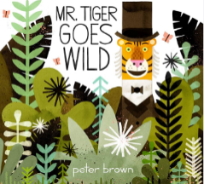  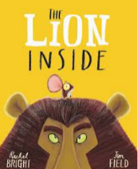  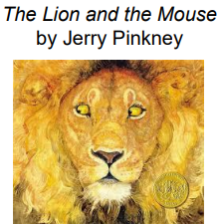  In Reading, we will be looking at a variety of different texts linked to the themes visited within the Writing quality text drivers. These themes focus on Lost and Found/Courage. |  |  | In Maths, we will continue to develop our Arithmetic skills.  We will also develop our skills and knowledge in:  - Number and place value  - Addition and Subtraction  - Measurement

