Task to be completed over this half term | Home Apps    Timetable Rockstars  Even in Y5, timetables are vital to support in many areas. | Suggested timetable  Monday - Oxford reading buddy - Spellings  Tuesday - Spellings - Timestables Rockstars  Wednesday - Oxford reading buddy - Spelling  Thursday - Spellings - Timestables Rockstars  Friday - Spelling - Oxford reading buddy | Reading  Continue to read at least 3 times a week.  This can be either using Oxford Reading buddy, a library book or using a book of your choice.  Please record any books you have read in your reading journal for your teacher to see.  Your teacher recommends and will be reading with you: Survivors and Heroes by David Long  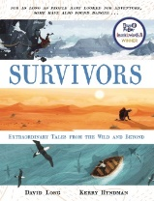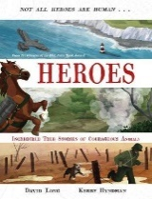  Use the internet to find out more information about some famous survivors such as Aron Ralston or Sir Earnest Shackleton. | Creative family project:  Submission date: W/C 31st March 2025, designs to be in school no later than the 3rd April 2025.  Get creative this Easter! Design and make your very own Easter headpiece, bonnet, or hat using materials from around your home. Let your imagination run wild—you could even create something that reflects your personality! We’ve teamed up with FOSS (Friends of Springwood Schools), who will judge the designs on Friday 4th April, the last day of term. Winners from each class will receive a delicious chocolate egg! We can’t wait to see the amazing creations! 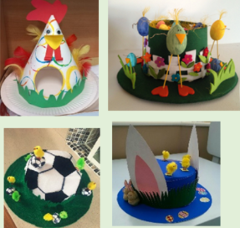
Oxford Reading Buddy

Login to read books matches to your child’s level and complete online comprehensions.

Oxford Reading Buddy - Log in
Spellings to learn at home | Week 1 Spellings (tested 07.03) - cian  magician  electrician  musician  optician  beautician  clinician  dietician  physician  tactician | Week 2 Spellings (Test 14.03) - sion  omission  decision  explosion  division  corrosion  extension  permission  persuasion  percussion | Week 3 Spellings (Test 21.03) -tion  election  section  reflection  congratulation  direction  attraction  opposition  competition  addition | Week 4 Spellings (Test 28.03) –  neighbour  nuisance  occupy  occur  opportunity  parliament  persuade  physical  prejudice  privilege | Week 4 Spellings (Test 4.4)  queue  restaurant  relevant  rhyme  sacrifice  secretary  shoulder  signature  soldier  stomach
In Geography, we are learning about:  - North American Study: Florida | In Science, we are learning about:  - Continuing our learning of how light behaves | Curriculum Overview  Spring 2  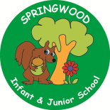  Year 5 | In PSHE, we are learning about:  Feelings and emotions, healthy relationship and valuing difference by considering:  - How to respond to feelings in others.  - Learning about consequences of actions.  - Working collaboratively.  - Negotiation and compromise  - Giving feedback  Valuing difference by considering  - Listening to others  - Raising concerns and challenge | In RE, we will be learning about:  - Theme/Unit: The Christian Story  - Concept: Salvation
In PE, we are learning:  - Hockey  - Netball | In Computing, we are learning about:  - Programming: Microbit |  | In Music, we are learning about:  - Viva Las Vegas! | In Art, we are:  - Swatch of individual batik  - Artist: Tan Rahim Zahici
In English, we are using Survivors By David Long and Kerry Hyndman  as our stimulus and will be writing:  - A first person narrative, including dialogue.  - An information paragraph about an aspect of survival.  In Reading we will be Reading complimentary texts including:  - Heroes by David Long  - Rescues by David Long  - Great Adventurers by Alastair Humphreys  - The Lost Book of Adventure by The Unknown Adventurer  - The Explorer by Katherine Rundell |  | In MFL, we are developing our French skills through:  Chez moi (My home ) | In Maths, we will continue to develop our Arithmetic skills.  We will also develop our skills and knowledge in:  - Addition and subtraction  - Fraction  - Statistics

