

Low Mood/Depression  
Understanding and Supporting your child.

**Possible signs of low mood:**

Withdrawn, unmotivated, suicidal thinking, negative thoughts, changes in mood, changes in appetite, hopelessness, tiredness, poor sleep, irritability, emotional

**Possible reasons for low mood:**

Significant life events, genetics, poor diet or sleep, drug or alcohol misuse, stress or anxiety, physical health difficulties, no apparent reason

**Suggestions for starting a conversation:**

Be aware of yours/their emotions, think about when/where to talk, use open body language, check your understanding, be non-judgemental, be curious, actively listen, be empathic, ask rather than tell, notice and wonder

**Low mood maintenance cycle**

**LIFE EVENTS**

e.g. loss, conflict, illness

**LESS REWARDING LIFE**

Low levels of positive reinforcement

**DEPRESSED FEELINGS**

e.g. Sad, tired, worthless, loss of energy, irritability

**BEHAVIOURAL RESPONSE (ATTEMPTED COPING)**

e.g. withdrawal, avoidance, rumination

**UNINTENDED CONSEQUENCES/**

**DEPRESSION**



**Key ideas:**



Encourage your child to do small activities, particularly enjoyable ones despite them feeling unmotivated or tired.

We know that in doing these things we will feel better. When we wait and decide we will do things once we feel up to them, they may take longer, or never happen!



Action before

Motivation

We need to act before we feel motivated, and the motivation will then follow. Evidence suggests that when we do things in the knowledge we will feel better, we can boost our motivation and energy quicker than waiting.

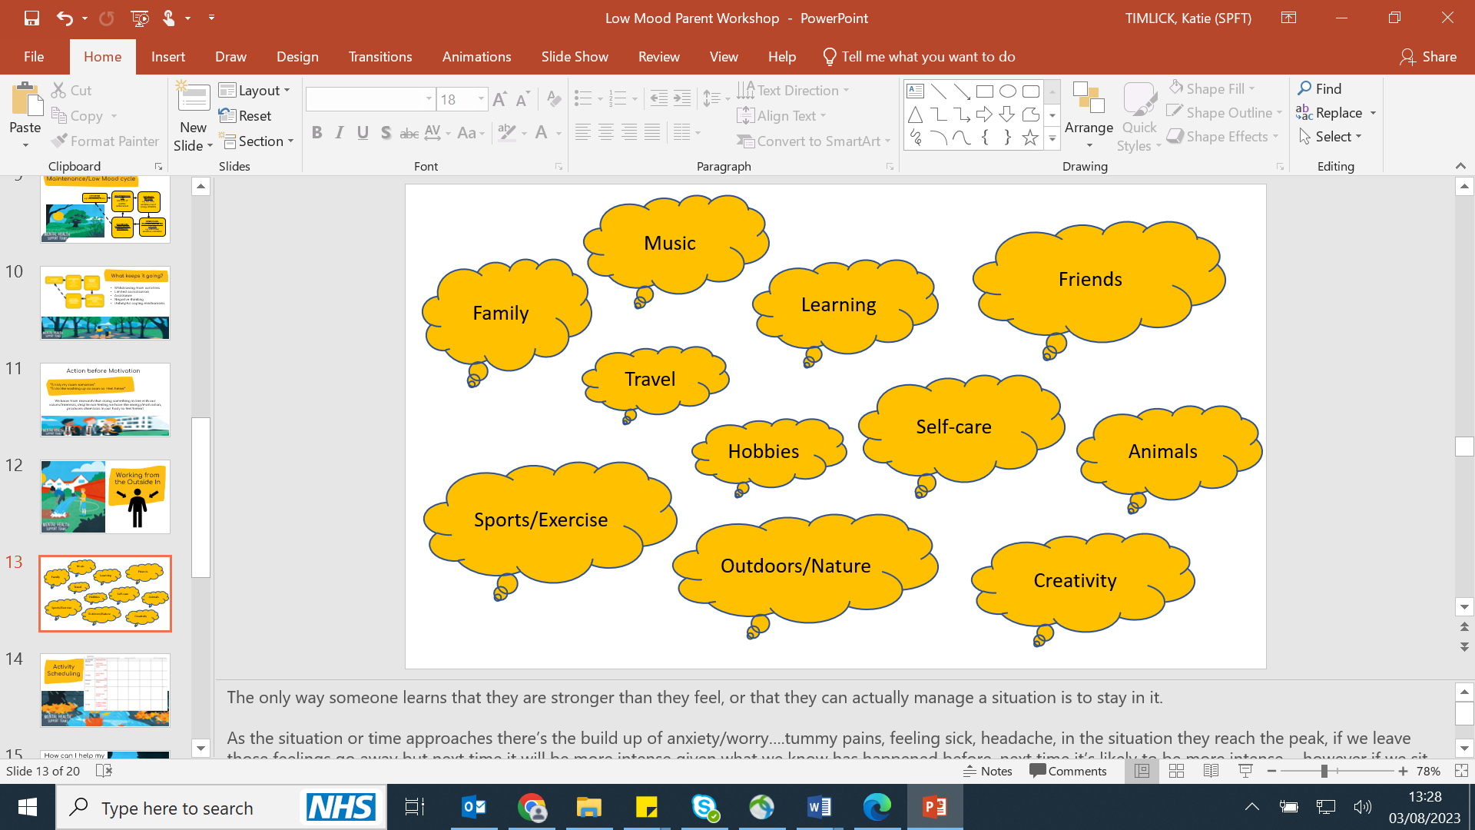

Values

Values are any aspect of life that a young person feels is important to them.

If we can do activities in line with our young person's values this may improve the enjoyment and achievement that they get from their life and begin to break our cycle of low mood.





What next…

**Helpful phrases for talking to your child:**

* I notice that…
* I wonder if…
* I’m curious about…
* I can see how difficult this is for you
* I’m here for you whenever you want to talk
* It’s okay to feel…
* Tell me more about that
* I may not know exactly how you are feeling but I want to understand

**Top tips to help your child:**

* Normalise feeling low
* Start small-schedule an enjoyable activity and encourage them to complete this
* Break down bigger tasks into smaller tasks initially
* Encourage positive self-talk and journaling to challenge negative thinking
* Validate your child’s feelings
* Encourage your child to work from the ‘Outside In’
* Focus on achievement, closeness and enjoyment when looking at activities
* Build routines particularly around sleep and eating

**Apps:** What’s Up?, StayAlive, MoodTools, In Hand, Fabulous- Daily Routine Planner

**Websites:**

[www.youngminds.org.uk](http://www.youngminds.org.uk/) [www.getselfhelp.co.uk](http://www.getselfhelp.co.uk/)

[www.themix.org.uk](http://www.themix.org.uk/) [www.hampshirecamhs.nhs.uk](http://www.hampshirecamhs.nhs.uk/)

**Books:**

Teenage Depression: A CBT Guide For Parents: Help your child beat their low mood by Shirley Reynolds & Monika Parkinson

Think Good, Feel Good: A Cognitive Behavioural Therapy Workbook for Children and Young People Paperback by Paul Stallard

Hampshire CAMHS wellbeing in ACTion booklet or Parent Handbook

Have You Filled a Bucket Today?: A Guide to Daily Happiness for Kids



