**Making new friends!**

Macie in 5J has been keen to share some of the class discussions about World War 11 she and her classmates have been having, first with her Mum and then with Edwin, who is one of the residents of Wellesley Court in Denmead where her Mum works. Her interest sparked conversations between Molly at Wellesley Court and myself. Together, we decided to provide our children and elderly residents with an opportunity to build new and unique friendships to support each other.

On Thursday 2nd November 2023, Year 5 were delighted to receive what we hope is the first of many special visits from some of the residents from Wellesley Court. Throughout the morning, the residents helped children with their reading, and the children helped the residents create poppies in preparation for Springwood’s Remembrance Service. The morning was full of so many smiles! Our children spent their wet play time making cards, paper chains and other gifts inked to Remembrance which their new friends took home and used to decorate their entrance hall. The children chatted about a whole range of topics, including football, schooling, time spent in an air raid shelter and even Edwin’s forthcoming 100th birthday!

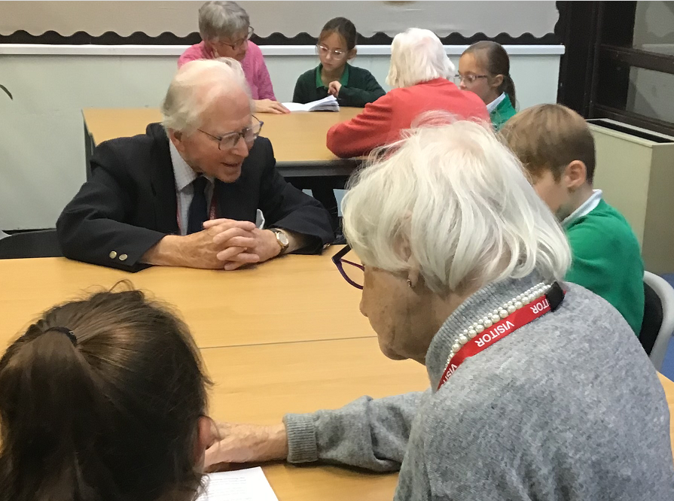 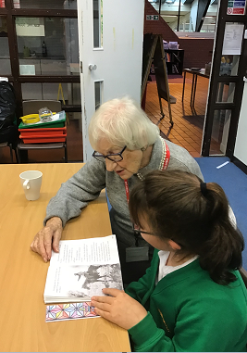 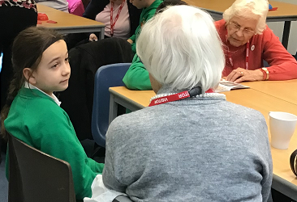

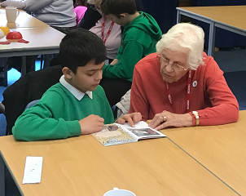 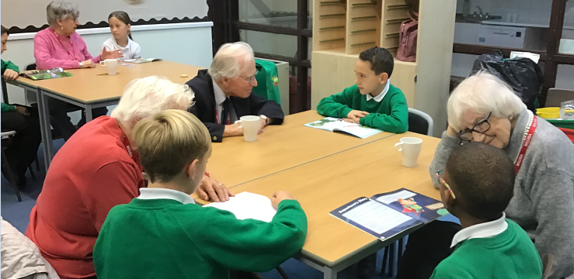

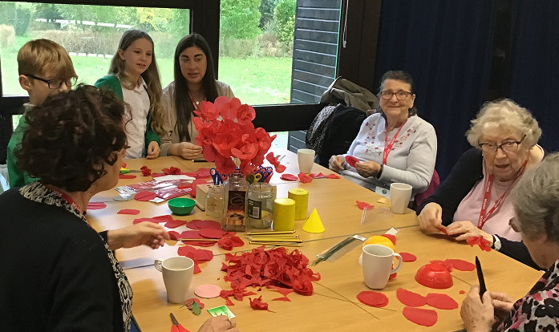 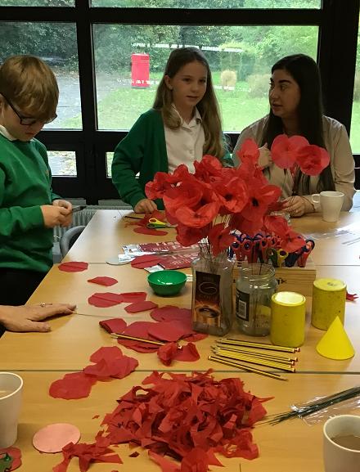

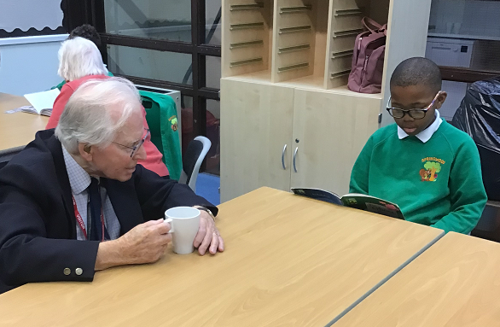 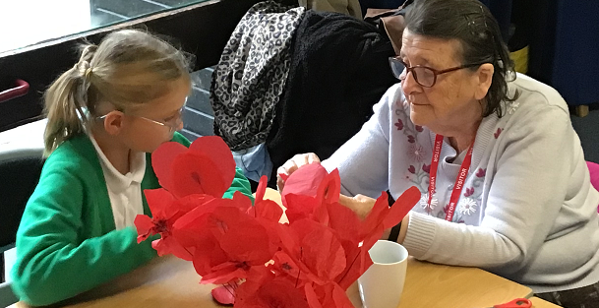

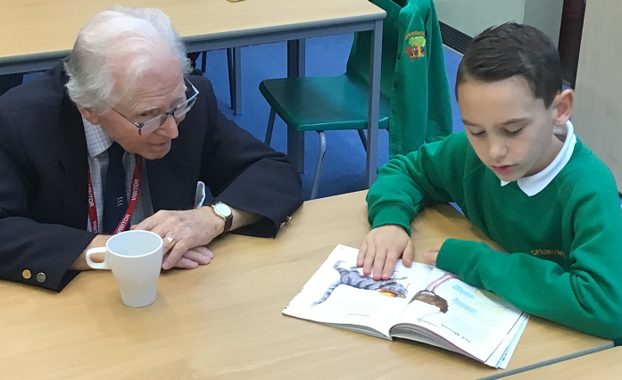

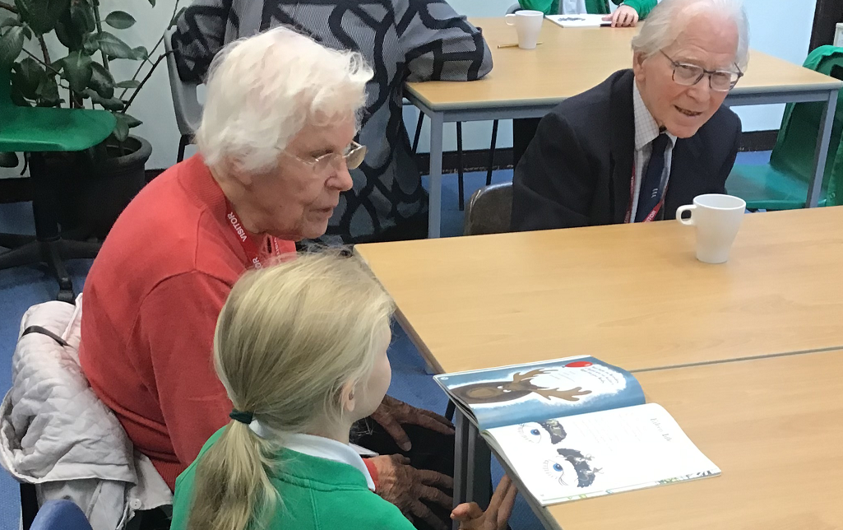 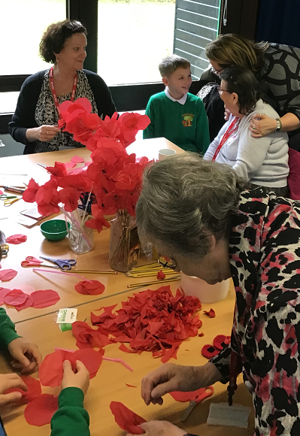

I could not have been prouder to receive the following email from Molly and I know the children are keen to see their friends again soon.

Here is the email:

*Hi Mrs Bryant,*

*I didn’t want to leave without emailing but thank you so much for hosting us today. We’ve already got our kind gifts and cards on display with our poppy tree (see attached).*

*We thoroughly enjoyed the visit and spending time with the children.*

*Still cannot believe that we met 60!!*

*They were so polite, friendly, and just amazingly behaved. They are a true credit to your school and staffing team – you are all doing such a wonderful job.*

*There’s been quite a buzz around Wellesley Court at lunch time about the visit and how it went. The resident’s that attended really had a lovely time and have been so happy! Although very tired. We’ve had others approach us about joining next time, sad that they missed out today!*

*A big pat on the back to you for organising such a nice morning!*

*Thank you!*

*Kind Regards,*

*Molly*

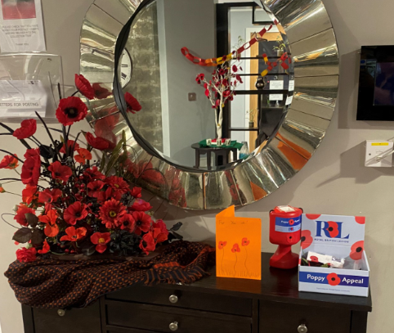 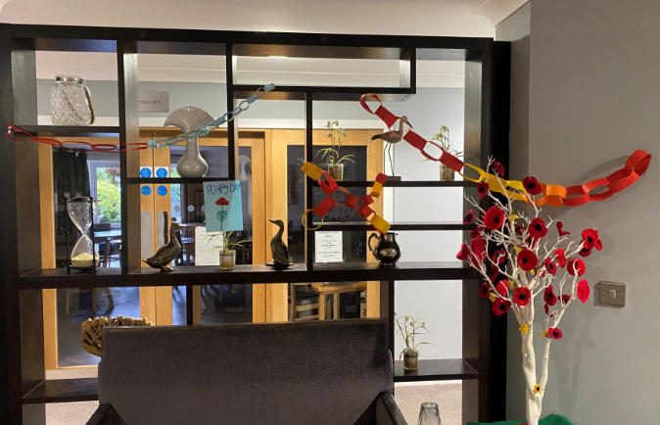

**Well done Year 5!**

**Mrs Bryant**