**25.04.25**

Year 3 remote learning for the day school closure.

Please send any work completed to - YearThree@springwood.hants.sch.uk

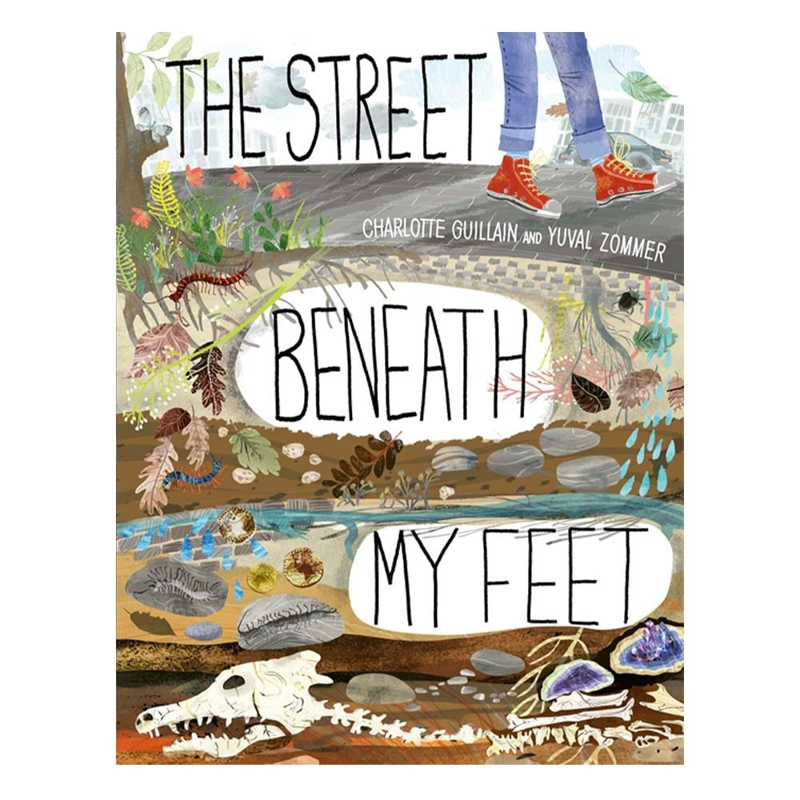When it is completed, a teacher will respond to the work that has been sent in. If you are unable to send the work in, your teacher would love to see your work next week.

**Reading**

Take a look at the front cover of our new text.

What do you think it might be about?

What kind of book do you think this might be? Fiction or non-fiction?

What can you see in the pictures that might give you a hint?

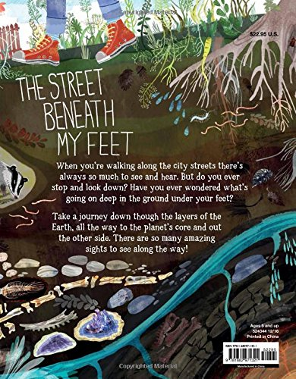

Write a prediction about what the book could include and what we might find when we read some of the pages.

You might want to use one of these sentence starters to help.

I predict that…

I wonder if…

Based on the front cover and the blurb…

I think that…

Can you include the conjunction because to further explain your reasoning?

**Spelling**

Our focus morpheme of the week is ‘th’.

The rules surrounding this are 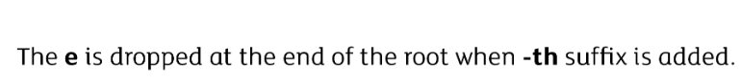

Can you practise these spellings in your neatest handwriting?

**Arithmetic**

Times tables focus with new learning of our 8x tables.

[8 Times Tables Song (Espresso by Sabrina Carpenter)](https://www.youtube.com/watch?v=gNsNcU5P1Wc)

|  |  |  |  |  |  |  |  |  |  |  |  |
| --- | --- | --- | --- | --- | --- | --- | --- | --- | --- | --- | --- |
| 8 | 16 | 24 | 32 | 40 | 48 | 56 | 64 | 72 | 80 | 88 | 96 |

Here are some questions for your child to have a go at. They are not required to complete all questions. Please encourage them to complete questions that would be appropriate for their level of understanding.

|  |  |  |
| --- | --- | --- |
| 10x table | 2x table | 5x table |
| 2 x 10 = | 2 x 2 = | 3 x 5 = |
| 5 x 10 = | 6 x 2 = | 7 x 5 = |
| 7 x 10 = | 4 x 2 = | 1 x 5 = |
| 4 x 10 = | 1 x 2 = | 9 x 5 = |
| 1 x 10 = | 8 x 2 = | 5 x 5 = |
| 10 x 10 = | 10 x 2 = | 11 x 5 = |
| 6 x 10 = | 12 x 2 = | 12 x 5 = |
| 9 x 10 = | 5 x 2 = | 2 x 5 = |
| 12 x 10 = | 11 x 2 = | 8 x 5 = |
| 3 x 10 = | 3 x 2 = | 4 x 5 = |
| 11 x 10 = | 7 x 2 = | 10 x 5 = |
| 8 x 10 = | 9 x 2 = | 6 x 5 = |

|  |  |  |
| --- | --- | --- |
| 3x table | 4x table | 8 x table |
| 2 x 3 = | 2 x 4 = | 3 x 8 = |
| 5 x 3 = | 6 x 4 = | 7 x 8 = |
| 7 x 3 = | 4 x 4 = | 1 x 8 = |
| 4 x 3 = | 1 x 4 = | 9 x 8 = |
| 1 x 3 = | 8 x 4 = | 5 x 8 = |
| 10 x 3 = | 10 x 4 = | 11 x 8 = |
| 6 x 3 = | 12 x 4 = | 12 x 8 = |
| 9 x 3 = | 5 x 4 = | 2 x 8 = |
| 12 x 3 = | 11 x 4 = | 8 x 8 = |
| 3 x 3 = | 3 x 4 = | 4 x 8 = |
| 11 x 3 = | 7 x 4 = | 10 x 8 = |
| 8 x 3 = | 9 x 4 = | 6 x 8 = |

**RE**

Our new RE topic is all about ‘Sacred Places’.

What does the word **sacred** mean?

What does the word **special** mean?

Can you use a dictionary or google (kids dictionary) to find out what these words mean.

Sacred means…….

Special means…….

How might you show a place is sacred?

How might people behave in a sacred/religious place?

Example: people might sing hymns or eat and drink special food.

Decide whether the below places are ‘special’ or ‘sacred’. You can draw your own table and draw or write the places in the correct side. Can you add any of your own ideas?

|  |  |
| --- | --- |
| Special | Sacred |
|  |  |

**Writing – Grammar focus**

Can you write down the subordinating conjunctions that you can spot within the following sentences?

I stayed inside because it was raining.

She smiled when she saw the puppy.

We will go to the park if it stops raining.

He felt tired although he had slept well.

I will wait until you are ready.

Can you complete the grid to show which statements contain a subordinate clause and which ones do not?

|  |  |  |
| --- | --- | --- |
| Sentence | Contains a subordinate clause | Does not contain a subordinate clause |
| Sam hung his coat on the peg. |  |  |
| You may join us if your homework is done. |  |  |
| Mia read her little brother a story. |  |  |
| Let me know after you pack your bag. |  |  |
| They stayed indoors while the storm passed. |  |  |

Can you write some of your own sentences using subordinating conjunctions?

Extra Writing challenge:

Can you improve the following sentences?

A boy walked through the forest. He heard a noise. He turned around.

The girl opened the brown door. She saw…

The wind was blowing. The trees were blowing. The flowers were blowing.

The house sat on the hill. It looked scary.