Year 4 Remote learning for 25.04.25

Please send any work completed to YearFour@springwood.hants.sch.uk
When it is completed, a teacher will respond to the work that has been sent in. If you are unable to send the work in, your teacher would love to see your work next week.

Reading
LO: To be able to draw sound inferences.
Key Question: Is it a happy home?
1) Follow the link and read ‘The Gorilla’ by Anthony Browne up to page 8.
Gorilla by Anthony Browne Pages 1-30 - Flip PDF Download | FlipHTML5
2) Generate some ideas on the t-table about whether it is a happy home or not.
Happy | Unhappy
Hannah has a roof over her head, clothes to wear and food to eat. | Hannah’s father works a lot and does not have a lot of time for her.

Writing
LO: To generate sentences suitable for a diary.
Key Question: How would you feel if you had to spend the day with someone that you always argue with?
1) Follow the link and read ‘The Tunnel’ by Anthony Browne
The-Tunnel-by-Anthony-Browne.pdf
2) Next week, we will be writing a diary in the role of the boy or girl reflecting on the moment their mother sent them out to play together. We would like you to generate some sentences that could be used in your diary.
e.g.
question: Why can’t I stay at home and read my book?
exclamation: How annoying! What a joke!
statement: My brother is always throwing and kicking.
Command: Make sure you’re back for lunch.
Compound sentence: I wish I could see my friends and play football.
Complex: My sister is such a baby because she is scared of the dark.
Maths
LO: To be able to use column addition and subtraction
Have a go at using column addition and subtraction to work out these problems.

Check your answers using the inverse (hint: the inverse means you check your answer with the opposite operation e.g check + with - and check + with -
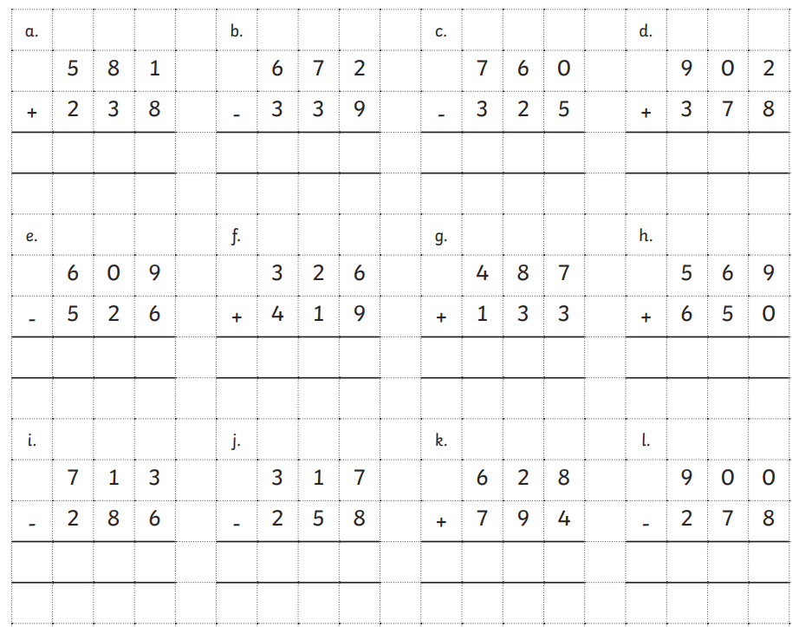

Challenge: Can you work out the missing numbers in the calculations below?
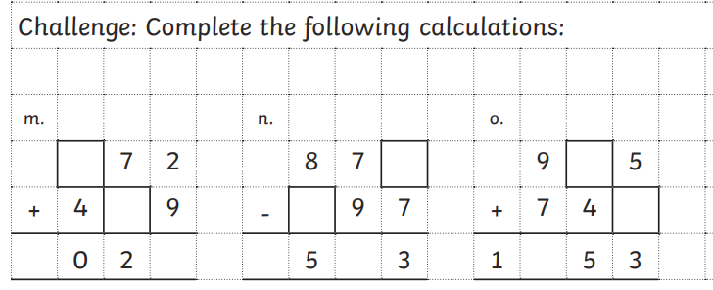

Spelling
Practise our focus spellings.
diagram  grammar  program  diagrams  hologram  monogram  telegram  grammatical  grammatically  programs  programmed  programmer  programming | cycled  city  slice  ice  science  dance  spicy

Science
LO: To be able to represent a circuit.
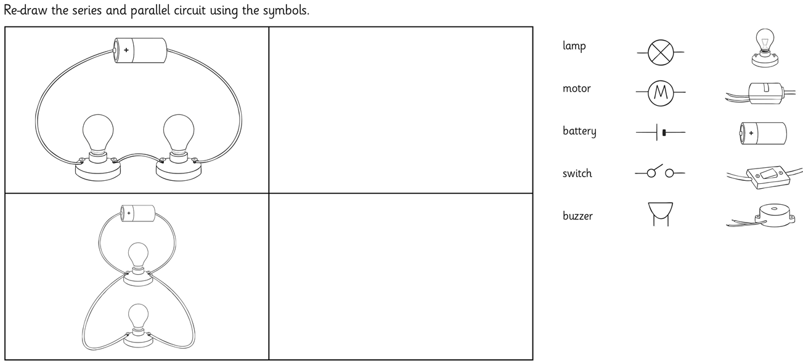
Re-draw the circuits below using the symbols given.

Now, have a go at creating your own circuit imagining what the electrical circuit might look like in one of your items at home e.g a doorbell / a nightlight / an alarm clock

