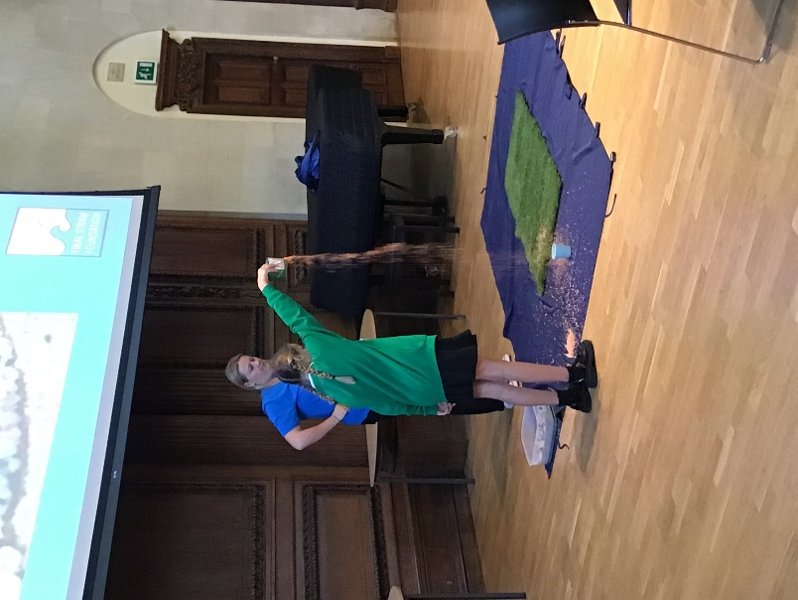On the 29th of September, some of **Springwood’s Environmental Ambassadors** attended an eco-conference at Winchester College.

They learnt about **nurdles**, which are tiny granules of plastic used in a lot of manufacturing. Our environment is becoming very polluted by nurdles.

One of our Environmental Ambassadors demonstrated to other schools what would happen if these nurdles were to be spilt into our environment.

They then researched a range of methods that have already been invented to prevent this pollution. Our Ambassadors came up with their own ideas and inventions to tackle the nurdle problem.

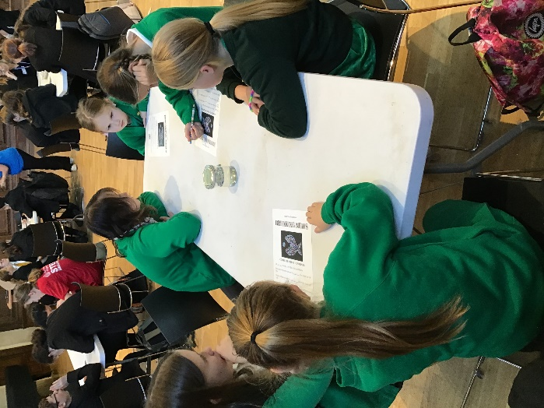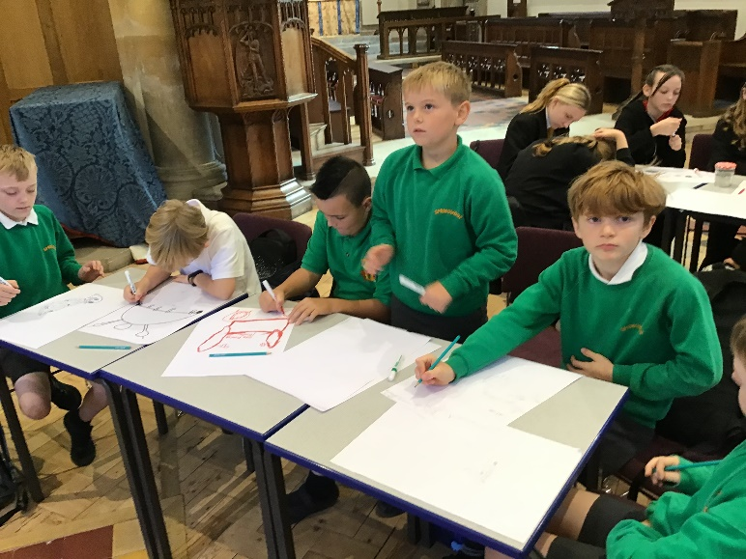

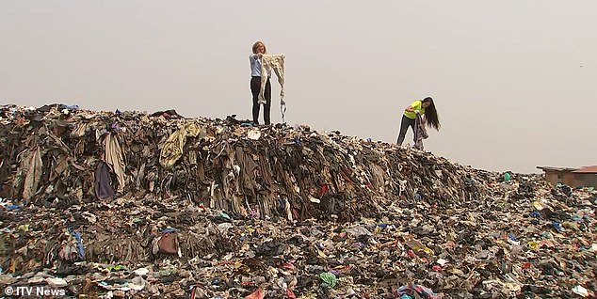After lunch, our Environmental Ambassadors learnt about **fast fashion**.

**Fast fashion** can be defined as cheap, trendy clothing that is made at breakneck speed to meet demand. The idea is to get the newest styles on the market as fast as possible, so shoppers can snap them up while they are still at the height of their popularity and then, sadly, discard them after a few wears. This then ends up in landfill.

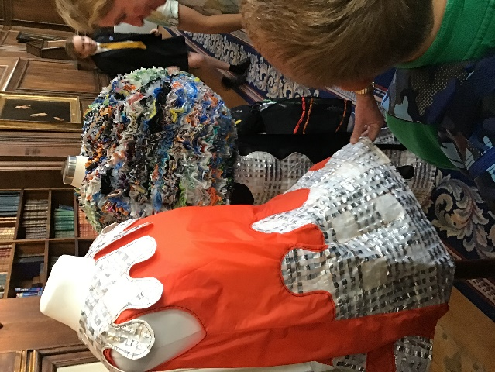The children repurposed t-shirts that would have ended up in landfill. They turned them into bags and discussed how we could recycle clothing and come up with different uses for it.

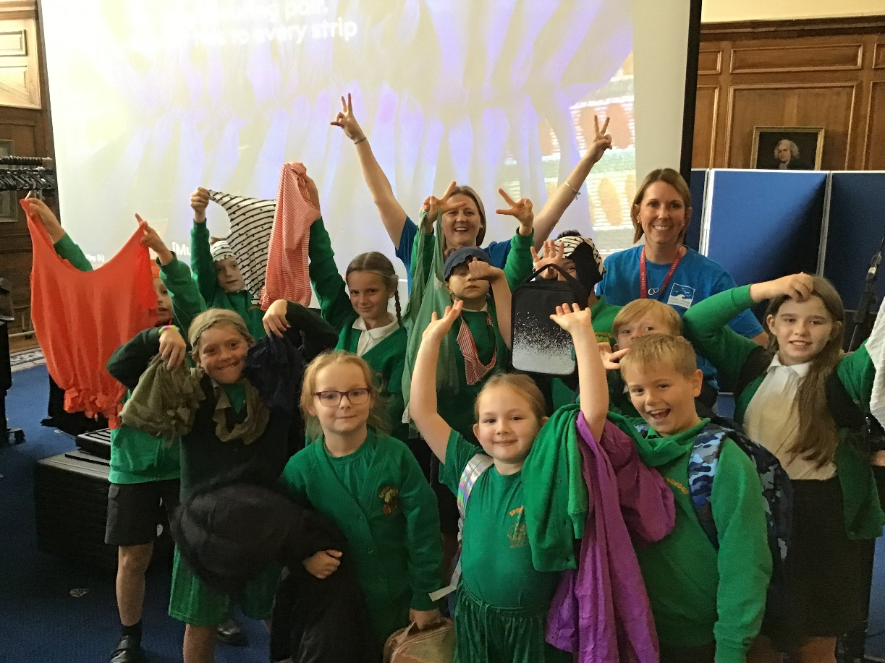The children met a fashion designer who makes clothing purely out of recycled materials, including cereal packets, old tents, crisp packets and much more.

