
Pupil Premium Strategy Statement – Springwood Junior School 2025-26 to 2027-28

It outlines our pupil premium strategy, how we intend to spend the funding in this academic year and the effect that last year’s spending of pupil premium had within our school.

School overview
Detail | Data
School name | Springwood Junior School
Number of pupils in school | 176
Proportion (%) of pupil premium eligible pupils | 49%
Academic year/years that our current pupil premium strategy plan covers (3 year plans are recommended) | 2025-26 to 2027-28
Date this statement was published | September 2025
Date on which it will be reviewed | Annually (however actions are ongoing)  Updates to be provided at FGB.
Statement authorised by | FGB
Pupil premium lead | Jo Livingstone
Governor / Trustee lead | TBC
Funding overview
Detail | Amount
Pupil premium funding allocation this academic year | £158,395.00
Recovery premium funding allocation this academic year | 0
Pupil premium funding carried forward from previous years (enter £0 if not applicable) | 0
Total budget for this academic year  If your school is an academy in a trust that pools this funding, state the amount available to your school this academic year | £158,395.00

Part A: Pupil Premium Strategy Plan

Statement of intent
At Springwood, our core values are:
- Staying Safe
- Treating Each Other as you Wish to be Treated
- Trying Your Best and Being Proud
Therefore, we aim to develop responsible, self-regulated and self-motivated children.

Children in Springwood rapidly develop a love of learning and are aspirational. Therefore, our aim is to use the pupil premium funding to ensure that all disadvantaged children progressively acquire the broad range of knowledge and skills required to enable them to problem-solve and satisfy enquiries they have about the world in which they live. Thus sustaining positive outcomes.

Although Springwood’s strategy is focussed on the needs of disadvantaged children, it will benefit all pupils in our school where funding is spent on whole school approaches. These approaches include:
- Quality Teaching First
- Differentiation and variation according to individual’s needs to ensure there is improved progress alongside their peers
- Opportunities that enable off track/not making expected progress children to close gaps in skills and understanding.
- Teachers reshaping learning in the moment so children are enabled to secure skills and make rapid progress.
- The use of Quality Text Drivers for the stimulus for the vast majority of learning journeys for reading and writing
- Long term Curriculum Map and home learning (equipping children with the knowledge and cultural capital they need to succeed in life)
- Embedded use of the Reading for Comprehension Toolkits (also used to support the reading part of the writing learning journey)
- Specific teaching of vocabulary across all subjects (red, amber and green)
- Home learning policy
- Access to books to support the wider curriculum
- Working walls to share the learning journeys and to capture key learning across subjects
- Laptops assigned to families who need support.

This strategy is integral to the School Improvement Plan.

Challenges

This details the key challenges to achievement that we have identified among our disadvantaged pupils.
Challenge number | Detail of challenge
1 | Outcomes  Many of our Pupil Premium Children have dual characteristics (e.g. are on the SEND register), so the wider context must be considered.  Post Covid has shown a marked increase in the numbers of pupils requiring significant additional support. We need to continue to build capacity in our school to meet the needs of disadvantaged children, ensuring all make good progress from their starting points.  Teachers need to consistently support pupils to develop independent skills and precision so that children make rapid progress.
2 | Attendance  Our attendance data over the last year indicates that attendance among disadvantaged pupils has been between 92.6-93.3%. However, this does include children with reduced timetables. The overall figure for disadvantaged pupils for 2024-25 was 92.6% with reduced timetables, 95.1% without reduced timetables. Therefore, our target was met for 2024-25 which was 95%. Non disadvantaged attendance was 95.3%, 95.9% without reduced timetables.  Our assessments and observations indicate that absenteeism is negatively impacting on disadvantaged pupils’ progress, whether it is social and emotional and/or academic.
3 | Empowering parents and carers to support the child’s emotional wellbeing within the home and school  At Springwood, we recognise that parents looking after their family’s wellbeing is very important. Families all need some help from time to time due to life changes or events.
4 | Cultural Capital  Through observations and conversations with pupils and their families, we find that disadvantaged pupils generally have fewer opportunities to develop cultural capital outside of school.  Junior Summer 2025 pupil surveys evidenced that the children take part in school activities outside of lessons, like clubs, supports, music and art sometimes 24%, not very often 15% and never 23% (total – 62%)

Intended outcomes
This explains the outcomes we are aiming for by the end of our current strategy plan, and how we will measure whether they have been achieved.
Intended outcome | Success criteria
- Outcomes  Meeting the Needs of all our Pupils  To improve attainment in reading, writing, mathematics and the wider curriculum so that outcomes for Non SEND pupils at least meet the National Average at ARE and Greater Depth  Aspirational target over time will be for 100% of Non-SEND pupils to meet ARE.  We believe this will be a three year journey and we are commencing on our third year.  To improve attainment in reading, writing, mathematics and the wider curriculum so that outcomes for targeted SEND pupils meet Age Related Expectations  Children with Cognition and Learning as their Primary Need, at least one year's progress is made in every strand.  Aspirational expectations are in place for children with EHCPs. Outcomes, provision and short-term targets are understood by adults in the year team, utilised in planning and progress tracked.  We believe this will be a three-year journey and we are commencing on our third year. | The percentages below include SEND pupils; further breakdowns will be made during the termly data drops.  By the end of Year 3:  In Reading, 59% of pupils to meet ARE  In Writing, 61% of pupils to meet ARE  In Maths, 57% of pupils to meet ARE  By the end of Year 4:  In Reading, 67% of pupils to meet ARE  In Writing, 57% of pupils to meet ARE  In Maths, 67% of pupils to meet ARE  By the end of Year 5:  In Reading, 62% of pupils to meet ARE  In Writing, 50% of pupils to meet ARE  In Maths, 62% of pupils to meet ARE  By the end of Year 6:  In Reading, 72% of pupils to meet ARE  In Writing, 72% of pupils to meet ARE  In Maths, 65% of pupils to meet ARE
- Attendance  Attendance meets national expectations for PP pupils, particularly in light of current National challenges | Disadvantaged children’s attendance is sustained from 2025-26 and 95%+.  Therefore steps to success:  95%+ sustained from 2025-26  (note 2022-23's target was 93% which was achieved, 2023-24's was 94% which was achieved and 2024-25's was 95% which was achieved).  In cases where attendance is below the national average (or target for the academic year), the school can evidence gains for those children.  Note -The Attendance Action Plan details specific actions and further Success Criteria
- Empowering parents and carers to support the child’s emotional wellbeing within the home and school | Support children to recognise their emotions by using zones of regulation.  -Behavioural incidents reduce for disadvantaged pupils  Target families through the ‘INclude Me’ Program
- Cultural Capital  Disadvantaged pupils are given more opportunities to attend school trips and residentials.  Provide three additional clubs (run by staff members) for at least six weeks and ensure the is fair representation of PP families and children with SEND:  School Clubs  -Environmental  -Art/Sports  -Drama and Singing | -Whole school curriculum identifies experiences for children  -PP funding supports families to access wider experiences  -Pupil conferencing evidences opportunities given  -Pupil Questionnaire in Summer 2026 evidences an improvement from responses from Summer 2025.

Activity in this academic year
This details how we intend to spend our pupil premium (and recovery premium funding) this academic year to address the challenges listed above.

Teaching (for example, CPD, recruitment and retention)
Budgeted cost: £70,000 (approx.)
Activity  (Area of Focus in line with the SIP) | Evidence that supports this approach  EEF Documentation consulted:  -Metacognition and self-regulated learning  -Pupil Premium Guide  Putting Evidence to Work – A School’s Guided to Implementation | Challenge number(s) addressed
Developing High Quality Teaching:  -English and Maths leaders attend termly core provision for their subjects and disseminate the training for all staff through PDMS, phase team meetings, INSET days as well as TA training  - Implement new EEF Maths Curriculum  - Implement Oracy into the classroom  - Termly visits from LLP on identified SIP Strands  - Deputy Headteacher to use ongoing CPD to coach and monitor ECTs and teachers so that teacher’s use metacognitive strategies to enable children to plan, monitor and evaluate their learning  To deliver Professional Development Meetings throughout the year with specific focus on:  -No Lost Learning Time  -Is it Right for Everyone  -Progress for All  - Additional training for all staff across all roles to support ‘Meeting the Needs of our most Vulnerable Pupils) (Key Objectives Three and Four) | Education Endowment Foundation (EEF) recommends high quality CPD to ensure teachers are highly skilled so that teachers’ use AfL, formative assessment and knowledge of the pupils’ learning to shape planned learning opportunities and task design so that misconceptions are addressed in a timely manner and pupils make strong progress.  EEF - Metacognition and self-regulated learning  The Inclusive Classroom by Daniel Sobel and Sara Alston  Reaching the Unseen Children – Jean Gross | 1
 |  | 1
Termly pupil progress meetings focus on pupil premium children to enable teachers to review progress and provision and make adaptations to meet individual needs | Data analysis, including capturing of finer points of progress, will ensure that teaching is targeted to close gaps in learning | 1

Targeted academic support (for example, tutoring, one-to-one support structured interventions)
Budgeted cost: £70,000 (approx.)
Activity | Evidence that supports this approach  EEF Documentation consulted:  -Metacognition and self-regulated learning  -Pupil Premium Guide  Putting Evidence to Work – A School’s Guided to Implementation | Challenge number(s) addressed
Developing High Quality Teaching:  INSET Days x 2 – Oracy and Maths.  DHT attending Oracy Training  Maths Lead attending EEF Maths Training | EEF’s ‘Effective Professional Development’ | 1
PPRs identify ‘at risk children’. Quality First Teaching and Tutoring after school:  - 1:1 word reading  - Targeted reading, writing and maths support from pupil progress reviews  - Social skills (lunch time)  - Targeted Phonics  - Fine and gross motor control  - Handwriting and spelling  - Maths (areas specific to gaps)  - SATs Companion  - Oxford Reading Buddy/Owls  Cluster Moderation events at local schools to agree judgements | EEF states that “where TAs are working individually/or in small groups with low attaining pupils, the focus should be on retaining access to high quality teaching, for example by delivering brief, but intensive, structured interventions”. PPRs identify how the interventions are to be used and the frequency of the intervention in order for the children to make accelerated progress. | 1
Regular supplementary reading for children identified as the lowest 20% of readers | EEF identify reading and discussing books to support and improve literacy skills | 1
Personalised Speech and Language interventions for those children whose language skills are not on track | EEF research highlights the importance of good language skills in order to support learning. | 1

Wider strategies (for example, related to attendance, behaviour, wellbeing)
Budgeted cost: £15,000 (approx.)
Activity | Evidence that supports this approach  EEF Documentation consulted:  -Metacognition and self-regulated learning  -Pupil Premium Guide  Putting Evidence to Work – A School’s Guided to Implementation | Challenge number(s) addressed
Senior Admin Assistant to work with EHT to rigorously implement Attendance and Punctuality Action Plan and offer support to pupil premium pupils at risk of meeting targets:  95%+ from 2025-26  Interventions/Activities include:  - Attendance letter detailing actions which will take place so that all parents are clear  - Breakfast via Activ8  - Daily telephone calls for pupils not in attendance. Home visits to check on welfare if contact cannot be made for two days (in line with Attendance Policy)  - Cluster Attendance Leaflet  - Friendly phone call  - Challenging phone call  - Text Messages  - Meetings  - Letters  - Home collections  - Home Visits  - Support with routines at home and resources  - Child and parent agreements  - Reward Systems  - Referral Level 2 FSS  - School Nurse referral  - Children Services Referral  - Referral to LICO  - Reduced timetable/  alterations to school timings  - Assigned Family Key Worker  - Funding Taxis  Assemblies and Facebook also used to promote good attendance | The Department for Education (DfE) recommendations include “Recognise attendance as an important area of school improvement. Make sure it is resourced appropriately (including through the use of pupil premium funding) to create, build and maintain systems and performance”. | 2
Families and pupils supported through:  - INclude Me Program  - Preloved uniform  - Signposting food banks, local support re energy prices, etc  - Emotional Literacy Support Assistant (ELSA) programme to support well-being  - Nurture/Sharing and turn taking groups with targeted pupils  - Support with lunch times with lunch skills and social skills.  - Balanced diet promoted through PE, DT and lunchtime expectations | There is evidence from the EEF that supporting children’s social and emotional skills, will result in improved outcomes, e.g. progress and attainment, behaviour and friendships with peers. | 3
Children whose parents cannot afford to pay for school trips, afterschool clubs and residential will have their places paid for | All children including those from disadvantaged backgrounds, deserve a well-rounded and broad curriculum with plenty of opportunities. | 4
Total budgeted cost: £158,395.00

Part B: Review of outcomes in the previous academic year

Pupil premium strategy outcomes
This details the impact that our pupil premium activity had on pupils in the 2022-2023 academic year.
Outcomes:
Attainment in reading, writing, mathematics and the wider curriculum at least meet the National Average at ARE and Greater Depth.
All children make strong progress from their individual starting points.

2025 End of Year Results
Teacher Assessment
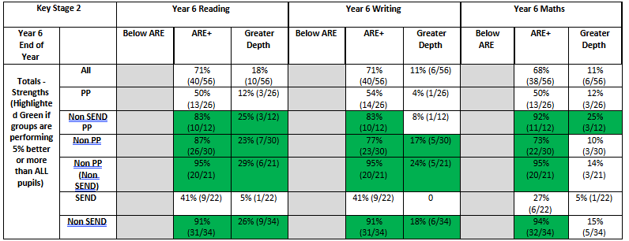SATs 2025
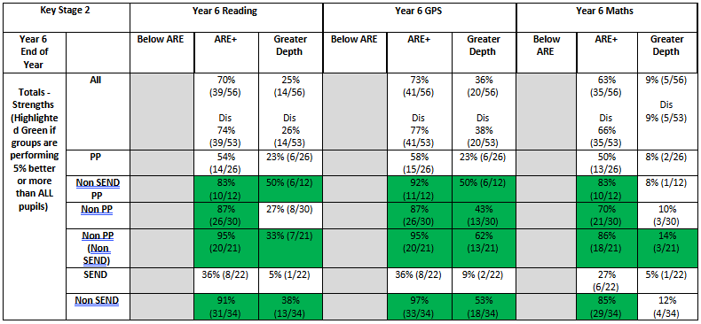

Attendance meets national expectations for PP pupils, particularly in light of current National challenges
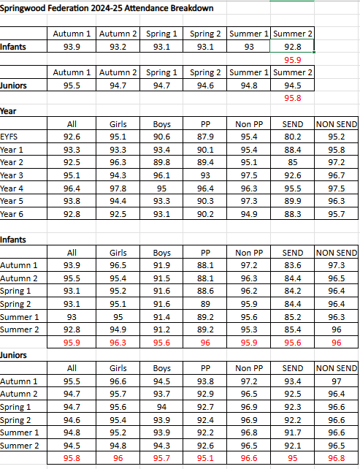

Behavioural incidents decrease for disadvantaged children
Behavioural incidents captured as a whole federation (juniors):
Autumn Incidents – 224
Spring Incidents - 263
Summer Incidents – 171

Disadvantaged pupils are given more opportunities to attend school trips, residential and after school clubs
Whole school curriculum identifies experiences for children
Springwood's Curriculum | Springwood Infant School (springwoodfederation.co.uk)
PP funding has supported families to access wider experiences, such as the historic dockyard, Mary Rose Museum.

Autumn 2024
Three clubs in place.
27 children at the juniors
PP at the juniors is 49%, of the children attending the clubs 43% 16/37 are PP.
SEND at the juniors is 41%, of the children attending the clubs 49% (18/37) have SEND.

Spring and Summer 2025
Two clubs in place.
20 children at the juniors
PP at the juniors is 48%, of the children attending the clubs 60% 12/20 are PP.
SEND at the juniors is 43%, of the children attending the clubs 35% (7/20) have SEND.

Externally provided programmes
Please include the names of any non-DfE programmes that you purchased in the previous academic year. This will help the Department for Education identify which ones are popular in England
Programme | Provider
SATS Companion
Oxford Reading Owls/Buddy
Essential Letters and Sounds

Service pupil premium funding (optional)
For schools that receive this funding, you may wish to provide the following information:
Measure | Details
How did you spend your service pupil premium allocation last academic year? | Pupils from service families are approximately 5%. They are captured in the above analysis. However needs are assessed on a case by case basis.  Note that Service Pupils are growing across the Federation. The funding and provision will be developed on the Pupil Premium Action Plan. Please book an appointment with Mrs Jo Livingstone if you wish to discuss this further.
What was the impact of that spending on service pupil premium eligible pupils?

Further information (optional)

