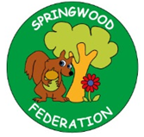
Revise these previously taught sounds:
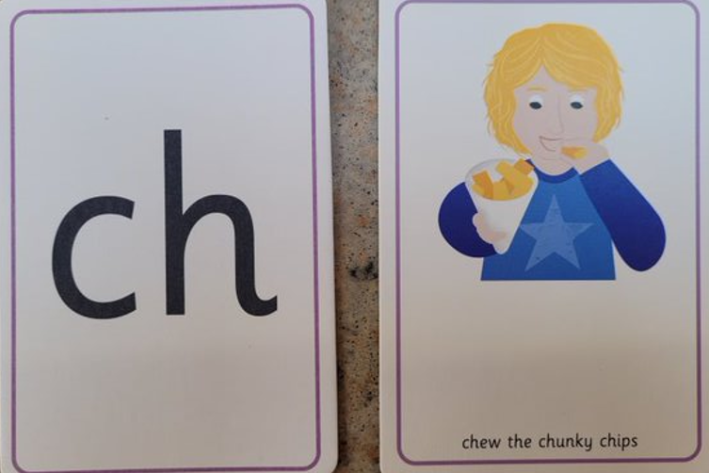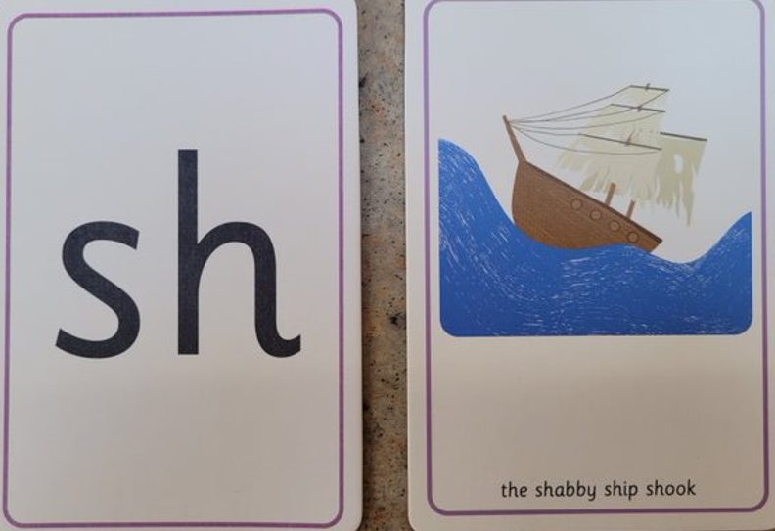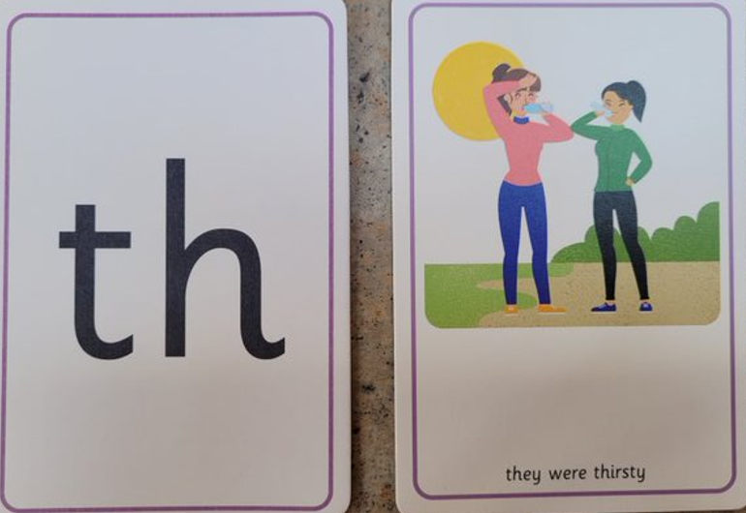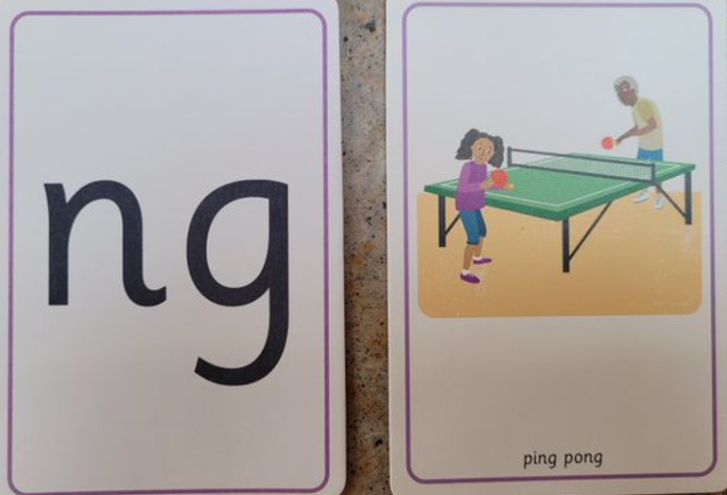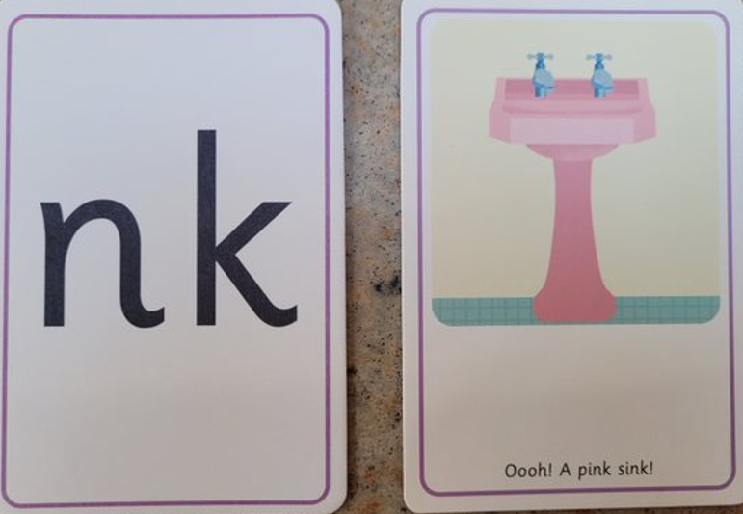
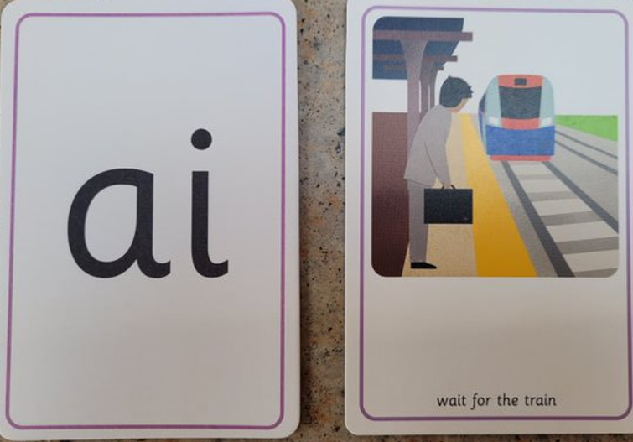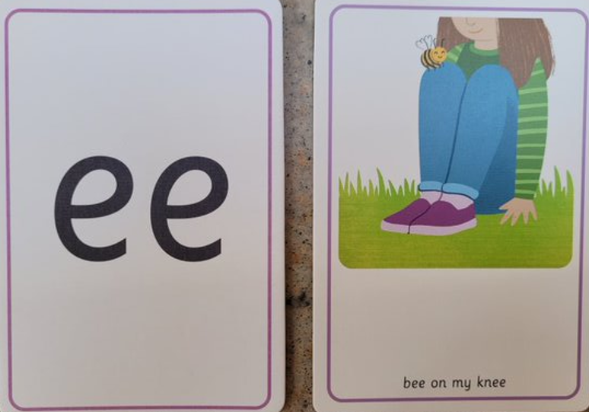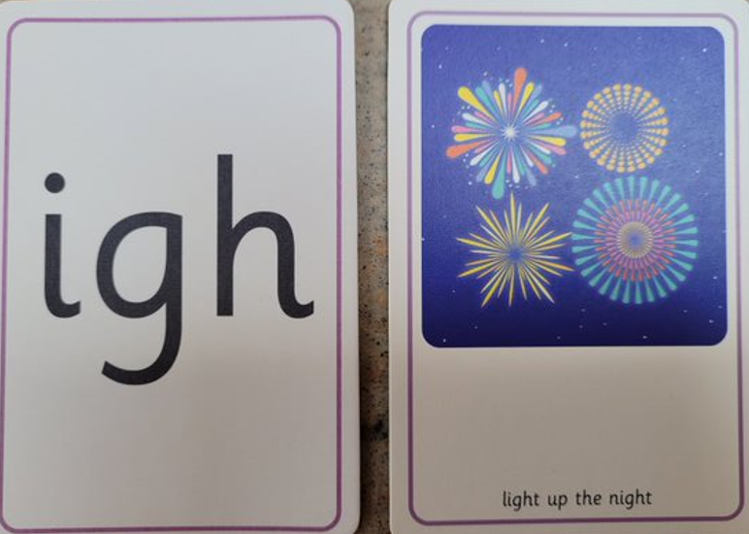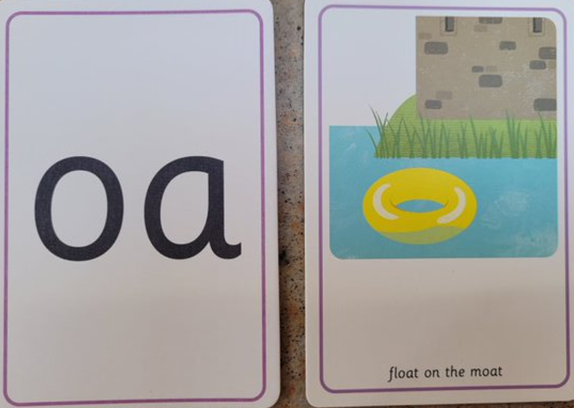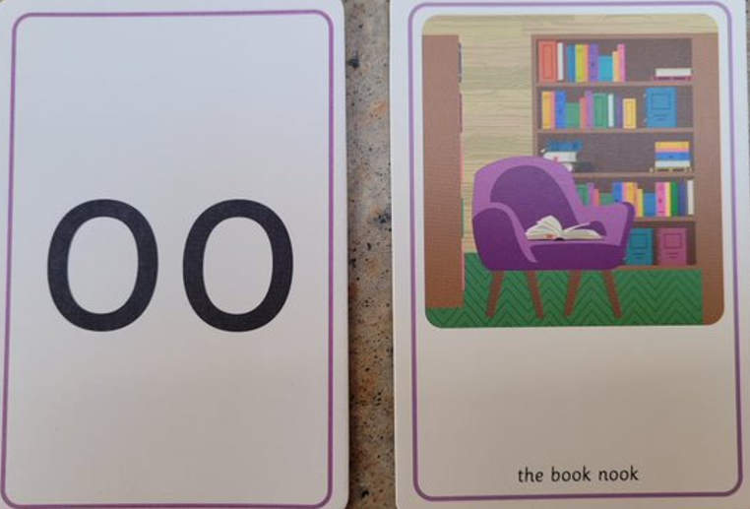
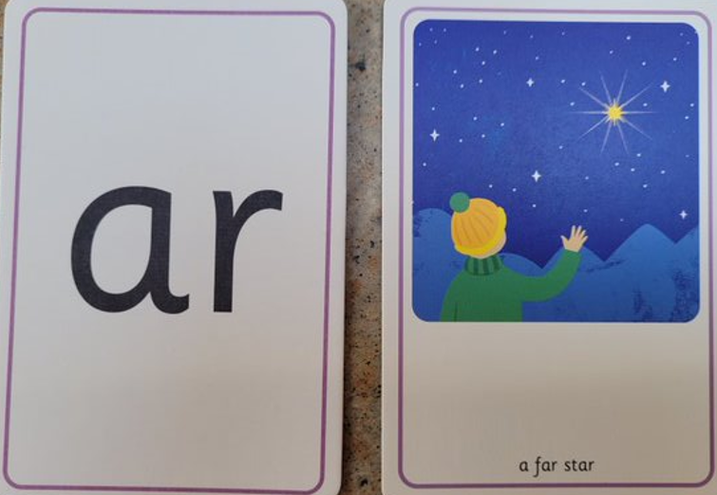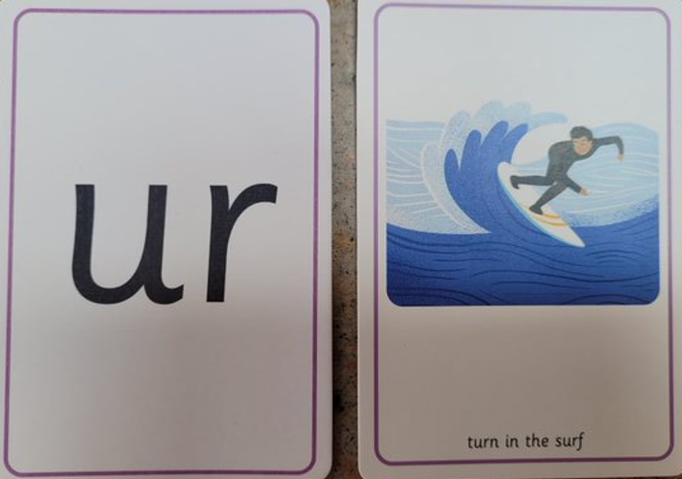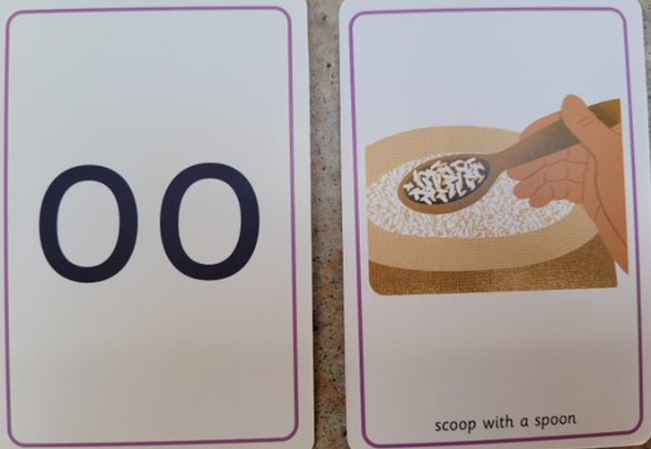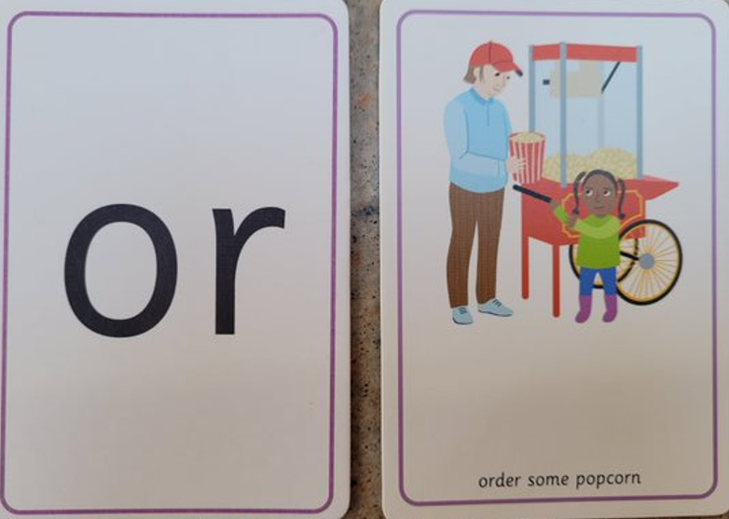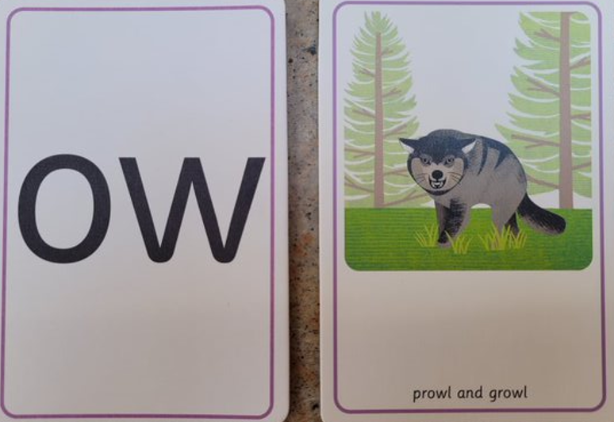
Your child needs to know them by sight (without the pictures), so find them within a word or ask them to write a word containing these sounds from memory. (Read 3 x a week)
Pre-teach poster
Year 1
Spring 2

Reading  Ask you child questions about what they have read.  Why has this happened?  How do they feel?  What do you think will happen next? | Learn these hard to read words by sight:  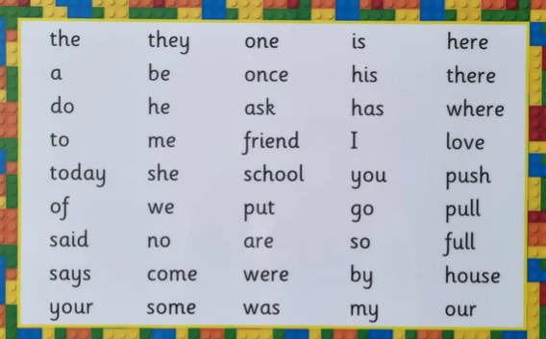  Skill: To understand what you are reading.  When you read a text, link together the facts and clues to see the bigger picture and understand what’s happening. This is called comprehension. | Tricky word song:  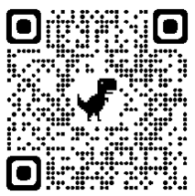  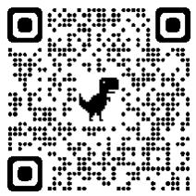  Comprehension:  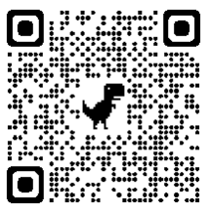
Writing  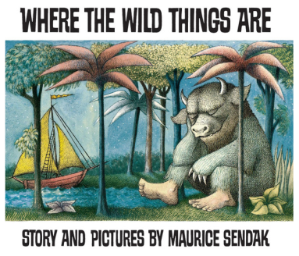 | Words to read, write and understand the meaning of; back, horns, teeth, feathers, beak, lips, eyes, talons, claws  Skill: To write a character description.  One night Max puts on his wolf suit and makes mischief of one kind and another, so his mother calls him 'Wild Thing' and sends him to bed without his supper. That night a forest begins to grow in Max's room and an ocean rushes by with a boat to take Max to the place where the wild things are. Max tames the wild things and crowns himself as their king, and then the wild rumpus begins! But when Max has sent the monsters to bed, and everything is quiet, he starts to feel lonely and realises it is time to sail home to the place where someone loves him best of all. | 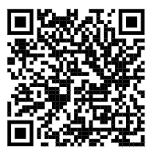
Maths | Words to use: compare, different, fewer, more  Skill: Addition and subtraction: Comparing numbers. | 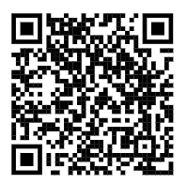
Maths | Words to use: part, whole, equal, unequal, divide, half  Skill: Fractions: To identify half of a shape or object | 

