Task to be completed over this half term | Multiplication tables  Help your child to login to their Times Tables Rock Stars account using the password provided.    Keep practising your times tables up to 12 x 12.  Try to aim for 1000 coins a week as this will support you in many other areas too.  In class, we are recapping how to multiply and divide by 10 and 100 using a place value grid. Have a go at practising these skills at home:  308 x 100 = 4150 ÷ 10 =  523 x 10 = 1096 ÷ 10 = | Spelling  Strategies to support learning spellings:  - Look, cover, write, check.  - Pyramid words.  - Write the tricky part in a different colour.  - Draw around the word to show the ascenders and descenders.  - Pictoword.  - Spelling word in a picture. | Reading  Reading  Oxford Reading Buddy  Login to read books matches to your child’s level and complete online comprehensions.  https://www.oxfordreadingbuddy.com/uk  Continue to read at least 3 times a week.  At least one of these reads should be using Oxford Reading Buddy but make sure you also enjoy a library book or a book of your choice. |  | Creative Family project (Submission date: 20.10.25)  Be a geographer!  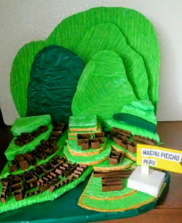  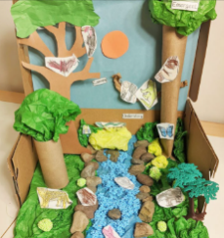  Using your research skills and creative ideas, find out more about our focus country Peru. Be as creative as you can by making an artwork, presenting a powerpoint, constructing a model, designing a travel document, to inform others about Peru’s geography, history, culture or art. Some other ideas:  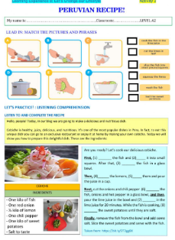  🎨 Art & Craft Projects  - Machu Picchu 3D model.  📖 Storytelling & Writing Projects  - Inca myth comic strip.  🎶 Music & Performance Projects  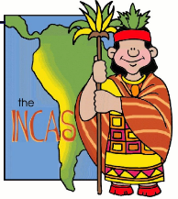  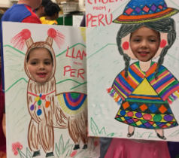  - Festival Dance.  🍲 Food & Culture Projects  - Traditional recipe.  🌍 Geography & Science Projects  - Amazon Rainforest diorama.  - Mountain Habitat poster.  - Weather report.  https://kids.britannica.com/kids/article/Peru/345766?utm_source=chatgpt.com  https://kids.nationalgeographic.com/geography/countries/article/peru?utm_source=chatgpt.com
Spelling to learn at home. | Week 1 Spellings (Test 12.09)  accident(ally) actual(ly)  address answer  appear arrive  believe bicycle  breath breathe | Week 2 Spellings (Test 26.09)  build busy/business  calendar caught  centre century  certain circle  complete consider |  | Week 3 Spellings (Test 03.10)  continue decide  describe different  difficult disappear  early earth  eight enough |  | Week 4 Spellings (Test 10.10)  exercise experience  experiment extreme  famous favourite  February forward(s)  fruit grammar | Week 5 Spellings (Test 17.10)  group heart height history imagine increase important guard  guide heard | Week 6 Spellings (Test 24.10)  heart height  history imagine  increase important  interest island  knowledge learn

In Geography, we are learning about:  - Peru and their natural resources. | In Science, we are learning about:  - Fossils, geological time and classification. | Curriculum Overview  Autumn 1  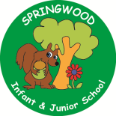  Year 5 | In PSHE, we are learning about:  Health and Wellbeing by considering:  - What positively and negatively affects health and wellbeing  - making informed choices; benefits of a balanced diet;  - Recognising what they are good at; setting goals; aspirations.  - Intensity of feelings; managing complex feelings. Coping with change  - Strategies for managing personal safety in the local environment; online safety; including sharing images; mobile phone safety. | In RE, we will be learning about:  - Theme/Unit: Shahada and salat.  - Concept: Belonging.
In PE, we are learning:  - the skills needed to play dodgeball.  - Orienteering. | In Computing, we are learning about:  - Programming: Music. |  | In Music, we are:  - Australia - Read, Write and Remember to Twinkle. | In Art, we are:  - creating Indigenous Australian Art.
In English, we are using The Arrival as our stimulus and will be writing:  - a detailed narrative building suspense and tension.  In Reading we will be Reading complimentary texts including:  - The boy in the back of the class – Onjali Q Rauf. |  | In MFL, we are developing our French skills through:  - La phonetique (Phonics and Pronunciation)  - La date (The date) | In Maths, we will continue to develop our Arithmetic skills.  We will also develop our skills and knowledge in:  - Number, Place Value and reasoning with whole numbers  - Problem solving with addition and subtraction  - Statistics (Line graphs and time tables)  - Measurement (area and perimeter)  - Multiplication and Division

