In History, we are learning about:  - Katherine Johnson -(significant historical person). | In Science, we are learning about:  - Space and Gravity | Curriculum Overview  Autumn 2  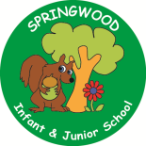  Year 5 | In PSHE, we are learning about:  Treat others as you wish to be treated  - Responding to feelings in others  - Working collaboratively  - Negotiating and compromise  - Giving feedback  - Respecting and resolving differences  Stay Safe  - Changes at puberty (recap Y4) | In RE, we will be learning about:  - Theme/Unit: Christmas- the 2 birth narratives  - Concept: Interpretation
In PE, we are learning:  - The skills needed to play football.  - Gymnastics – counterbalance and tension. | In Computing, we are learning about:  - Mars Rover 1 – Identifying some of the types of data that the Mars Rover collects and transmits data to Earth. |  | In Music, we are:  - Katherine Johnson – civil rights. | In DT, we are:  - Electrical Systems:  - Focus: More complex Switches and Circuits  - Outcome: Automatic Nightlight.
In English, we are using ‘Pandora Discovered’ as our stimulus and will be writing:  - Non chronological report (to inform).  - Instructions (to inform and entertain).  - Discursive text (to inform).  In Reading we will be Reading complimentary texts including:  - Destination Earth by Ali Sparkes.  - Impossible Creatures by Katherine Rundell.  - Poem focus – Iron Man by Brenda Williams. |  | In MFL, we are developing our French skills through:  Goldilocks and the Three bears | In Maths, we will continue to develop our Arithmetic skills.  We will also develop our skills and knowledge in:  - Multiplication and Division  - Area and perimeter

Task to be completed over this half term | Multiplication tables  Help your child to login to their Times Tables Rock Stars account using the password provided.    Keep practising your times tables up to 12 x 12.  Try to aim for 1000 coins a week as this will support you in many other areas too.  We will be working with factors, multiples and squares this term in class.  Recap your timestables up to x12 to develop your speed! | Spelling  Strategies to support learning spellings:  - Look, cover, write, check.  - Pyramid words.  - Write the tricky part in a different colour.  - Draw around the word to show the ascenders and descenders.  - Pictoword.  - Spelling word in a picture. | Reading  Oxford Reading Buddy  Login to read books matches to your child’s level and complete online comprehensions.  https://www.oxfordreadingbuddy.com/uk  Continue to read at least 3 times a week.  At least one of these reads should be using Oxford Reading Buddy but make sure you also enjoy a library book or a book of your choice. |   Creative Family project:  Handed in by Friday 12th December  Create a project with your family to showcase Space. You could  - Make your own space story or documentary.  - Design your own space colony – Life beyond Earth.  - Solar System in a Box.  Try to use recycled materials where possible!  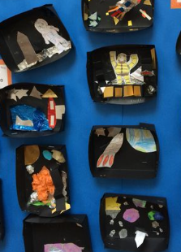    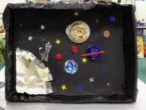
Spelling to learn at home. | Week 1 Spelling (Test 14.11)  accommodate accompany  according achieve  aggressive amateur  ancient apparent  appreciate attached | Week 2 Spellings (Test 21.11)  category cemetery  committee communicate  community correspond  critic +ise curiosity  definite desperate | Week 3 Spellings (Test 28.11)  dictionary disastrous  embarrass environment  equipment especially  exaggerate excellent  familiar foreign | Week 4 Spellings (Test 5.12)  identity immediate (ly)  individual interfere  interrupt language  leisure lightning  marvellous mischievous  muscle necessary | Week 5 Spellings (Test 6.12)  horrible terrible  probable adorable  comfortable visible  forcible enjoyable  parliament persuade | Practicing skills:  Look Cover Write Check.  Pyramid Words.  Different colour vowels.

