In History, we are learning about:  - Earliest civilizations overview of ALL (Egypt, Sumer, Indus Valley, Shang China) and in-depth study of Shang dynasty. | In Science, we are learning about:  - Space and gravity/ how light behaves. | Curriculum Overview  Spring 1  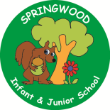  Year 5 | In PSHE, we are learning about:  - Safe Relationships.  - Physical contact and feeling safe.  - Protecting the environment; compassion towards others. | In RE, we will be learning about:  - Theme/Unit: The Golden rule  - Concept: Love
In PE, we are learning:  - Invasion: Tag Rugby  - Dance: Space | In Computing, we are learning about:  - Search Engines. |  | In Music, we are learning about:  Pathway to Musical Independence  Title/Context:  Tech and Timbre  Viva Las Vegas! | In DT, we are looking at:  Food  Focus: Celebrating culture and seasonality  Outcome:  Seasonal stew
In English, we are using ‘Inside the Villains’ as our stimulus and will be writing:  - An information page for the troll (Billy Goats).  In Reading we will be Reading complimentary texts including:  - Zomierella. |  | In MFL, we are developing our French skills through:  Do you have a pet? | In Maths, we will continue to develop our Arithmetic skills.  We will also develop our skills and knowledge in:  - Area and perimeter  - Fractions and decimals  - Angles

Task to be completed over this half term | Multiplication tables  Help your child to login to their Times Tables Rock Stars account using the password provided.    Keep practising your times tables up to 12 x 12.  Try to aim for 1000 coins a week as this will support you in many other areas too.  We will be working with factors, multiples and squares this term in class.  Recap your timestables up to x12 to develop your speed! | Spelling  Strategies to support learning spellings:  - Look, cover, write, check.  - Pyramid words.  - Write the tricky part in a different colour.  - Draw around the word to show the ascenders and descenders.  - Pictoword.  - Spelling word in a picture. | Reading  Oxford Reading Buddy  Login to read books matches to your child’s level and complete online comprehensions.  https://www.oxfordreadingbuddy.com/uk  Continue to read at least 3 times a week.  At least one of these reads should be using Oxford Reading Buddy but make sure you also enjoy a library book or a book of your choice.  Your teacher recommends and will be reading with you:  Use non-fiction to learn about early civilisations. | Creative Family project:  Handed in by Monday 9th February 2026.  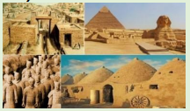  Early Civilisation mini bake off!  As part of our history topic on Early Civilisations, we would like you to create an edible dish from one of these civilisations. It can be a recipe you have researched or one from the selection we have provided.  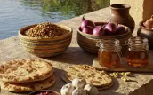  Shang Dynasty  Ancient Egyptians  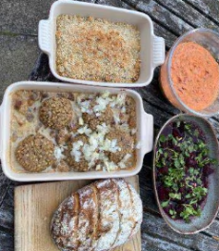  Indus Valley  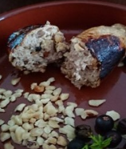  Ancient Sumer  Eg.  Eat Like a Mesopotamian: Experts Reconstruct 4000-Year-Old Recipes | Ancient Origins
Spelling to learn at home. | Week 1 Spelling (Test 16.1)  interact  intercept  interfere  familiarise  unfamiliar  divided  individual / ly | week 2 spellings (test 23.1)  individuals  interrupting  intersection  familiarised  over / familiarity  dividend  although  toughest | week 3 spellings (test 30.1)  mischievous  thought  curious  critical  cemetery  committee  country  vehicle | week 4 spellings (test 6.2)  muscle  sincere  category  sacrifice  especially  necessary  cautious  marvellous | Week 5 Spellings (Test 13.2)  system  symmetry  symbolic  ecosystems  sympathetic  desperate  secretive / ly  secretary

