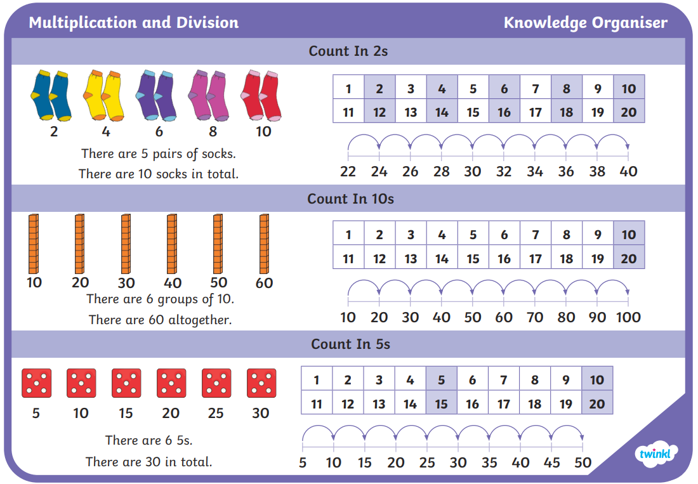
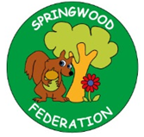

Pre-teach poster
Year 2
Summer 1

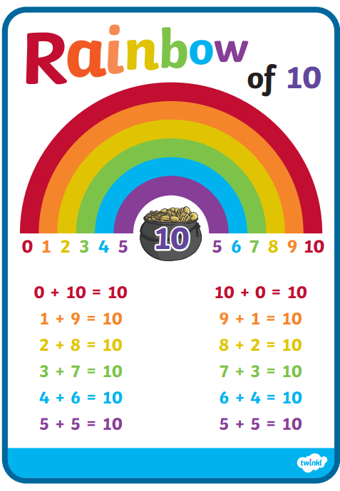
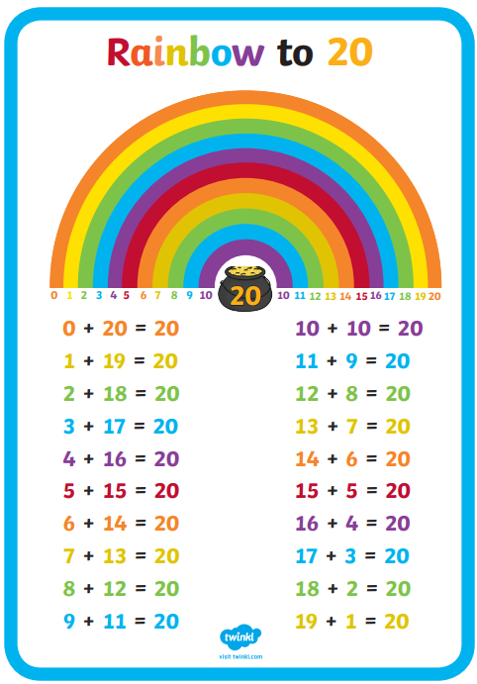

Learn your number bonds to 10 and 20.

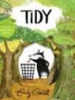  Writing |   Text: Tidy – Emily Gravett  Key vocabulary: persuade, idea, forest, leaves, burrows, trees, seasons, tidy, clean, sweep, pick, vacuum, wash, build, destroy, mess, regret, habit, nature, responsibility  Scan me  Skill: To write a persuasive letter
Phonics | Skill: To secure our understanding of phase 3 and 5 sounds  

