Tasks to be completed over this half term | Suggested Timetable: |  | Maths  Now that we are in our final term, it is the perfect opportunity to master our times table knowledge.  You should know your 2x 5x and 10x tables up to 12x fluently, with no hesitation.  If you know these, move onto your 3x table.  Other skills that are beneficial to master include:  Telling the time to the hour, half past, quarter to and quarter past.  - Knowing your doubles and halves. |  | Reading  *Continue to read at least 3 times a week. Try to read both fiction and non-fiction texts.  * Use Oxford Reading Buddy to access books at your level and answer comprehension style questions.  Your teacher recommends and will be reading a range of stories focusing on the theme ‘The Classics’  e.g.  - The Wind in the Willows – Kenneth Grahame  - Winnie the Pooh – A A Milne  - The Sheep-Pig – Dick King Smith  - The Legend of Podkin One-Ear - Keiron Larwood  - Cicada- Shaun Tan |  | Creative Family project Submission date: Monday 13th July  Reading with a purpose...  Can you follow a recipe, instructions for building a model eg. Lego, or for playing a board game.  Then ask an adult to take a photograph of your finished creation, game or model and send it in via email to:  adminoffice@springwood.hants.sch.uk  (put year two home learning as the subject)  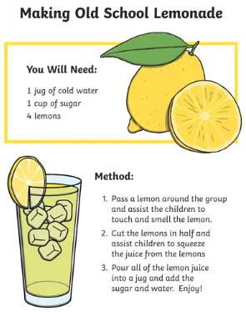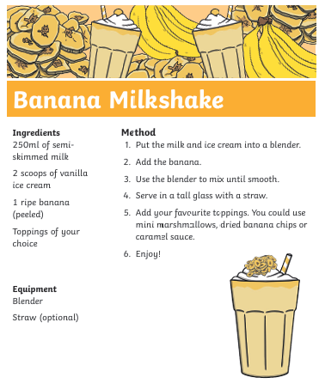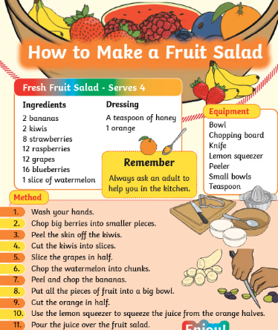
  Week 1 | Spellings  Read 3x  x table focus
  Week 2 | Spellings  Read 3x  Telling the time focus
  Week 3 | Spellings  Read 3x  Doubles & halves focus
  Week 4 | Spellings  Read 3x  x tables focus
  Week 5 | Spellings  Read 3x  Telling the time focus
  Week 6 | Spellings  Read 3x  Doubles & halves focus
Weekly Spellings | Week 1 (Testing on 12.06)  Add ness but no change to the route word:  sadness  closeness  kindness  lateness  wickedness  sickness  rudeness | Week 2 (Testing on 19.06)  Suffix -ly – consider when you need to drop the y  quickly  slowly  carefully  hopefully  creatively  happily  patiently |  | Week 3 (Testing on 26.06)  Drop the y add ied:  replied  supplied  cried  fried  worried  partied  emptied |  | Week 4 (Testing on 03.07)  Drop the y add ies:  cherries  bunnies  babies  fairies  cities  berries  marries  stories  countries  parties |  | Week 5 (Testing on 10.07)  Er and est:  happier  happiest  dottier  dottiest  choppier  choppiest  prettier  prettiest  lovelier  loveliest | Week 6 (Testing on 17.07)  Drop the y and add i and er  stickier  lonelier  angrier  drier  lazier  fancier  steadier  noisier  hairier  busier
In Geography, we are learning about:  - UK Weather & Seasons | In Science, we are continuing to learn about:  - Plants and growing | Curriculum Overview  Summer 2  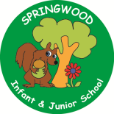  Year 2 | In PSHE we will be learning about being  - Healthy and safe  -diet  -cleaning teeth  -Railways  -Sun safety  -road safety  -changes and transition | In RE, we will be learning about:  - God by thinking about different ideas.
In PE, we are learning about:  - Rackets, bats and balls  - Health and wellbeing | In Computing, we are learning:  - Data Handling |  | In Music, we are going to continue learning:  - Ukulele | In Art, we are learning about:  - Sea-themed weaving using textiles and materials.
In English, we are using ‘The Hodgeheg’ as our stimulus and will be writing:  - A setting description from the point of view of Max the Hedgehog  - A guide to road safety for Hedgehogs (leaflet)  - A letter to parents about road safety outside our school  In Reading we will be looking at the theme anthropomorphism (animals taking on human characteristics. We will be using the following texts in our reading journeys:  - The Sheep pig by Dick King Smith  - Tiger Who Came to Tea by Judith Kerr  - Giraffes Can’t Dance by Giles Andreae  - Fantastic Mr Fox by Roald Dahl |  |  | In Maths, we will continue to develop our Arithmetic skills.  We will also develop our skills and knowledge in:  - Capacity  - measurement  - Multiplication and Division  - Addition and Subtraction

