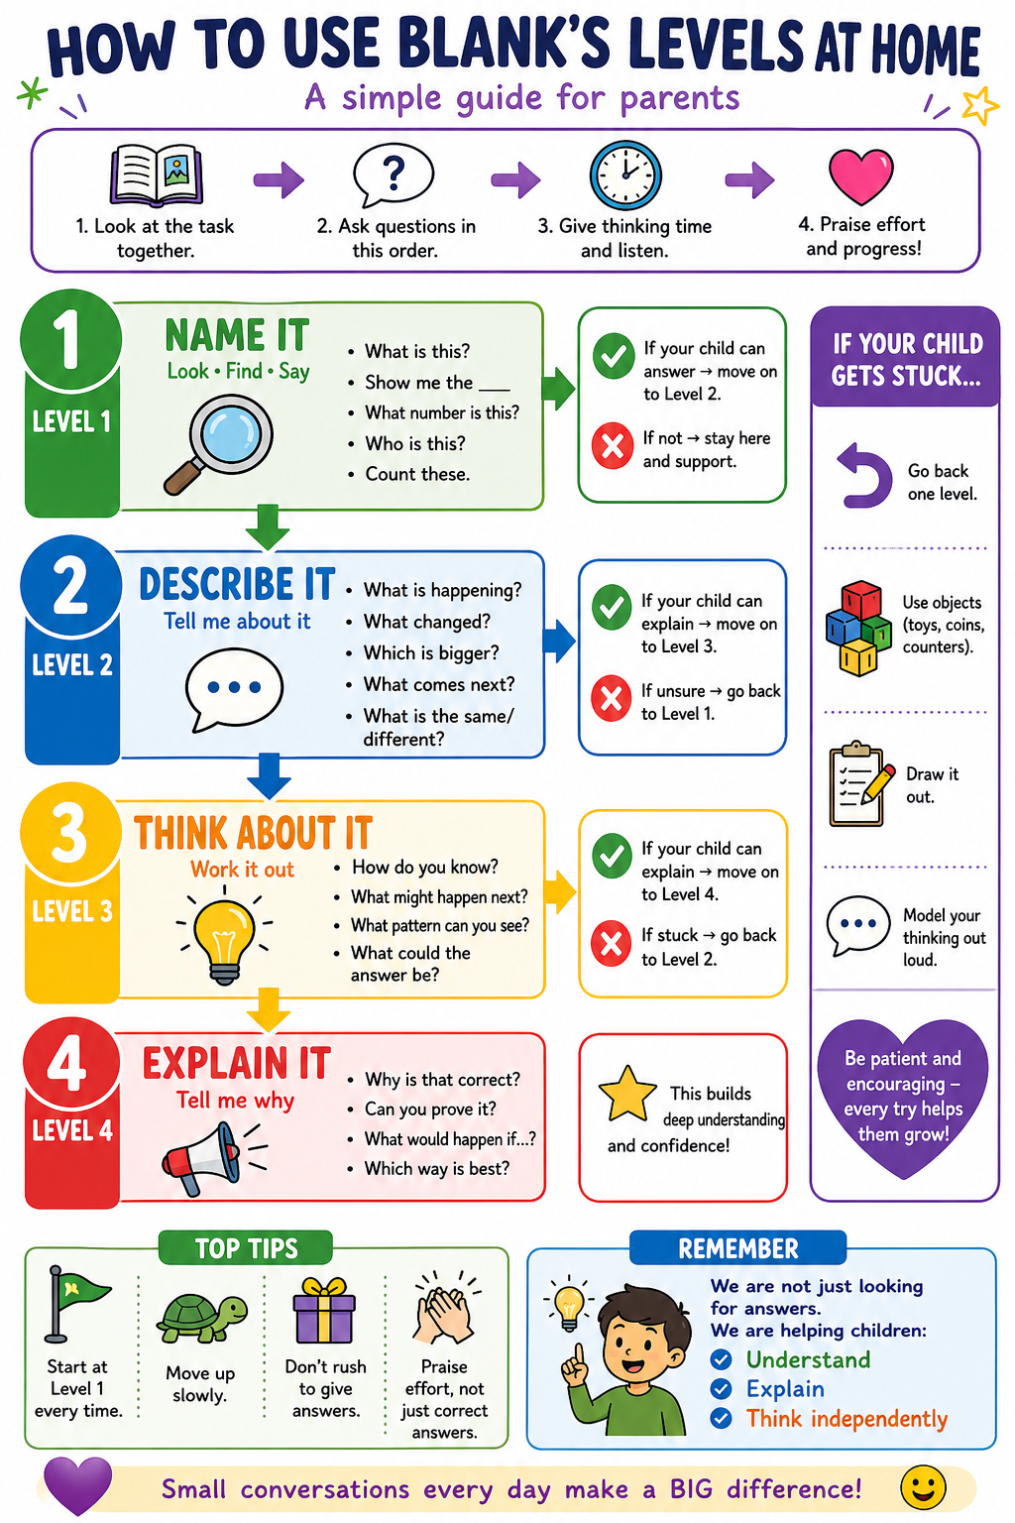

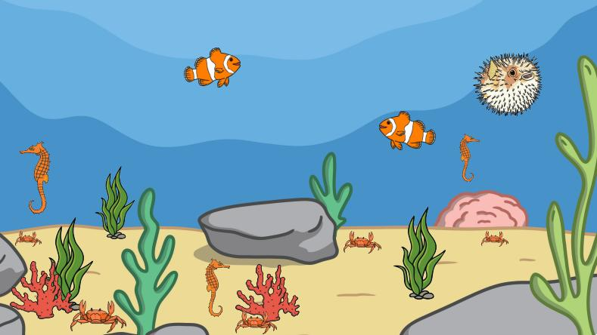
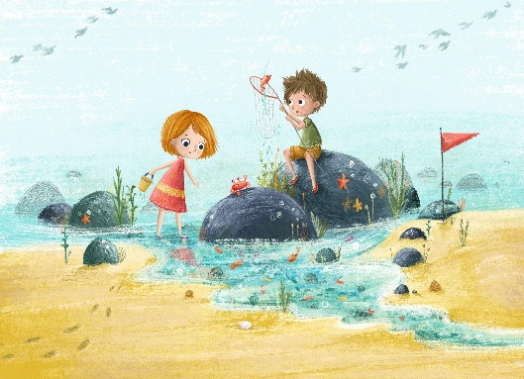
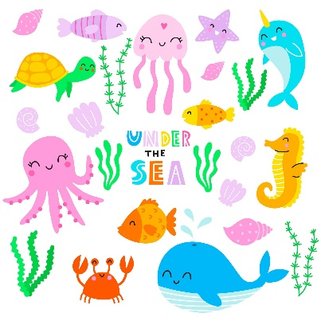
Year R – Summer Term: Under the Sea

Key vocabulary: sea, fish, crab, shell, turtle, waves, swim
Level 3
What might happen next?
Where could the fish hide?
What does the turtle need to swim?
Which animals are the same?
Which animals are different?
What would you take to the beach?
Level 2
What is the fish doing?
Where is the turtle?
What colour is the crab?
Which animal is big?
Which animal is small?
What lives under the sea?
Level 1
What can you see?
Show me the fish.
Point to the turtle.
Show me something blue.
What animal is this?
Can you find something that swims?
Level 4
Why do fish live in water?
Why might a crab hide?
What would happen if the sea was dirty?
How can we look after the sea?
Why do some sea animals have shells?

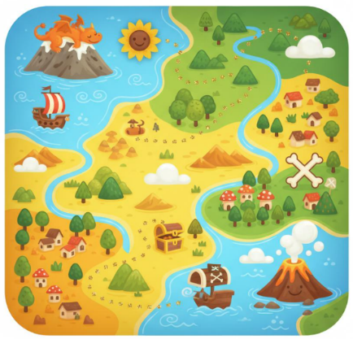
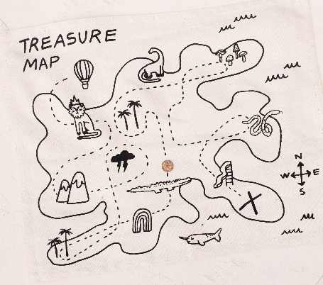
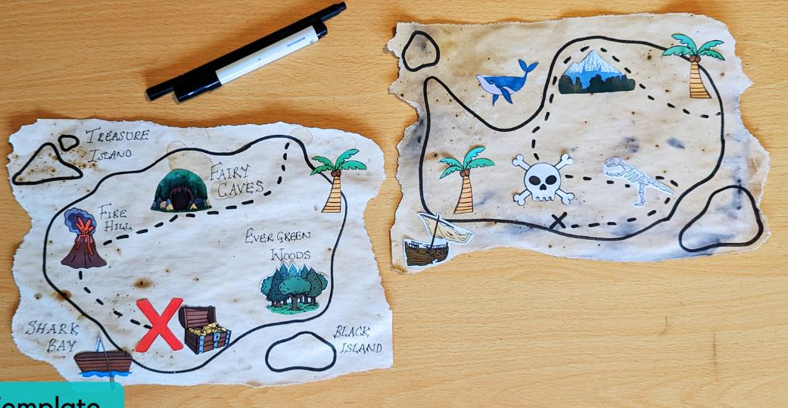
Year R – Summer Term: Treasure Maps

Key vocabulary: map, treasure, path, X, route, near, far, next to, under, behind, forwards, backwards, left, right
Level 1
What can you see?
Show me the map.
Point to the treasure.
Show me the path.
Where is the X?
What places can you see?
Level 2
What is happening on the map?
Where does the path go?
What is near the treasure?
What do you pass first?
What comes next?
Is the treasure near or far?
Level 3
How do we know where to go?
What might the X mean?
What could happen if we go the wrong way?
Which way should we go first?
What could we add to our map?
How could we make a treasure map for our classroom or garden?
Level 4
Why do people use maps?
How does a map help us find places?
Why do we need signs or symbols on a map?
How can we make sure someone follows our map correctly?
What would happen if the map was missing the X?

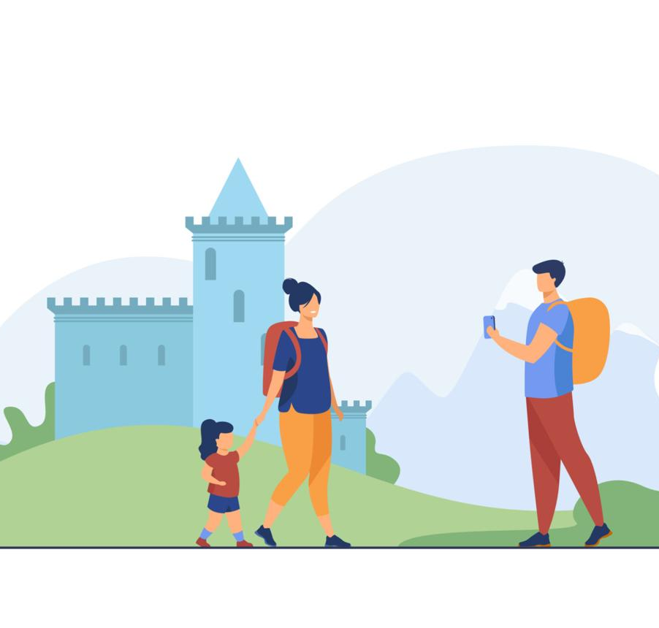
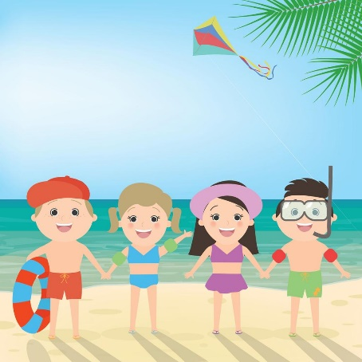
Year R – Summer Term: Holidays and places we have visited
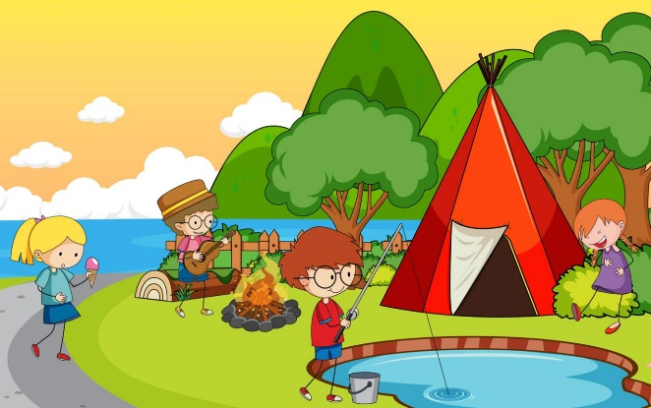

Key vocabulary: holiday, visit, journey, beach, city, countryside, home, near, far, travel, suitcase, map
Level 4
Why do people visit different places?
Why might people choose the beach / city / countryside?
How do we know this place is different from home?
What would happen if we forgot something important?
Which place would you like to visit? Why?

Level 3
What would you pack for a holiday?
How is this place different from home?
Why do people go on holidays?
What would you like to do there?
What places have you visited?
Level 2
What is happening?
What is the place like?
What can you do there?
Is it near or far?
What might the weather be like?
How did they get there?
Level 1
Show me the beach.
Point to the family.
What are they doing?
Where are they?
What did they take with them?

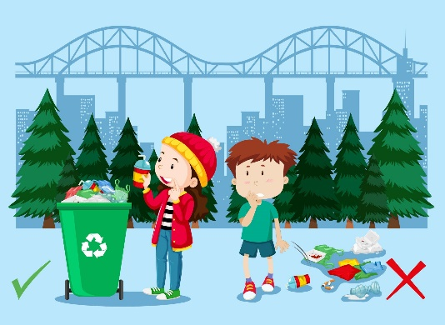
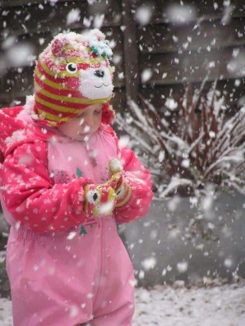
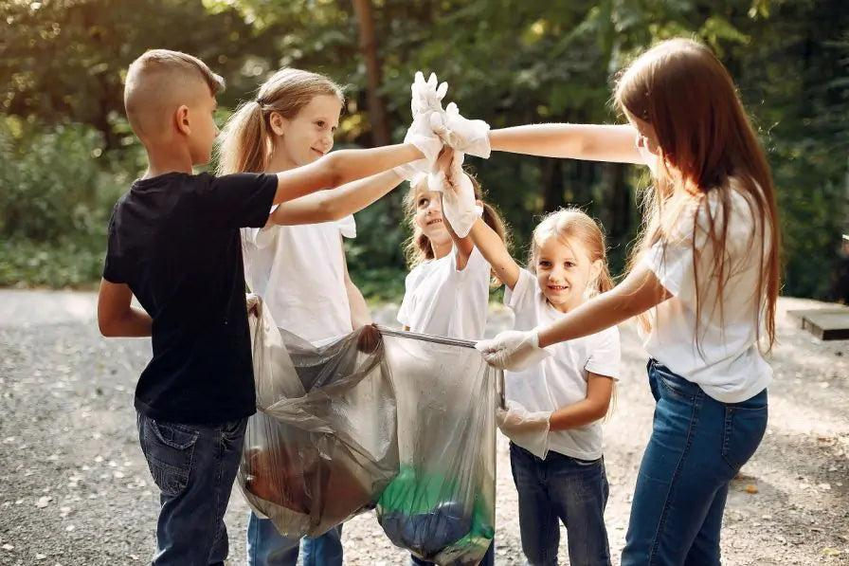
Year R – Summer Term: Weather and the Environment

Key vocabulary: story, book, Bible, Hindu story, Christian story, lesson, idea, community, tradition, remember, share
Level 4
Why is weather important?
Why do we need to look after the environment?
What would happen if no one picked up rubbish?
How can we keep our outdoor area safe and clean?
Why do plants and animals need a healthy environment?
Level 3
Why do we wear different clothes in different weather?
What might happen if it rains a lot?
Why do plants need rain?
Why should we put rubbish in the bin?
What could happen if animals find rubbish?
How can we help plants grow?
Level 2
What is the weather like?
What are the children doing?
What clothes do we need in this weather?
What is happening to the environment?
Is this place clean or messy?
How are the children helping?
Level 1
Show me something growing
Show me the sun.
Point to the rain.
Show me the wind.
What is the child wearing?
Can you see any rubbish?
• Show me something growing.

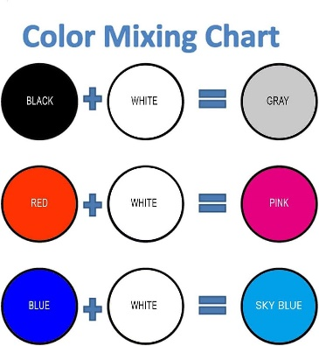
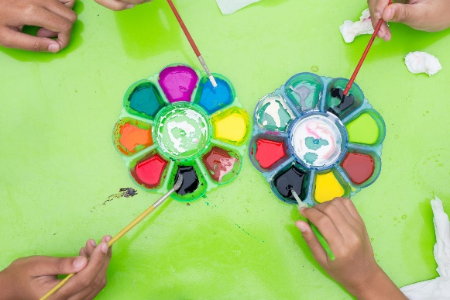
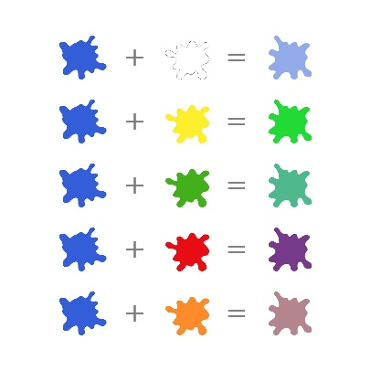
Year R – Summer Term Art: Tints and Shades

Key vocabulary: colour, paint, mix, light, dark, tint, shade, white, black
Level 3
How can we make this colour lighter?
How can we make this colour darker?
Why do artists use light and dark colours?
What colour would you use for the sky / sea / night?
What might happen if we add too much black/white?
Level 4
Why is this called a tint?
Why is this called a shade?
How can light and dark colours change a picture?
Why might an artist use dark colours?
Why might an artist use light colours?
Level 2
What happens when we add white?
What happens when we add black?
Which colour is lighter?
Which colour is darker?
What does this colour remind you of?
How has the colour changed?
Level 1
What colour can you see?
Show me a light colour.
Show me a dark colour.
Point to the paint.
Which colour do you like?
Can you find blue / red / yellow?

