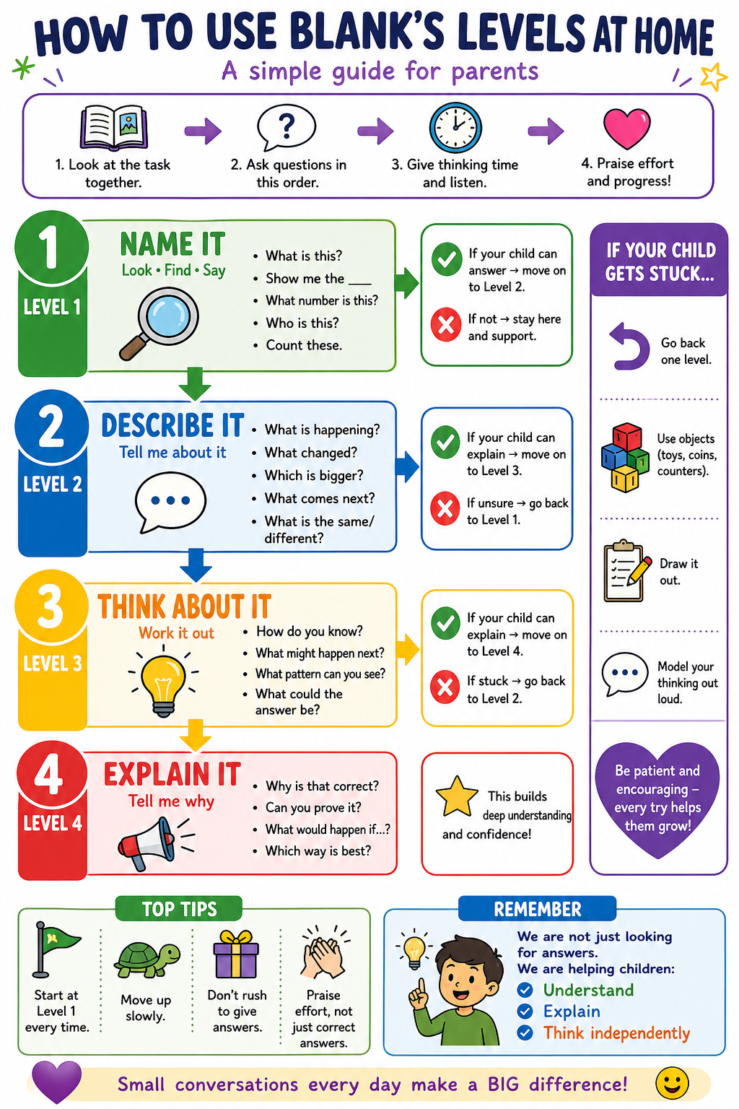

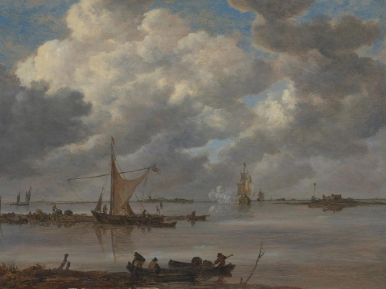
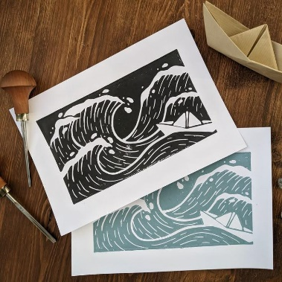
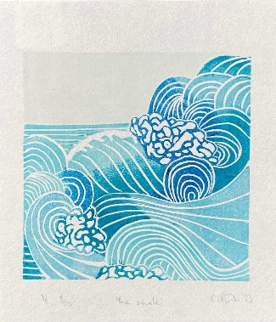
Year 5 – Summer Term Art Unit: Printed Seascapes

Level 1
What can you see? (sea, sky, boats)
What type of artwork is this?
What patterns or marks can you see?
Where is the sky? Where is the sea?
What tool or method might have been used?
Key vocabulary: Relief print, block print, hatching, stippling, negative space, composition, atmospheric
Level 4
Why does the seascape feel calm or stormy?
How does the composition help guide your eye?
Why are some areas more detailed than others?
What makes this artwork atmospheric?
How does this style reflect the artist’s ideas?
Level 2
What do you notice about the colours?
What do you notice about the textures?
How has the artist shown waves or movement?
Where are the darker and lighter areas?
How is the picture arranged?
Level 3
How has the artist created texture?
Why might printmaking be used for this image?
What is left blank (negative space)? Why?
How do the marks (lines/dots) show movement?
How could you create this effect in your own work?

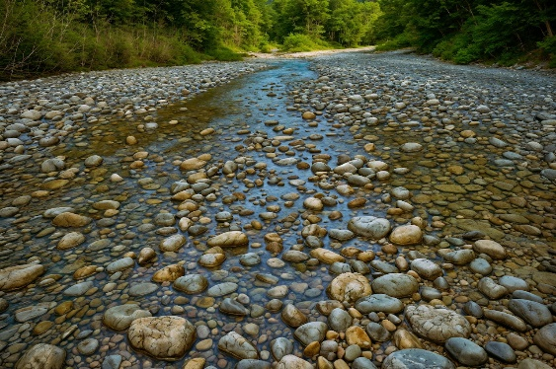
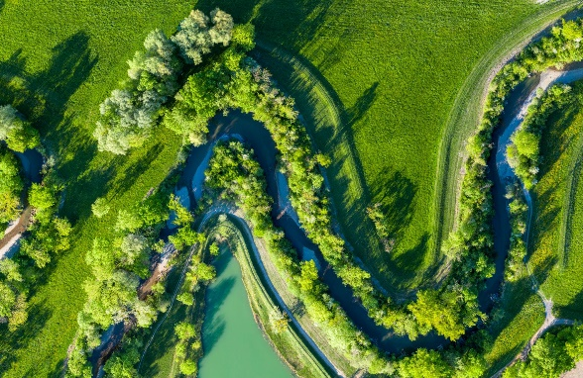
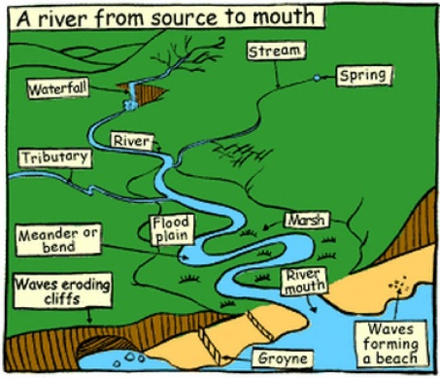
Year 5 – Summer Term Geography Unit: Rivers

Key vocabulary: River bed, banks, erosion, transportation, deposition, flow
Level 3
Why does the river wear away the banks?
Why does the water carry rocks and sand?
Why does material get dropped in some places?
Why is the water faster in some parts?
What happens to the river over time?
Level 1
Show me the river bed
Show me the river banks
Where is the water flowing?
Where is the water fast?
Where is the water slow?
What can you see in the water?
Level 4
Why does erosion happen more in some places than others?
How does the river change the land over time?
Why does deposition happen when water slows down?
How do these processes shape the river?
How might this affect people living nearby?
Level 2
What is happening to the water as it moves?
What is happening to the river banks?
What is the water carrying?
Where is the river changing shape?
What happens when the water slows down?

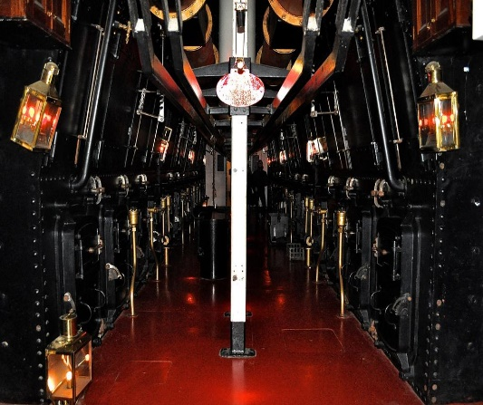
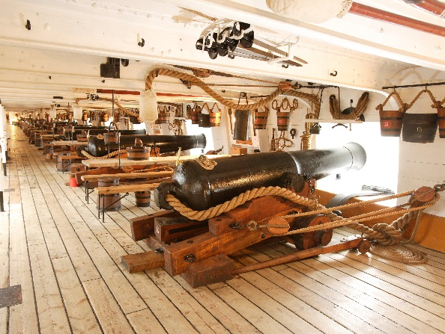
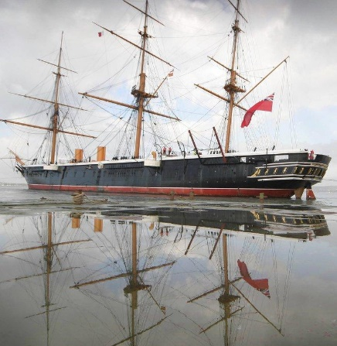
Year 5 – Summer Term History Unit: HMS Warrior

Key vocabulary: Islamic civilisation, Baghdad, Golden Age, scholar, House of Wisdom, innovation, translation
Level 4
Why does HMS Warrior show change in Britain’s history?
How did new technology improve ships like this?
Why was this ship important to the local area?
What does this tell us about Britain at the time?
How is this ship similar or different to modern ships?
Level 3
Why was HMS Warrior important when it was built?
How is this ship different from earlier ships?
Why was iron used instead of wood?
What technology can you see?
How might life on this ship be different from today?
Level 2
What is the ship used for?
What do you notice about how it is built?
What are the cannons used for?
What is different about this ship compared to wooden ships?
What clues show this is from the past?
Level 1
What is this object?
What type of transport is it?
What can you see on the ship? (cannons, sails, metal)
Point to the sails
What materials can you see?

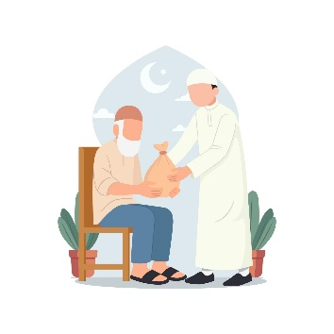
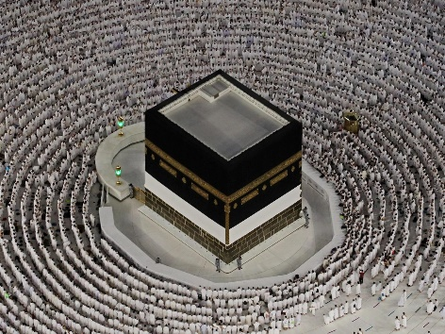
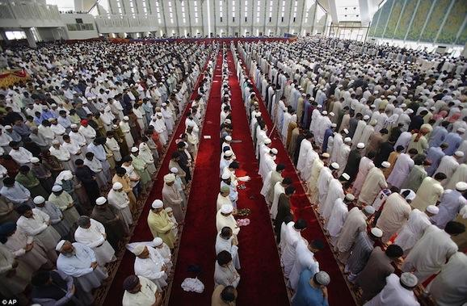
Year 5 – Summer Term RE Unit: Hajj, Zakat & Umma

Key vocabulary: Umma, community, Hajj, pilgrimage, Zakat, charity, belonging
Level 1
What can you see?
Where are the people?
What are they doing?
How many people are there?
What looks the same about them?
Level 3
Why do so many people gather together?
How might the people feel being part of this group?
Why is giving to others important?
What does this show about community (Umma)?
How does this bring people together?
Level 4
Why is Umma important to Muslims?
Why might Hajj strengthen a sense of community?
Why is Zakat important in a community?
What are the benefits of belonging to a community?
Is community important in your life? Why?
Level 2
What is happening in these pictures?
How are the people working or acting together?
What do you notice about how they are dressed or standing?
What is happening in the giving/charity picture?
What do these actions show about the group?

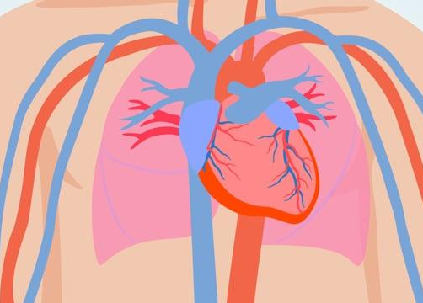
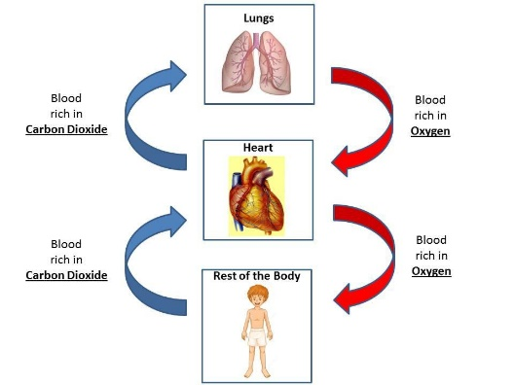
Year 5 – Summer Term Science Unit: Circulation
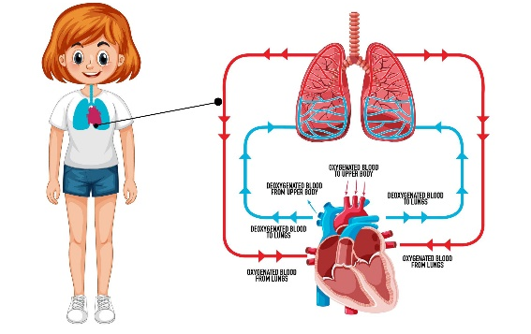

Key vocabulary: Water resistance, air resistance, friction, undulations, interlock, gears, pulley, lever
Level 2
What happens when we breathe in?
What happens to oxygen in the lungs?
What does the heart do?
Where does the blood travel?
What do muscles need to work?
Level 3
Why do we need oxygen in our blood?
Why does blood travel around the body?
How does the heart help the body work?
Why do muscles need oxygen and sugar?
What would happen if blood did not move?

🔴 Level 4 – Explaining (Understanding & health)
- Why is the heart an important organ?
- How does the circulatory system keep us alive?
- Why does exercise help the heart?
- How does a healthy diet help blood vessels?
- What could happen if blood vessels are blocked?
Complete:
The circulatory system is important because _______
We can keep it healthy by _______________________

❤️ Key Vocabulary
Heart, lungs, blood, oxygen, blood vessels, pump, muscles, circulation

💡 Why these images are better
✔ Clear arrows = easier to follow the journey
✔ Simple shapes = less cognitive overload
✔ Focus on process, not detail
✔ Perfect for Blank’s Level 1 pointing

If you want to make this even stronger, I can:
- Create a step-by-step flow strip (lungs → heart → body → back)
- Or a cut-and-sequence activity (very effective for this unit)
- Or simplify further for SEN/EAL
Just tell me 👍

Level 4
Why is the heart an important organ?
How does the circulatory system keep us alive?
Why does exercise help the heart?
How does a healthy diet help blood vessels?
What could happen if blood vessels are blocked?
Level 1
Show me the lungs
Show me the heart
Show me the blood vessels
What is moving around the body?
Where does oxygen enter the body?

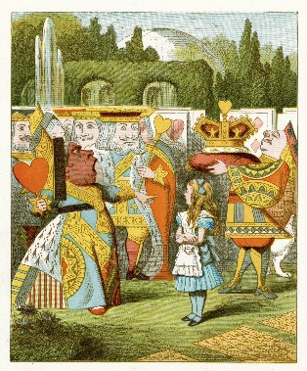
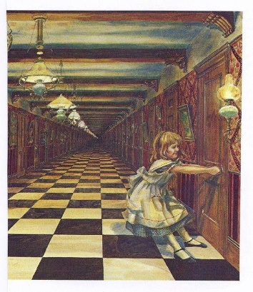
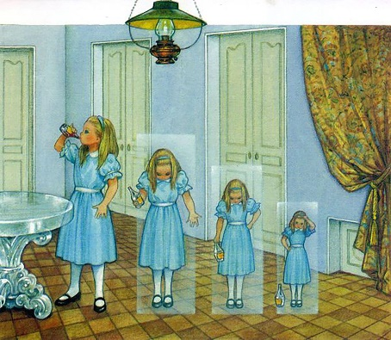
Year 5 – Summer Term Writing Unit: Alice in Wonderland

Key vocabulary: shrink, curious, strange, tiny, enormous, mysterious, furious, puzzled, Wonderland, royalty
Level 1
What can you see?
Who is in the picture?
What is happening to Alice?
Point to the drink
Who is the Queen?
Level 2
What is happening in each scene?
How does Alice feel?
What does the place look like?
What is strange or unusual?
What is the Queen doing?
Level 3
Why is Alice shrinking?
How does she feel about the doors?
What might she be thinking?
Why is the Queen angry?
What might happen next?
Level 4
Why is the shrinking important in the story?
•Why are the doors important for Alice’s journey?
What does the Queen of Hearts show about Wonderland?
Why do strange things keep happening to Alice?
What kind of world is Wonderland? How do you know?

