Tasks to be completed over this half term |   Home Apps  Timetable Rockstars  https://play.ttrockstars.com/  UR Brainy  MTC - Multiplication Tables Check - URBrainy.com | Spelling  Practise spelling daily using words from the Year 3 and Year 4 spelling list.  Did you know that this is a list of 100 words that children in England are expected to be able to spell by the end of Year 4? How many can you spell? | Reading for pleasure  Challenge yourself to read a narrative and a non-fiction book this half term.  Your teacher recommends and will be reading with you:  Leo and the Gorgon’s Curse by Joe Todd Stanton.  Mythical Beasts and Magical Creatures by Stephen Krenksy  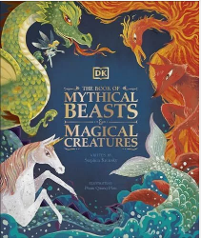  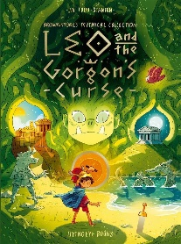 | Creative Family project: Anglo-Saxons and Scots  Submission Date: Week commencing 19.10.26  Get historical!  Thinking about Saxons – this is your chance to get creative to make, draw, build or model a traditional Saxon house.  Your challenge is to use recycled items where possible.  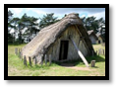  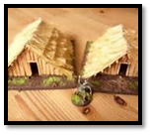  Think about the shape of the house and what it was made from.
Tasks to be completed over this half term | Oxford Reading Buddy  Login to read books matches to your child’s level and complete online comprehensions.  https://www.oxfordreadingbuddy.com/uk
Tasks to be completed over this half term | Letter-Join: Handwriting  Login to use Letter-Join at home: letterjoin.co.uk/log-in  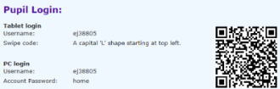
Spellings to learn at home | Week 1  accident  accidentally  address  answer  appear  arrive  believe  bicycle  breath  breathe | Week 2  build  busy  business  calendar  caught  centre  century  certain  circle  opposite | Week 3  complete  consider  continue  decide  describe  different  difficult  disappear  early  ordinary | Week 4  earth  eight  eighth  enough  exercise  experience  experiment  extreme  famous  particular | Week 5  favourite  February  forward  fruit  grammar  group  guard  guide  heard  heart | Week 6  height  history  imagine  increase  important  interest  island  knowledge  learn  length | Week 7  library  material  medicine  mention  minute  natural  notice  occasion  occasionally  often

In History, we are learning about:  - Britain’s settlement by Anglo-Saxons and Scots. | In Science, we are learning about:  - Mixtures and separating them. | Curriculum Overview  Autumn 1  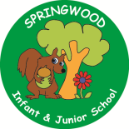  Year 4 | In PSHE, we are learning about Mental Health and Wellbeing. Our topics are:  - Describing emotions  - Understanding internal and external distractions  - Exploring different thinking habits  - Different ways to manage  worries  - Strategies for calm  - How do people manage change and loss? | In RE, we are learning about:  - Neighbours  - Concept: Community
In PE, we are learning:  - Ultimate Frisbee  - Orienteering | In Computing, we are learning about:  - Collaborative learning when using Microsoft Office 365.  - E-safety: The accuracy of results when searching online. |  | In Music, we are learning:  - Ukulele | In DT, we are learning:  - Healthy and varied diets.  - We will make a healthy Springwood Community Picnic.
In English, we are using the following text drivers:  - Arthur and the Golden Rope by Joe Todd-Stanton  A character description of Fenrir the wolf.  - Beowulf (Monster Slayer) by Chris Riddell  Graphic recount of the battle scene between Beowulf and Grendel  - The Hippocrump (poem) by James Reeves  Performance poetry.  In Reading, we will be looking a variety of different texts with themes of mythical beasts and legends. |  | In MFL, we are developing our French skills through:  - La phonetique (Phonics and Pronunciation)  - Les Saisons (Seasons) | In Maths, we will develop our skills and knowledge in:  - Reasoning with large numbers  - Addition and subtraction  - Multiplication and Division

