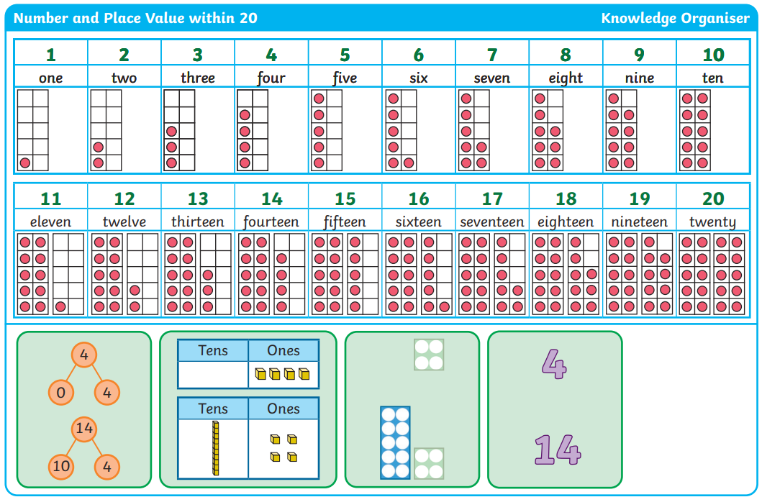
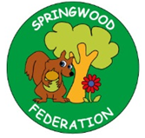

Pre-teach poster
Year 2
Autumn 1

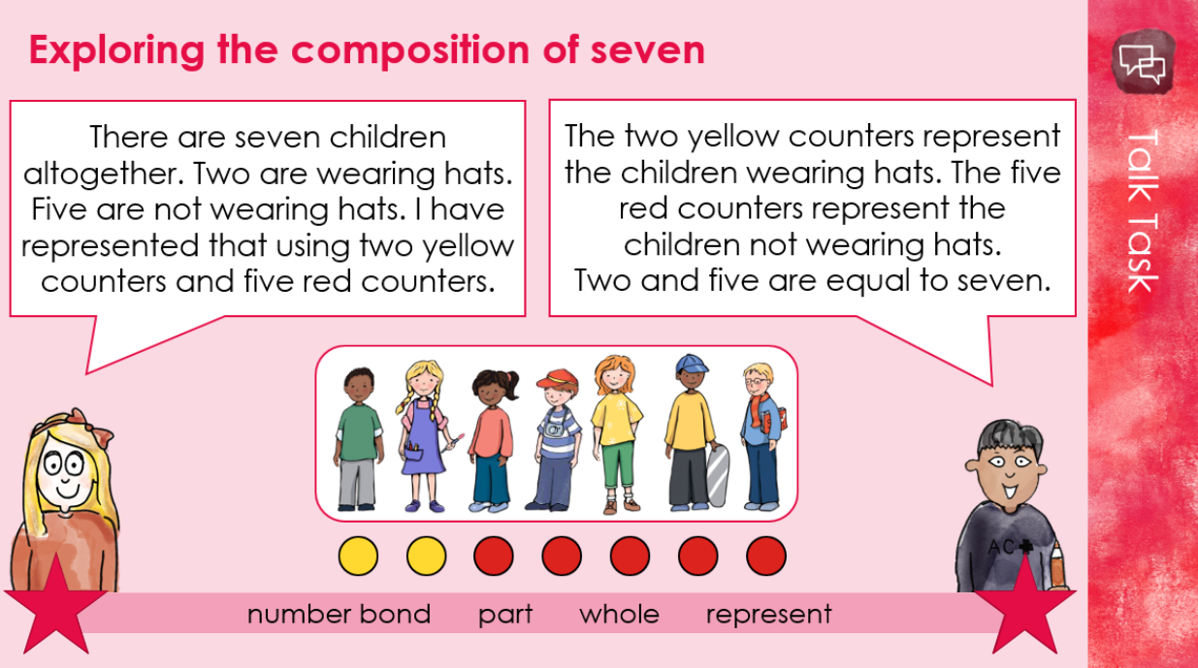

Writing  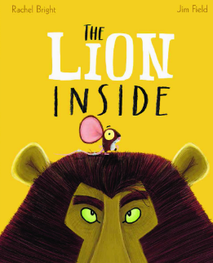 |   Text: The Lion Inside  Key vocabulary: lion, mouse, mighty, roar, brave, tough, meek, pack, creature, confidence, impressed, afraid  Scan me  Skill: Writing a character description by…  Using adjectives such as: big, loud, fury, strong, fierce, brave  Using noun phrases such as: fury body, strong legs, loud roar, powerful legs
Phonics | Skill: To secure our understanding of phase 2 and 3 sounds  

