Task to term be completed over this half | Home Apps  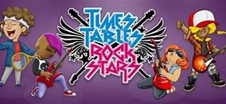  Timetable Rockstars  Even in Y6, timetables are vital to support in many areas.  At least four times a week. | Spelling  Practise daily spelling using the word sums that we will be focusing on in class.  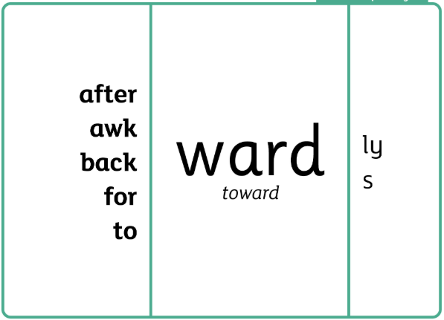  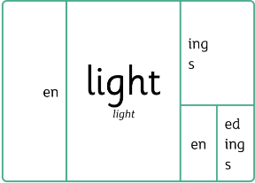  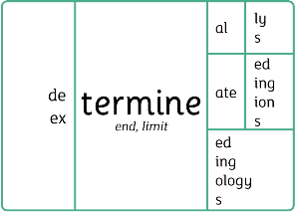 | Reading  Continue to read at least 4 times a week using the Oxford Reading Buddy.  Challenge yourself to read a narrative and a non-fiction book this half term.  Your teacher recommends and will be reading with you King Kong by Anthony Browne.  Can you remind yourself of other Anthony Browne texts?    These include:  - The Tunnel, Voices in the Park, Into the Woods, Gorilla, Hide and Seek |  | Creative Family project: Seasonal Vegetables  Submission date: w.c. 19.10.26  In DT, we are looking at Harvest and seaonal vegetables. Can you answer following questions:  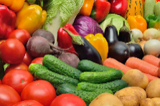  *Why is harvest celebrated?  *Why is harvest important to different groups of people?  *What harvest traditions are there?  Consider similarities and differences in Harvest celebrations from around the world.  Research using the sites below:  https://school-learningzone.co.uk/key_stage_two/ks2_religious_education/ks2_harvest/harvest_ks2.html  You can present your learning in your own creative way: a recipe, a poster, a leaflet, a PowerPoint, a model, a painting, a print or even some tasty meals or snacks!  Try and use recyclable materials where possible!
Task to term be completed over this half | Oxford Reading Buddy  Login to read books matches to your child’s level and complete online comprehensions.  Oxford Reading Buddy - Log in  At least four times a week.
Spellings to learn at home | Week 1 Spellings (Test 18.9)  advantageous  adventurous  ambiguous  boisterous  cantankerous  humorous  humungous  infamous | Week 2 Spellings (Test 24.9)  jealous  joyous  marvellous  ridiculous  rigorous  scandalous  spontaneous  courteous | Week 3 Spellings (Test 2.10)  ambitious  cautious  infectious  scrumptious  fictitious  repetitious  nutritious  pretentious | Week 4 Spellings (Test 9.10)  malicious  conscious  unconscious  semiconscious  serious  spacious  vicious  suspicious |  | Week 5 Spellings (Test 16.10)  various  oblivious  curious  copious  religious  ingenious  ferocious  rebellious | Week 6 Spellings (Test 23.10)  Amphibious  contagious  luxurious  hilarious  delicious  glorious  gracious  envious
In Geography, we are learning about:  - The UK and understanding of physical and human features | In Science, we are learning about:  - Making new substances | Curriculum Overview  Autumn 1  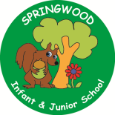  Year 6 | In PSHE, we are learning about mental health and wellbeing.  Our topics are:  - Regulating emotions  - Managing distraction  - Developing positive thinking habits  - Managing rumination and worry  - Managing stress  - How do people manage loss and support each other? | In RE, we will be learning about:  - Theme/Unit: Revelation of the Qu’ran, sawm and Ramadan  - Concept: Peace
In PE, we are learning:  - Invasion: Dodgeball  - OAA: Communication | In Computing, we are learning about:  - Bletchley Park |  | In DT, we are:  - Food  - Focus: Celebrating culture and seasonality  - Outcome: Harvest Soups
In English, we are using The Island by Armin Greder and King Kong by Anthony Browne and stimulus for writing:  - A letter/diary in role  - A contrasting character description from the perspective of Anne, Carl or Jack D at different points in the story.  - A love letter from the point of view of Kong  In Reading, we will be reading complimentary texts to consider and evaluate different viewpoints, attending to and building on the contribution of others. |  | In MFL, we are developing our French skills through:  - Phonics  - Clothes | In Maths, we will continue to develop our Arithmetic skills.  We will also develop our skills and knowledge in:  - Integers and decimals  - Multiplication and division  - Calculation problems

