Task to be completed over this half term | Suggested Timetable: |  |     Maths  Help your child to login to their Numbots and Times Tables Rockstar accounts using the password provided (it is the same for both programmes)  Can they achieve 1000 coins on TTRS?  We will be solving problems that include the 2, 5 and 10x table. Practise using arrays and a number line to count in these multiples.  Please continue to practise learning your number bonds to 20 fluently. |  | Reading for Pleasure  Reading  *Continue to read at least 3 times a week. Try to read both fiction and non-fiction texts.  Use Oxford Reading Buddy to login and read books at your child’s reading level. You will also find comprehension questions to answer about the text.    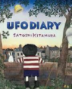  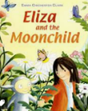  Your teacher recommends and will be reading a range of stories focusing on our reading theme of ‘Stepping into the unknown’  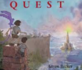 |  | Creative Family project:  Submission date: Handed in by Friday 12th December  Can you create a piece of art work entitled “Through the window”? This could be a winter scene looking out, or a cosy winter scene looking inside. Let your imagination run wild.  Here are some ideas:  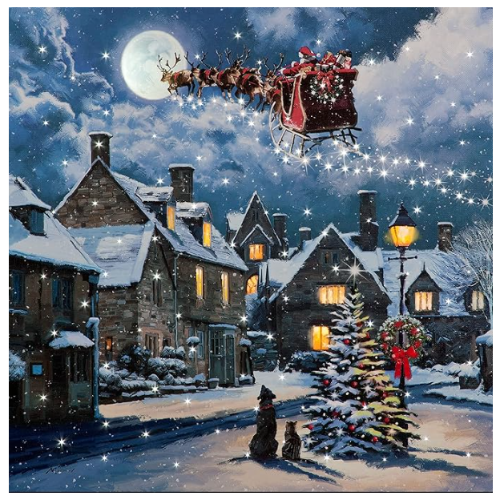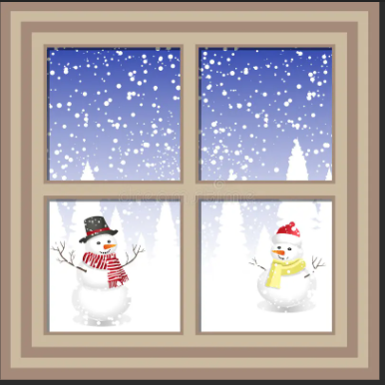  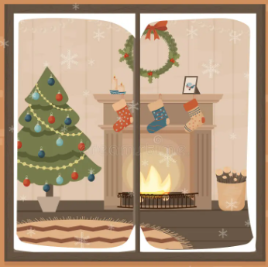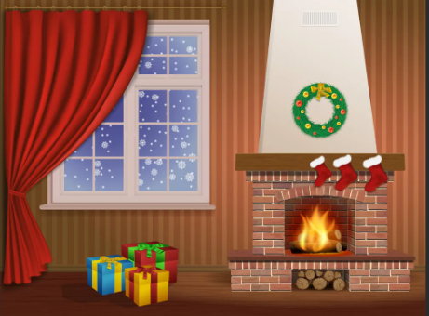
  Week 1 | Spellings  Oxford Reading Buddy  Maths focus – 2x table
  Week 2 | Spellings  Oxford Reading Buddy  Maths focus – Number bonds to 20
  Week 3 | Spellings  Oxford Reading Buddy  Maths focus – 5x table
  Week 4 | Spellings  Oxford Reading Buddy  Maths focus – Number bonds to 20
  Week 5 | Spellings  Oxford Reading Buddy  Maths focus – 10x table
Weekly Spelling | Week 1 (Test on 14.11)  be  he  she  we  me | Week 2 (Test on 21.11)  the  to  today  of  said |  | Week 3 (Test on 28.11)  his  has  you  your  they |  | Week 4 (Test on 5.12)  no  go  by  my  here  there |  | Week 5 (Test on 12.12)  come  some  are  pull  full
In History, we are learning about:  - Guy Fawkes and the Gunpowder Plot | In Science, we are continuing to learn about Animal Lifecycles then will begin…  - Changing Materials | Curriculum Overview  Autumn 2  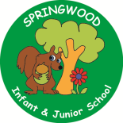  Year 2  In Reading we will be Reading texts like…  Toys in space – Mini Grey  Q Pootle 5 – Nick Butterworth  Eliza and the Moonchild – March and Rich Chamberlin  UFO Diary – Satoshi Kitamura  The Queen’s Lift-Off – Steve Antony  The Tunnel – Anthony Brown | In PSHE, we are learning about:  - Managing secrets; resisting pressure and getting help; recognising hurtful behaviour  - Recognising things in common and differences; playing and working cooperatively; sharing opinions | In RE, we will be learning about:  - Theme: Advent Concept: Waiting
In PE, we are learning about:  - Ball Skills: Hands  - Gymnastics: Pathways | In Computing, we are learning:  - Programming : Algorithms and debugging |  | In Music, we are learning about:  - Samba | In Art, we are:  - Sculpting – Guy Fawkes clay heads
In Writing, we will be exploring the texts…  Man on the Moon – Simon Bartram  Journey – Aaron Becker  Pet Dragon - MP Robertson  We will be writing a diary entry, a setting description and an information text about our very own dragon. |  |  | In Maths, we will continue to develop our Arithmetic skills.  We will also develop our skills and knowledge in:  - Securing numbers to 20  - Addition and subtraction within 20

